# Overview

This document contains the necessary information to build the Chatterbox. The Chatterbox is a switch scanning communication device which provides auditory feedback to guide the user while scanning.

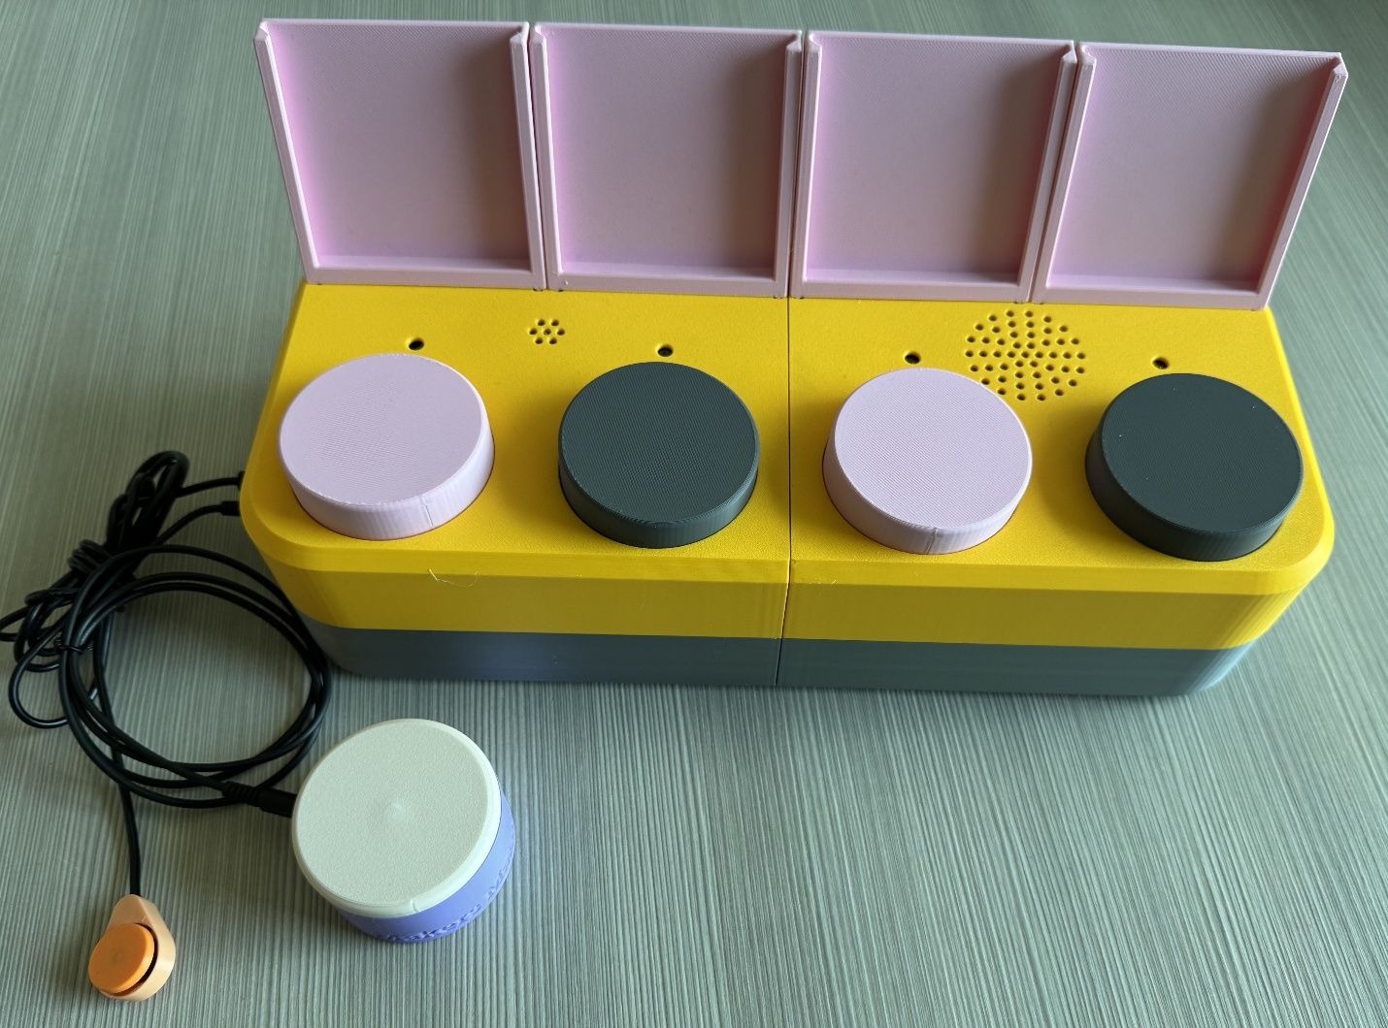

Contents

Overview 1

Maker Checklist 5

Maker To Do List 5

Items to Give to User 5

Tool List 6

Tools / Equipment 6

Supplies 6

Personal Protective Equipment (PPE) 6

Customization Guide 7

Custom Printed Circuit Board (PCB) Guide 7

Ordering the Custom PCBs 7

3D Printing Guide 8

3D Printing Summary 8

3D Printing Settings 8

Post-Processing 8

Examples of Quality Prints 9

Maker Component List 11

Assembly Guide 17

Part A: Main PCB 19

Part A: Required Components 19

Part A: Required Tools and Supplies 21

Part A: Required Personal Protective Equipment (PPE) 21

Soldering Image Guide 21

Part A: Main PCB Assembly Steps 21

Part B: Secondary PCB 46

Part B: Required Components 46

Part B: Required Tools and Supplies 48

Part B: Required Personal Protective Equipment (PPE) 48

Part B: Secondary PCB Assembly Steps 48

Part C: LED PCBs 66

Part C: Required Components 66

Part C: Required Tools and Supplies 67

Part C: Required Personal Protective Equipment (PPE) 67

Part C: LED PCB Assembly Steps 67

Part D: Enclosure Assembly 73

Part D: Required Components 73

Part D: Required Tools and Supplies 75

Part D: Required Personal Protective Equipment (PPE) 75

Part D: Enclosure Assembly Steps 75

Part E: Flashing Firmware to the Chatterbox 94

Part E: Required Components 94

Part E: Required Tools and Supplies 94

Step E-01: Connect the Chatterbox to the Computer 94

Step E-02: Setup Arduino IDE on Computer 94

Step E-03: Setup Arduino IDE for the Seeeduino Nano 94

Step E-04: Install Libraries 95

Step E-05: Enable Recording 95

Step E-06: Setup Local Code Directory 96

Step E-07: Flash Firmware to the Chatterbox 96

Testing 96

Battery Power 97

Mode Switch 98

Record Messages 98

Level Switch 98

Message Playback 98

Switch Scanning 99

Next Switch 99

Speed Switch 99

Volume 100

Troubleshooting 100

When powered, the first two lights start blinking and nothing else will happen 100

Chatterbox does not turn on with battery, but did on USB-C power 100

An LED does not turn on 100

When a button is pressed, the corresponding LED turns on very briefly but nothing else happens 101

The Chatterbox seems to skip playing a message while switch scanning, and goes right to the delay between messages 101

Nothing happens when I press a message button 101

Nothing happens when I press the assistive switch attached to the Select jack 101

Nothing happens when I press the assistive switch attached to the Next jack 101

# Maker Checklist

This list provides an overview of the steps required to build and deliver the Chatterbox

## Maker To Do List

* Read through the Maker Guide to become familiar with required components, tools, supplies, safety gear, and overall assembly steps.
* Talk to the User about customization options
  + What colour(s) they would like the Chatterbox printed in.
    - If they would like high contrast between the direct access switches and top of the enclosure.
  + If they would like any custom caps, or the regular flat top on the direct access switches.
  + How they would like to receive the “User Guide” (PDF or physical copy)
  + Ask if they would like the label holders connected or if they can connect them (having the label holders connected before shipping may make shipping more difficult)
* Order custom PCBs
* Order hardware components
* Gather tools, supplies, and safety equipment.
* Assemble the device
* Flash firmware to the Chatterbox
* Test the Chatterbox
* Print “User Guide” (if the User would like a physical copy)

## Items to Give to User

* Assembled Chatterbox in enclosure
* Label holders
* User Guide

# Tool List

## Tools / Equipment

|  |  |  |  |
| --- | --- | --- | --- |
| Tool ID | Description | Required / Recommended | Notes |
| T01 | Soldering iron | Required | Soldering components |
| T02 | Flush cutters | Required | Trimming electronic components |
| T03 | Wire strippers | Required | Stripping insulation off wires |
| T04 | Phillips head screwdriver (#2) | Required | Assembling the Chatterbox |
| T05 | Precision flathead screwdriver (2.5mm or smaller) | Required | Securing the speaker to the amp |
| T06 | Two assistive switches | Required | For testing the switch scanning functionality of the Chatterbox |

## Supplies

|  |  |  |  |  |
| --- | --- | --- | --- | --- |
| Supplies ID | Description | Quantity | | Notes |
| S01 | Solder | - | Soldering components together | |
| S02 | Hot glue or super glue | - | Holding the direct access switches in place | |

## Personal Protective Equipment (PPE)

|  |  |  |
| --- | --- | --- |
| PPE ID | Description | Notes |
| P01 | Safety goggles | Trimming electrical components and soldering may cause flying debris, which could harm your eyes if not wearing safety glasses. |

# Customization Guide

The device can be printed in the user’s desired colour(s). We recommend printing the enclosure top and button caps in colours with high contrast (ex: white and black) to make it easier for users with partial vision to locate the buttons, if they desire.

# Custom Printed Circuit Board (PCB) Guide

The Chatterbox uses three (3) custom printed circuit boards.

The custom PCBs can be ordered from one of a variety of PCB Manufacturers. Typically, the minimum quantity for a custom PCB is five. Shipping options vary significantly in cost and shipping time. Plan on at least a week from the time of order to the PCBs arrival.

## Ordering the Custom PCBs

1. Select a PCB Fabrication Company
   1. [JLPCB](https://jlcpcb.com/)
   2. [PCBWay](https://www.pcbway.com/)
   3. [OSH Park](https://oshpark.com/)
   4. [Seeed Fusion PCB](https://www.seeedstudio.com/fusion_pcb.html)
2. Create an account or use a guest login.
3. Upload the Gerber Files (e.g., Chatterbox_Main_PCB_YYYY-MM-DD.zip). TODO: update date
4. Select the fabrication options:
   1. PCB Layers: 2 Layers
   2. PCB Quantity:
      1. Main PCB: 5 boards
      2. Secondary PCB: 5 boards
      3. LED PCB: 20 boards*
   3. PCB Thickness: 1.6 mm
   4. Surface Finish: HASL with lead
   5. PCB Color: Choose what you like. Note that certain colours may impact build time and cost.
   6. The default settings for the other settings should work.
5. Select shipping option.
   1. Shipping options and costs vary significantly. Select the best option based on your budget and timing.
6. Submit the order.

*Note: we recommend ordering 20 LED PCBs as each Chatterbox requires four (4) LED boards. Ordering 20 boards lets you build up to five Chatterboxes on one PCB order, and the cost of 20 boards instead of 5 is negligible.

# 3D Printing Guide

The device was originally printed on a Bambu P1S with Bambu Studio, with the default slicer profile.

## 3D Printing Summary

|  |  |
| --- | --- |
| **Metrics** | **Single Unit** |
| Total Print Time (hour min) | 20h 10m |
| Total Number of Components | 24 |
| Typical Total Mass (g) | 707 |
| Typical Number of Print Setups | 8 |

## 3D Printing Settings

Note that the 3D printing material should be assumed to be PLA unless otherwise noted in the table below. The masses and print time are the total for each part (ex: each Label_Holder.stl weighs 19g, so all four are listed as 76 g).

|  |  |  |  |  |  |  |  |
| --- | --- | --- | --- | --- | --- | --- | --- |
| **Print File Name** | **Qty** | **Total Print Time (hr:min)** | **Mass (g)** | **Infill (%)** | **Support (Y/N)** | **Layer Height/ Nozzle Diameter(mm)** | **Notes** |
| Enclosure_Bottom_Left.stl | 1 | 2:49 | 106 | 20 | N | 0.2/0.4 |  |
| Enclosure_Bottom_Right.stl | 1 | 2:32 | 109 | 20 | N | 0.2/0.4 |  |
| Enclosure_Top_Left.stl | 1 | 2:17 | 89 | 20 | N | 0.2/0.4 |  |
| Enclosure_Top_Right.stl | 1 | 2:17 | 86 | 20 | N | 0.2/0.4 |  |
| Label_Holder.stl | 4 | 2:04 | 76 | 20 | N | 0.2/0.4 |  |
| Button_Base.stl | 4 | 2:44 | 104 | 20 | N | 0.2/0.4 |  |
| Button_Cap.stl | 4 | 1:48 | 52 | 20 | N | 0.2/0.4 |  |
| Button_Insert.stl | 4 | 1:28 | 28 | 20 | N | 0.2/0.4 |  |
| Center_Support.stl | 2 | 1:38 | 48 | 20 | N | 0.2/0.4 |  |
| Volume_Knob.stl | 1 | 0:13 | 2 | 20 | N | 0.2/0.4 |  |
| Battery_Cover.stl | 1 | 0:20 | 7 | 20 | N | 0.2/0.4 |  |

## Post-Processing

Inspect the 3D printed parts for any printing defects, sharp edges, or burrs. Sharp edges and burrs can be removed with sanding or deburring tools.

## Examples of Quality Prints

Compare your 3D prints to the images here. If there are significant differences, you may need to reprint the part.

|  |  |  |
| --- | --- | --- |
| Chatterbox Enclosure | | |
| Enclosure_Bottom_Left.stl | **Enclosure_Bottom_Right.stl** | **Enclosure_Top_Left.stl** |
|  |  |  |
| Enclosure_Top_Right.stl | **Label_Holder.stl** | **Button_Base.stl** |
|  |  |  |
| Button_Cap.stl | **Button_Insert.stl** | **Center_Support.stl** |
|  |  |  |
| Battery_Cover.stl | | **Volume_Knob.stl** |
|  | |  |

# Maker Component List

|  |  |  |  |  |  |  |  |  |
| --- | --- | --- | --- | --- | --- | --- | --- | --- |
| Main PCB | | | | | | | | |
| A01 | Main PCB | QTY: 1 | A02 | 2.2k Ohm resistor | QTY: 8 | A03 | 10uF Capacitor | QTY: 1 |
|  | | | Resistor 2.2K Ohm 5% 1/4W (25-Pack) - ProtoSupplies  A red and white rectangle  AI-generated content may be incorrect.  Note: The resistor body colour may change, but the bands will be the same. | | | A blue capacitor with metal rods  AI-generated content may be incorrect.  Note: The capacitor may be labelled with the number 106, and may be a different colour. | | |
| A04 | Two position switch | QTY: 1 | A05 | Three position switch | QTY: 2 | A06 | 8 position female header | QTY: 1 |
| Slide switch | | |  | | |  | | |
| A07 | 15 position female header | QTY: 2 | A08 | 3.5mm jack | QTY: 2 | A09 | Ribbon cable connector | QTY: 1 |
| 15 pin female header | | | Mono cable jack | | | Ribbon cable header | | |
| A10 | Seeeduino Nano | QTY: 1 | A11 | Micro SD card reader | QTY: 1 | A12 | 512 MB Micro SD Card | QTY: 1 |
| Seeeduino Nano | | | MicroSD card reader | | | Micro SD card printed in black | | |
| A13 | 24 AWG wire | QTY: 166 cm | A14 | 10 kOhm Logarithmic Potentiometer | QTY: 1 |
|  | | | Silver potentiometer on its side | | |

|  |  |  |  |  |  |  |  |  |
| --- | --- | --- | --- | --- | --- | --- | --- | --- |
| Secondary PCB | | | | | | | | |
| B01 | Secondary PCB | QTY: 1 | B02 | 10uF Capacitor | QTY: 2 | B03 | Two position switch | QTY: 1 |
|  | | | Note: The capacitor may be labelled with the number 106, and may be a different colour. | | | Slide switch | | |
| B04 | 5 position female header | QTY: 2 | B05 | 9V battery clip | QTY: 1 | B06 | Ribbon cable connector | QTY: 1 |
| 5 pin female header | | | Battery Clip | | | Ribbon cable header | | |
| B07 | Amp | QTY: 1 | B08 | Microphone | QTY: 1 | B09 | 24 AWG wire | QTY: 124 cm |
| Audio Amplifier | | | Max9814 microphone | | |  | | |
| B10 | Speaker | QTY: 1 |
| Speaker sitting on its coiled cable | | |

|  |  |  |  |  |  |  |  |  |
| --- | --- | --- | --- | --- | --- | --- | --- | --- |
| LED PCBs | | | | | | | | |
| C01 | LED PCB | QTY: 4 | C02 | 2.2k Ohm resistor | QTY: 4 | C03 | 5mm LED | QTY: 4 |
|  | | | Resistor 2.2K Ohm 5% 1/4W (25-Pack) - ProtoSupplies    Note: The resistor body colour may change, but the bands will be the same. | | |  | | |
| C04 | Completed Secondary PCB | QTY: 1 |
|  | | |

|  |  |  |  |  |  |  |  |  |
| --- | --- | --- | --- | --- | --- | --- | --- | --- |
| Enclosure | | | | | | | | |
| D01 | Enclosure Bottom - Left | QTY: 1 | D02 | Enclosure Bottom - Right | QTY: 1 | D03 | Assembled Main PCB | QTY: 1 |
|  | | |  | | |  | | |
| D03 | #4x3/8” machine screw | QTY: 20 | D04 | Centre support | QTY: 2 | D05 | Button base | QTY: 4 |
| #4 sheet metal screw | | |  | | |  | | |
| D07 | Tactile switch | QTY: 4 | D08 | Enclosure Top - Left | QTY: 1 | D09 | Enclosure Top - Right | QTY: 1 |
|  | | |  | | |  | | |
| D10 | Ribbon Cable | QTY: 1 | D11 | Assembled Secondary PCB and LED PCBs | QTY: 4 | D12 | Button insert | QTY: 4 |
| Grey ribbon cable folded in half | | |  | | |  | | |
| D13 | Button cap | QTY: 4 | D14 | Label holder | QTY: 4 | D15 | 9V battery | QTY: 1 |
|  | | |  | | | 9V Battery | | |
| D16 | Battery Cover | QTY: 1 | D17 | Volume knob | QTY: 1 |
|  | | |  | | |

# Assembly Guide

|  |  |
| --- | --- |
| Assembly Section | |
| Part A: Main PCB |  |
| Part B: Secondary PCB |  |
| Part C: LED PCBs |  |
| Part D: Enclosure Assembly |  |
| Part E: Flashing Firmware |  |

## Part A: Main PCB

### Part A: Required Components

|  |  |  |  |  |  |  |  |  |
| --- | --- | --- | --- | --- | --- | --- | --- | --- |
| Main PCB | | | | | | | | |
| A01 | Main PCB | QTY: 1 | A02 | 2.2k Ohm resistor | QTY: 8 | A03 | 10uF Capacitor | QTY: 1 |
|  | | | Resistor 2.2K Ohm 5% 1/4W (25-Pack) - ProtoSupplies  A red and white rectangle  AI-generated content may be incorrect.  Note: The resistor body colour may change, but the bands will be the same. | | | Note: The capacitor may be labelled with the number 106, and may be a different colour. | | |
| A04 | Two position switch | QTY: 1 | A05 | Three position switch | QTY: 2 | A06 | 8 position female header | QTY: 1 |
| Slide switch | | |  | | |  | | |
| A07 | 15 position female header | QTY: 2 | A08 | 3.5mm jack | QTY: 2 | A09 | Ribbon cable connector | QTY: 1 |
| 15 pin female header | | | Mono cable jack | | | Ribbon cable header | | |
| A10 | Seeeduino Nano | QTY: 1 | A11 | Micro SD card reader | QTY: 1 | A12 | 512 MB Micro SD Card | QTY: 1 |
| Seeeduino Nano | | | MicroSD card reader | | | Micro SD card printed in black | | |
| A13 | 24 AWG wire | QTY: 166 cm | A14 | 10 kOhm Logarithmic Potentiometer | QTY: 1 |
|  | | | Silver potentiometer on its side | | |

### Part A: Required Tools and Supplies

* Soldering Iron
* Solder
* Wire cutters/strippers
* Flush cutters

### Part A: Required Personal Protective Equipment (PPE)

* Safety glasses/goggles

### Soldering Image Guide

You can refer to this image guide throughout Parts A-C to check the quality of your solder joints.

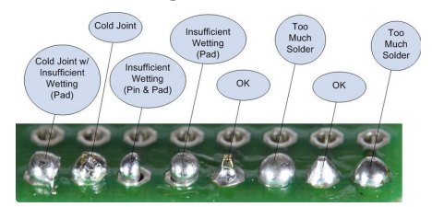

The above image is from [Adafruit’s soldering guide](https://cdn-learn.adafruit.com/downloads/pdf/adafruit-guide-excellent-soldering.pdf).

### Part A: Main PCB Assembly Steps

All electrical components will be inserted from the “Front” side of the board, and all soldering will be done on the “Back” side of the board.

#### Step A-01: Add resistors to PCB

Insert the resistors (A02) into the spaces labeled R2-R8 on the Main PCB (A01). Make sure the resistors are lying flat on the board, and bend the leads to hold the resistors in place.

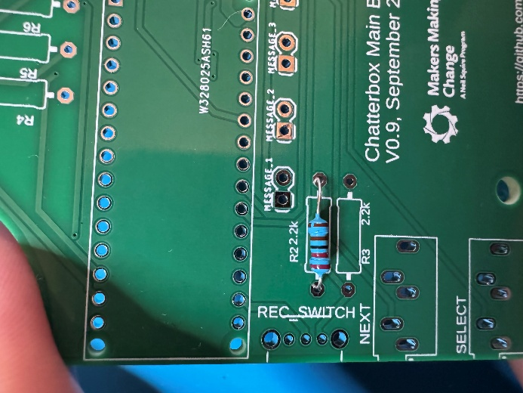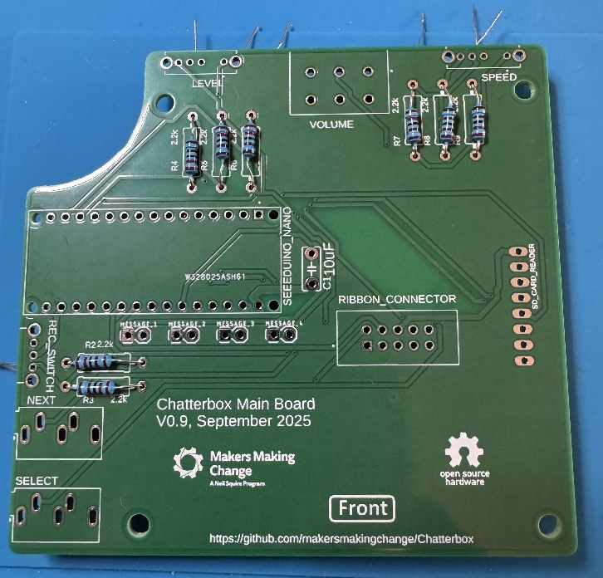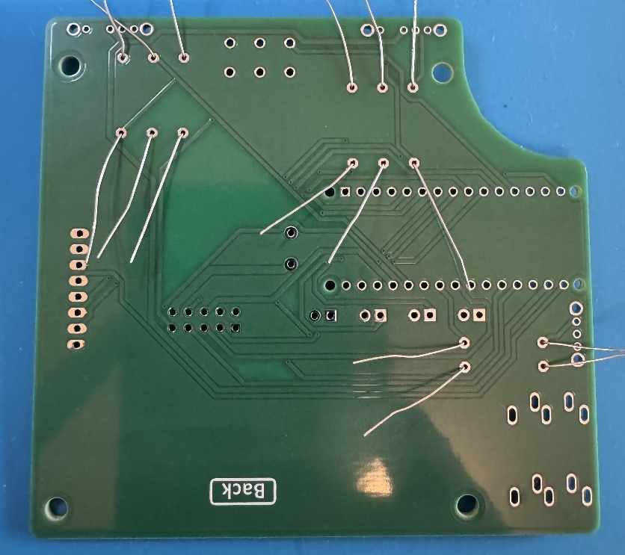

#### Step A-02: Solder and trim all resistor leads

Solder both leads of each resistor to the PCB. Once the leads are soldered, trim the excess wire off using the flush cutters.

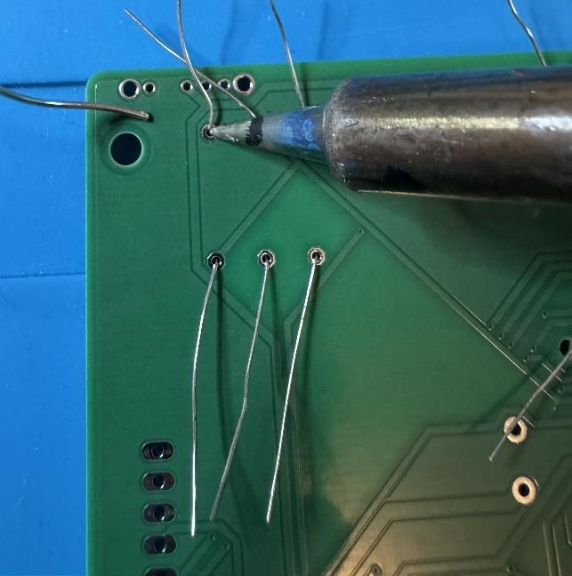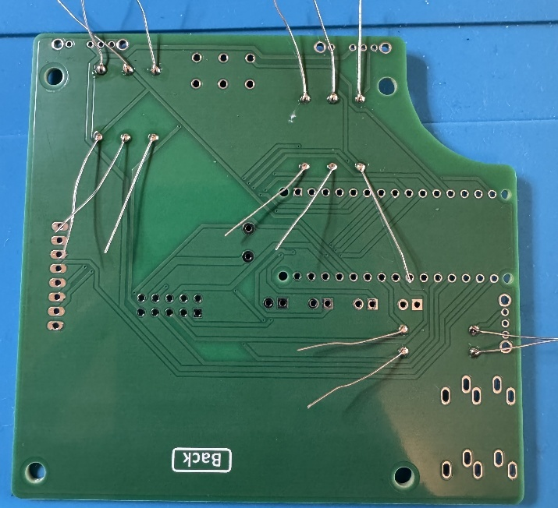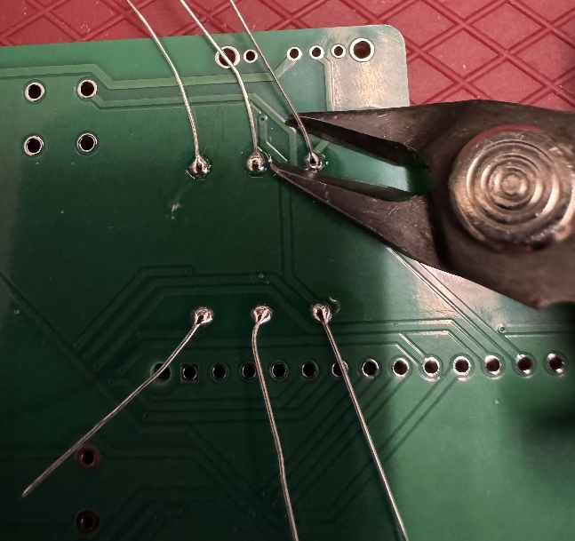

#### Step A-03: Insert capacitor

Insert the capacitor (A03) into the position labeled “C1” on the Main PCB. Make sure the capacitor sits flush to the PCB, then bend the leads to hold the capacitor in place.

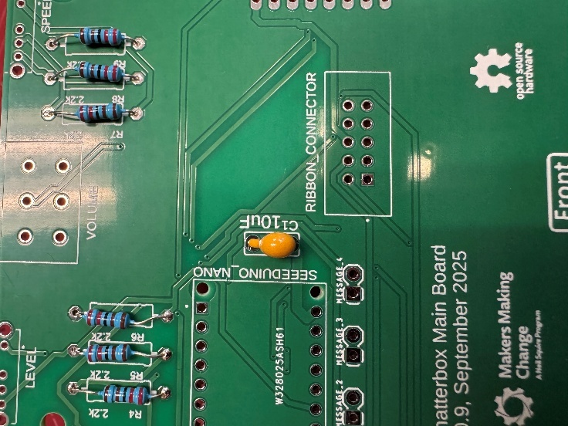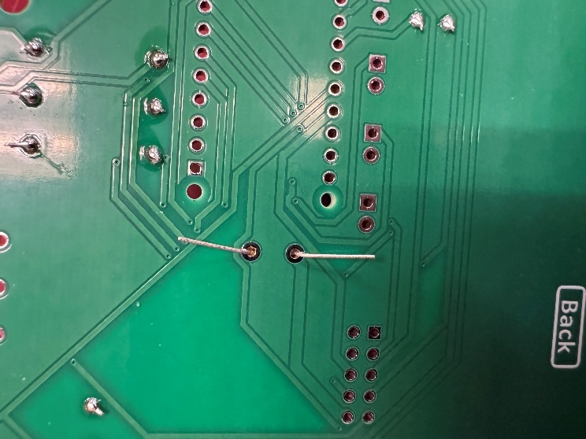

#### Step A-04: Solder capacitor and trim leads

Solder both leads of the capacitor to the pads on the main PCB. Once soldered, trim the excess lead with the flush cutters.

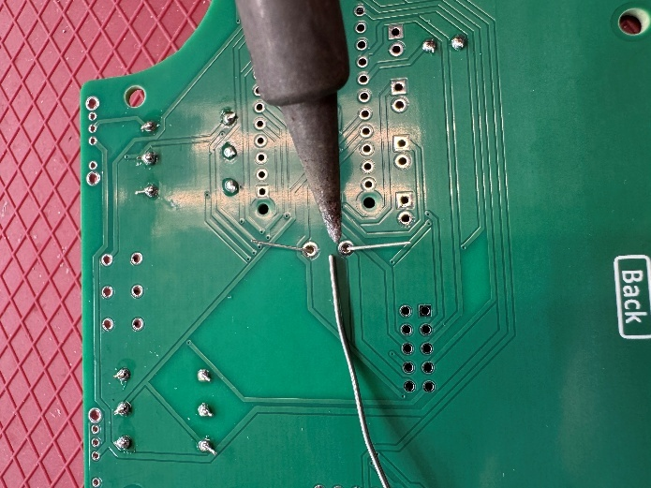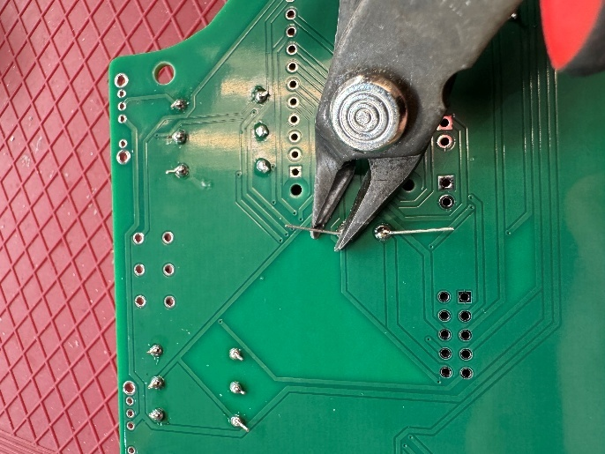

#### Step A-05: Insert “Mode” switch

Insert the two position slide switch (A04) into the position labeled “REC_SWITCH” on the main PCB. Make sure the slider on the switch (the black rectangle) is facing out of the board.

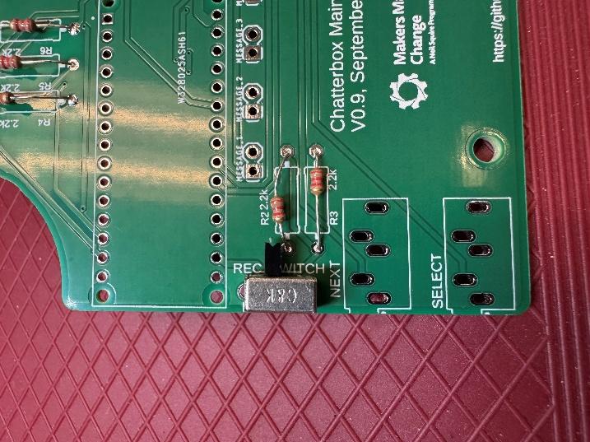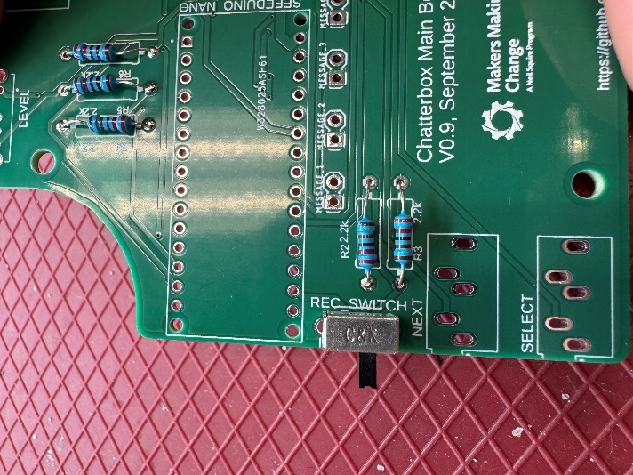

✓

X

#### Step A-06: Solder one switch lead and check alignment

Solder one of the three leads of the two position slide switch to the main board. Double check that the switch is sitting flush and square to the board. If the switch is sitting flush, move to the next step.

If the switch is not sitting flush, you can reheat the soldered joint to melt the solder and realign the switch as needed.

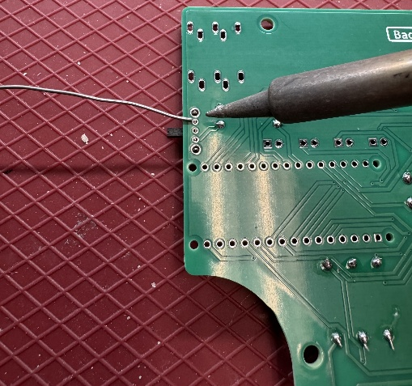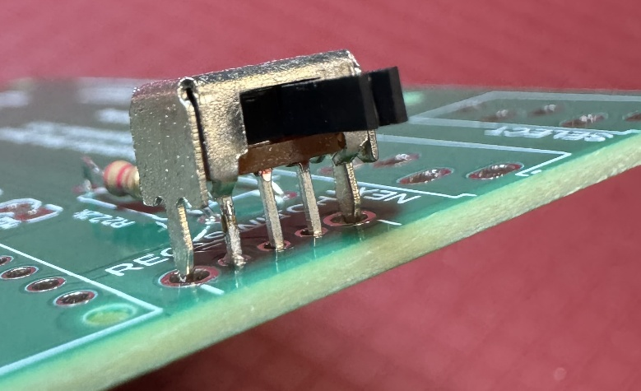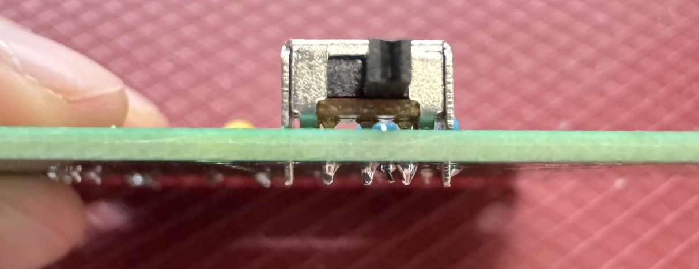

X

✓

#### Step A-07: Solder the remaining switch leads

Once the switch is aligned properly, solder the remaining two leads to the main PCB.

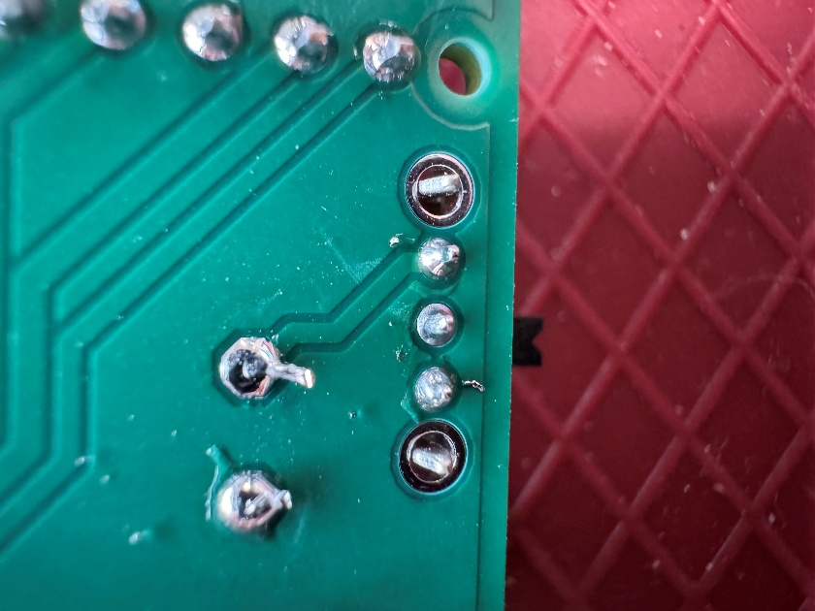

#### Step A-08: Insert the “Level” switch

Insert one of the two three position switches (A05) into the position labeled “LEVEL” on the main PCB.

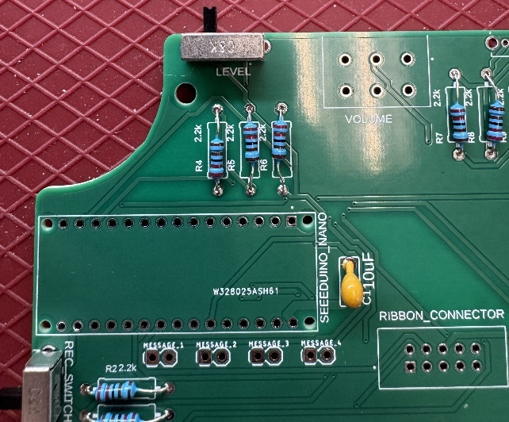

#### Step A-09: Solder one switch lead and check alignment

Solder one of the four leads of the three position slide switch to the main board. Double check that the switch is sitting flush and square to the board. If the switch is sitting flush, move to the next step.

If the switch is not sitting flush, you can reheat the soldered joint to melt the solder and realign the switch as needed.

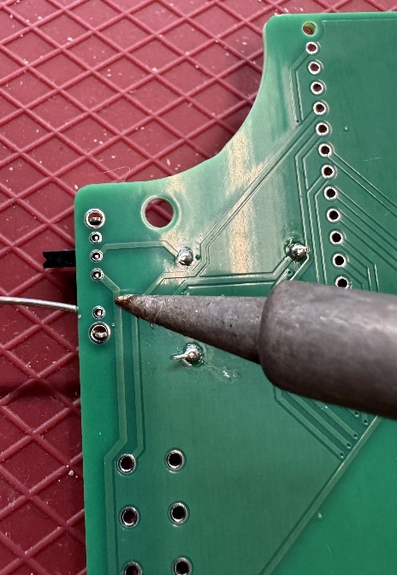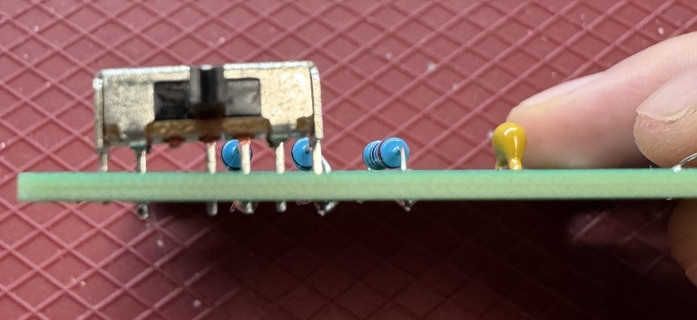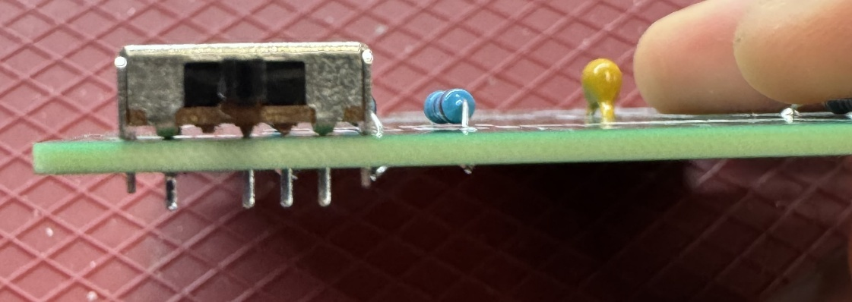

✓

X

#### Step A-10: Solder the remaining switch leads

Once the switch is aligned properly, solder the remaining three leads to the main PCB.

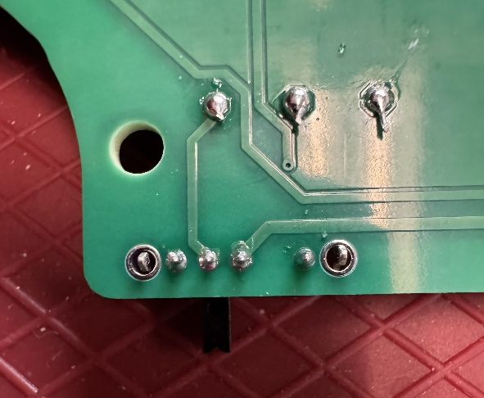

#### Step A-11: Insert the “Speed” switch

Insert the remaining three position switches (A05) into the position labeled “SPEED” on the main PCB.

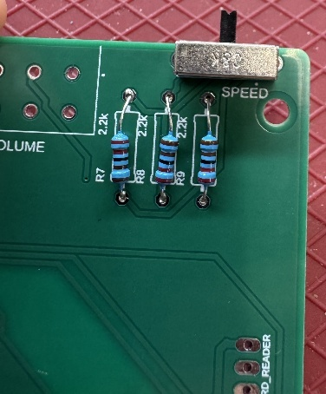

#### Step A-12: Solder one switch lead and check alignment

Solder one of the four leads of the three position slide switch to the main board. Double check that the switch is sitting flush and square to the board. If the switch is sitting flush, move to the next step.

If the switch is not sitting flush, you can reheat the soldered joint to melt the solder and realign the switch as needed.

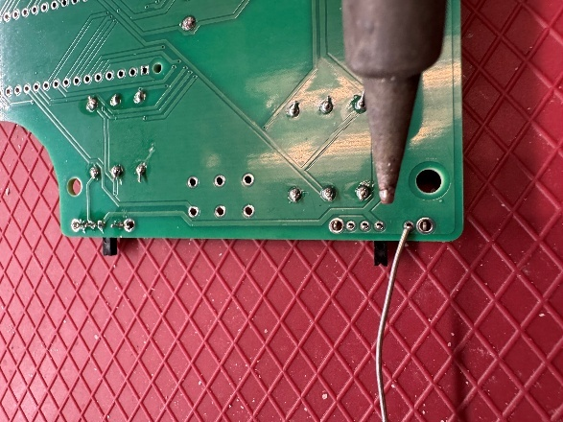

X

✓

#### Step A-13: Solder the remaining switch leads

Once the switch is aligned properly, solder the remaining three leads to the main PCB.

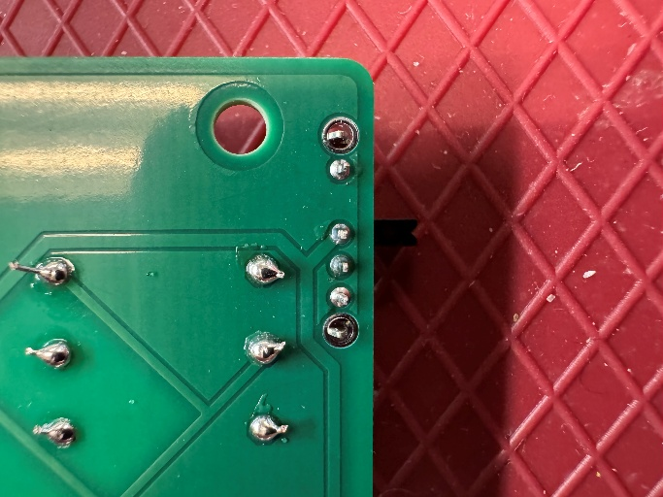

#### Step A-14: Insert 8 position female header

Insert the 8 position female header (A06) into the position labeled “SD_CARD_READER” on the main PCB.

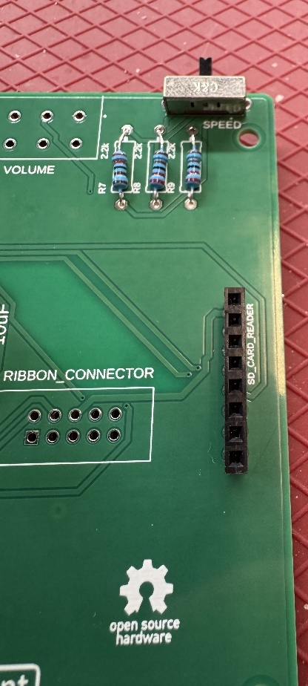

#### Step A-15: Solder one lead on the headers and check alignment

Solder one of the 8 leads to the main PCB. Double check that the headers are sitting flush and square to the board. If the headers are sitting flush, move to the next step.

If the headers are not sitting flush, you can reheat the soldered joint to melt the solder and realign the headers as needed.

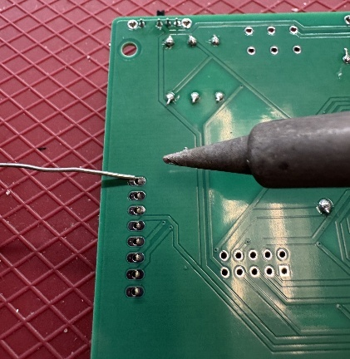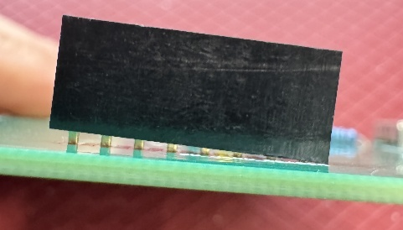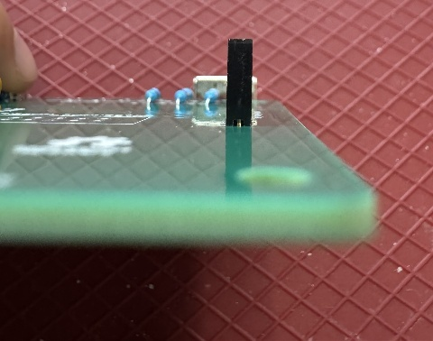

✓

X

#### Step A-16: Solder the remaining leads

Once the headers are aligned properly, solder the remaining seven leads on the female header to the PCB.

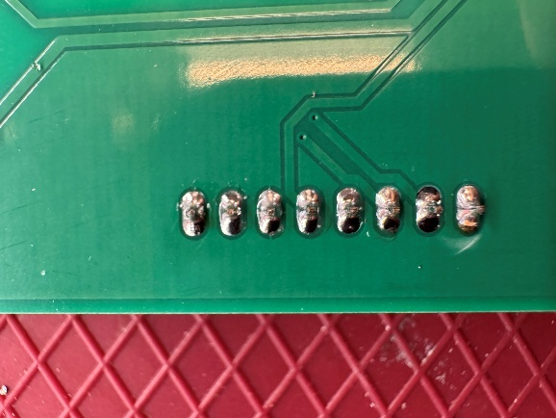

#### Step A-17: Attach female headers to microcontroller

Attach the 15 position female headers (A07) to the microcontroller (A10).

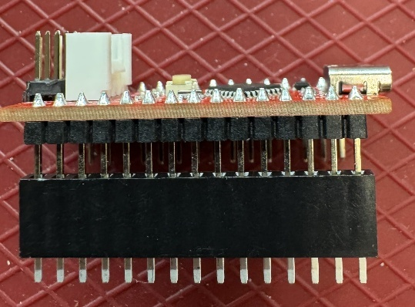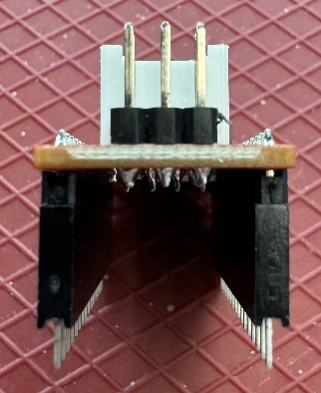

#### Step A-18: Insert female headers

Insert the female headers into the position labeled “SEEEDUINO_NANO” on the main PCB, while still attached to the microcontroller.

Make sure the leads are all in the holes with solder pads (metal circles or squares), not the screw holes at either end.

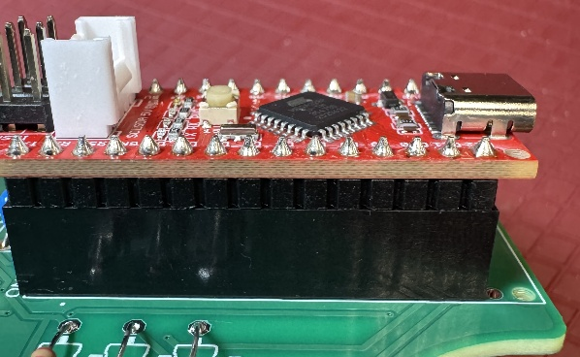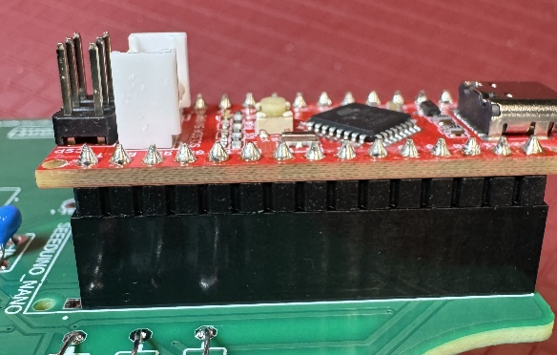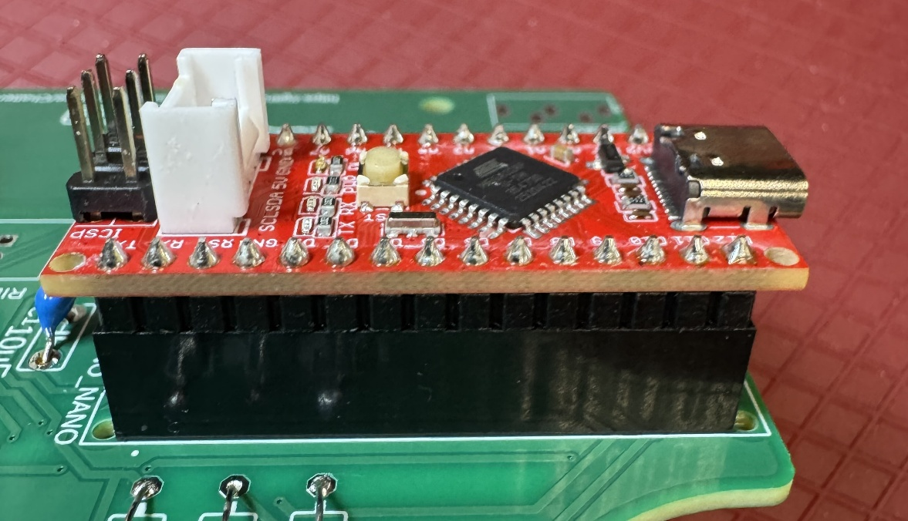

✓

X

X

#### Step A-19: Solder one lead of the female headers and check alignment

Solder one of the 30 leads to the main PCB. Double check that the headers are sitting flush and square to the board. If the headers are sitting flush, move to the next step.

If the headers are not sitting flush, you can reheat the soldered joint to melt the solder and realign the headers as needed.

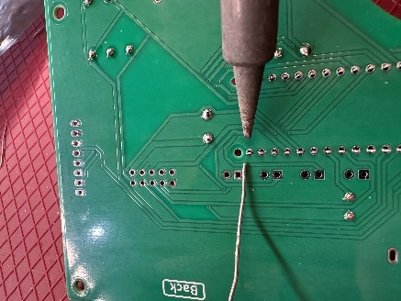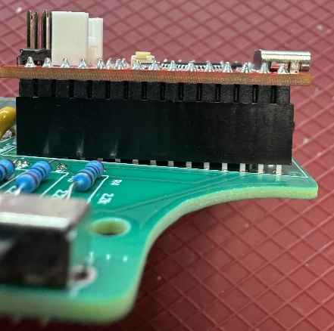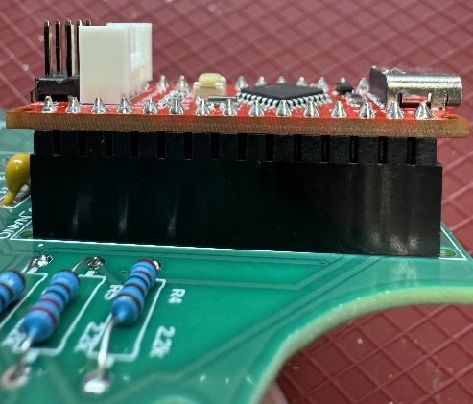

✓

X

#### Step A-20: Solder remaining leads and remove microcontroller

Once the headers are aligned properly, solder the remaining 29 leads on the female headers to the PCB. Once fully soldered, remove the microcontroller from the leads.

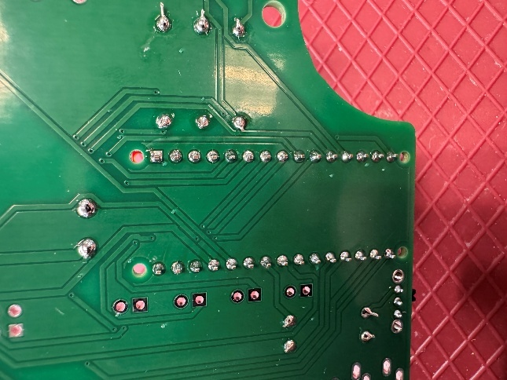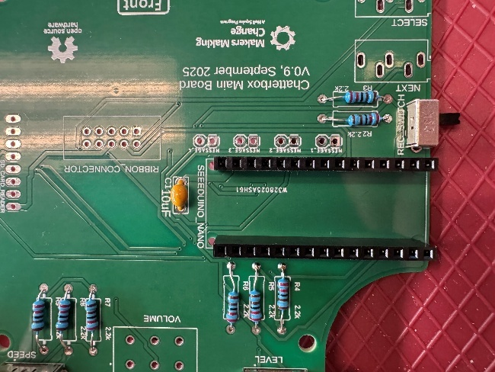

#### Step A-21: Insert the “Next” jack

Insert one of the two mono jacks (A08) into the position labeled “NEXT” on the main PCB.

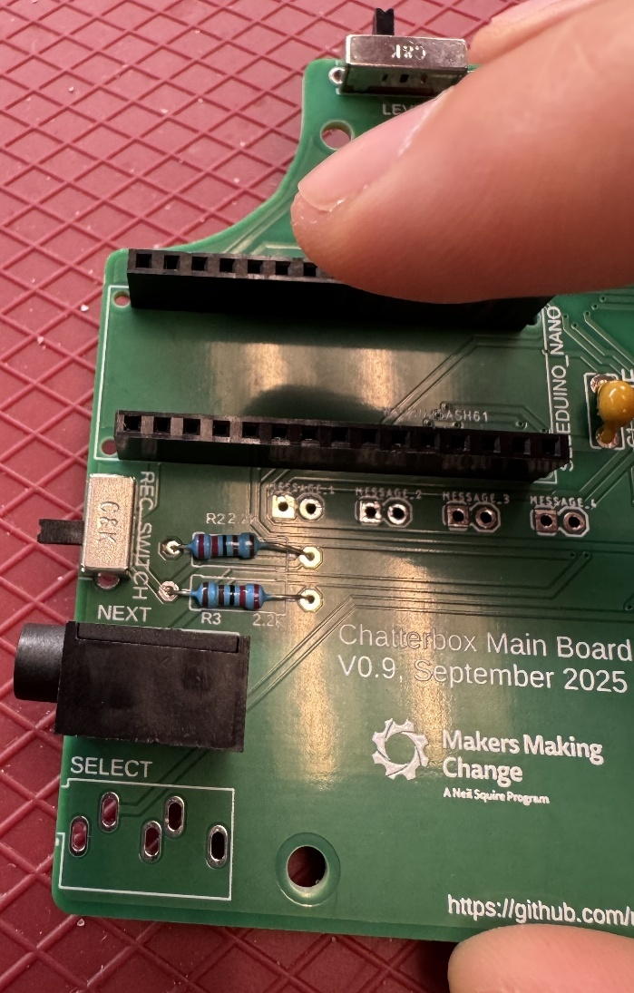

#### Step A-22: Solder one lead of the jack and check alignment

Solder one of the four leads to the main PCB. Double check that the jack is sitting flush and square to the board. If the jack sitting flush, move to the next step.

If the jack is not sitting flush, you can reheat the soldered joint to melt the solder and realign the jack as needed.

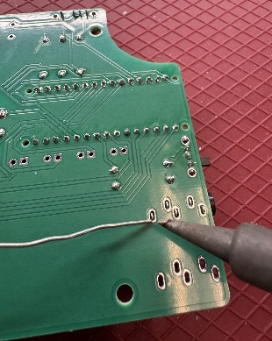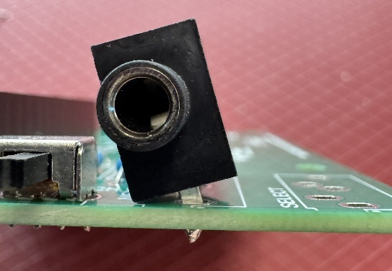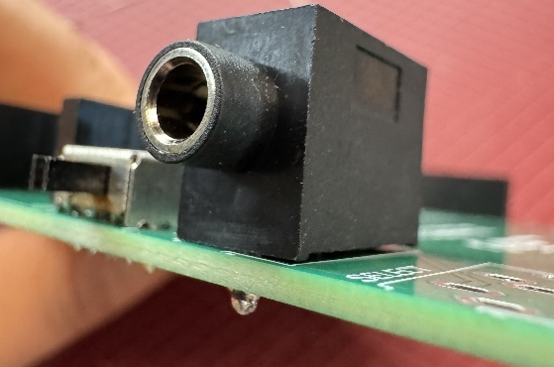

✓

X

#### Step A-23: Solder remaining leads

Once the jack is aligned properly, solder the remaining three leads to the main PCB.

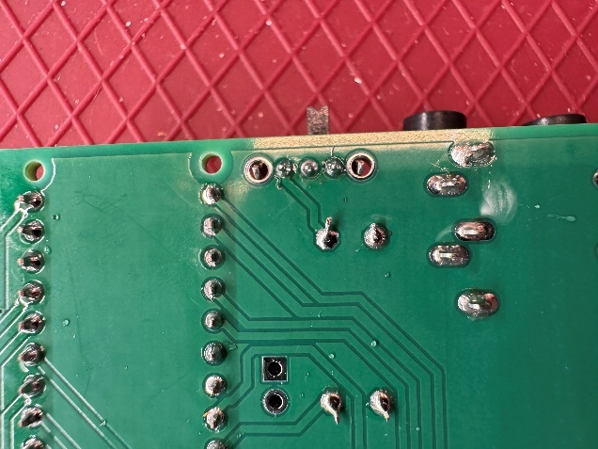

#### Step A-24: Insert the “Select” jack

Insert remaining mono jack (A08) into the position labeled “SELECT” on the main PCB.

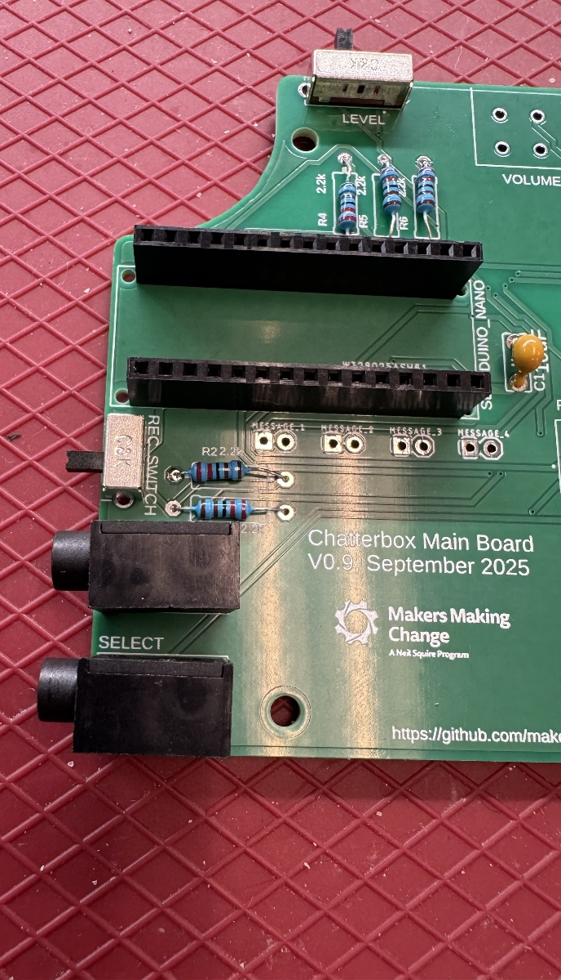

#### Step A-25: Solder one lead of the jack and check alignment

Solder one of the four leads to the main PCB. Double check that the jack is sitting flush and square to the board. If the jack sitting flush, move to the next step.

If the jack is not sitting flush, you can reheat the soldered joint to melt the solder and realign the jack as needed.

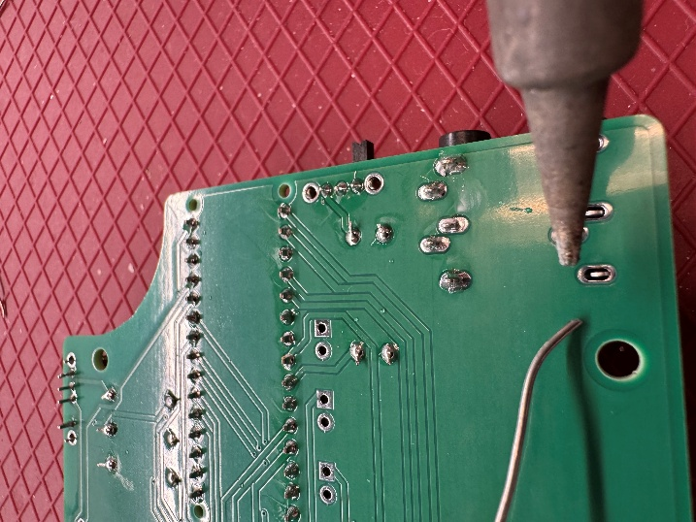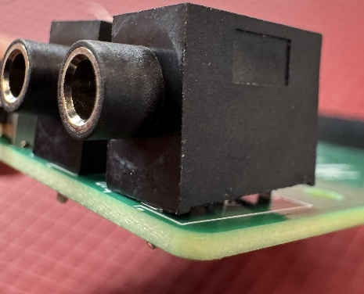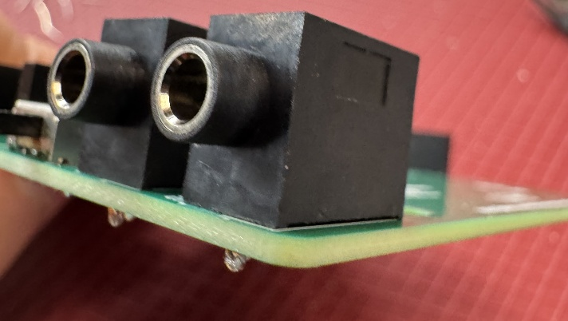

✓

X

#### Step A-26: Solder remaining leads

Once the jack is aligned properly, solder the remaining three leads to the main PCB.

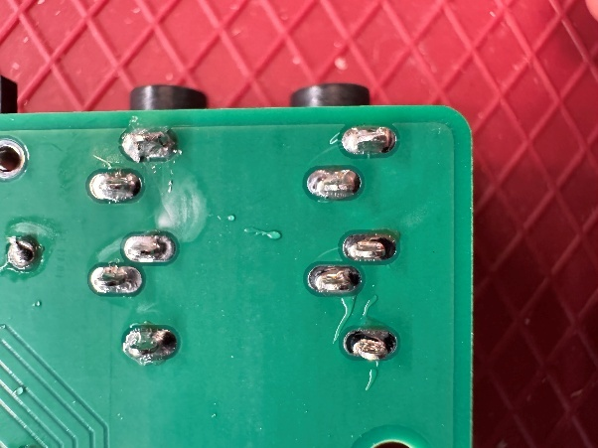

#### Step A-27: Insert ribbon cable connector

Insert the ribbon cable connector (A09) into the position labeled “RIBBON_CONNECTOR” on the main PCB. Make sure the slot in the top of the connector is on the same side as the opening on the outline on the PCB.

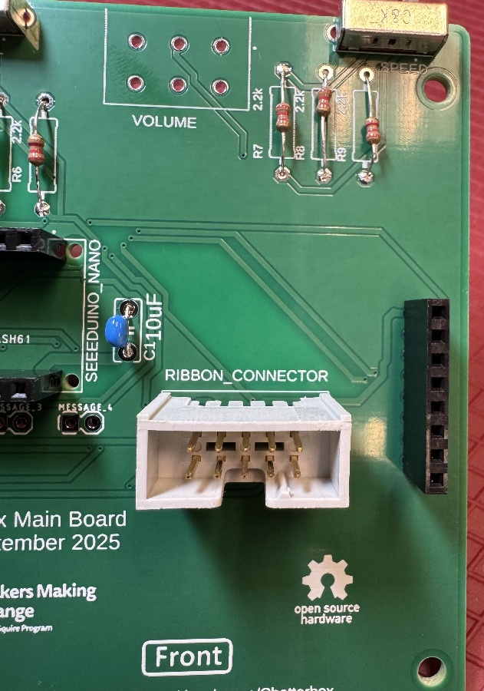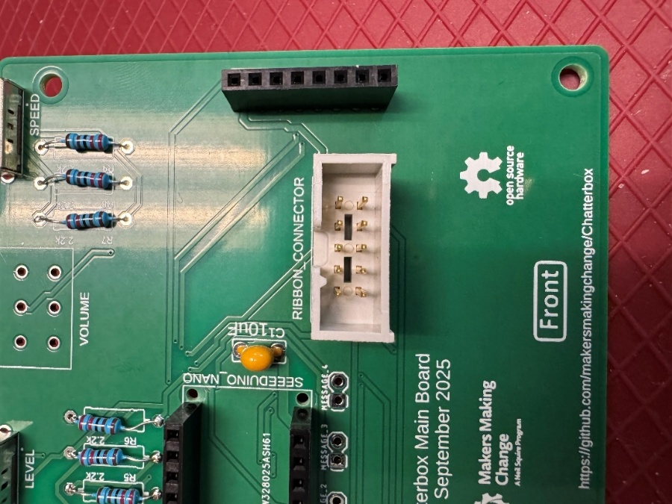

✓

X

#### Step A-28: Solder one lead and check alignment

Solder one of the 10 leads to the main PCB. Double check that the connector is sitting flush and square to the board. If the connector is sitting flush, move to the next step.

If the connector is not sitting flush, you can reheat the soldered joint to melt the solder and realign the connector as needed.

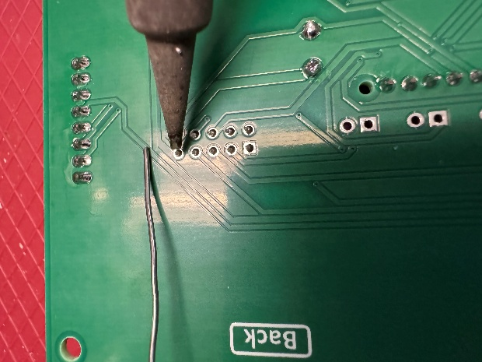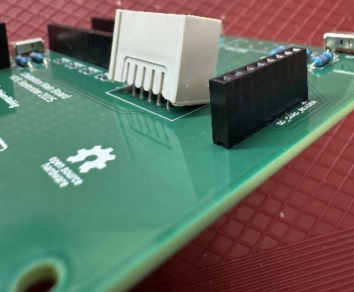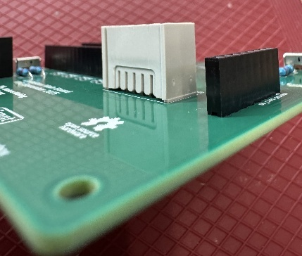

✓

X

#### Step A-29: Solder remaining leads

Once the connector is aligned properly, solder the remaining nine leads to the main PCB.

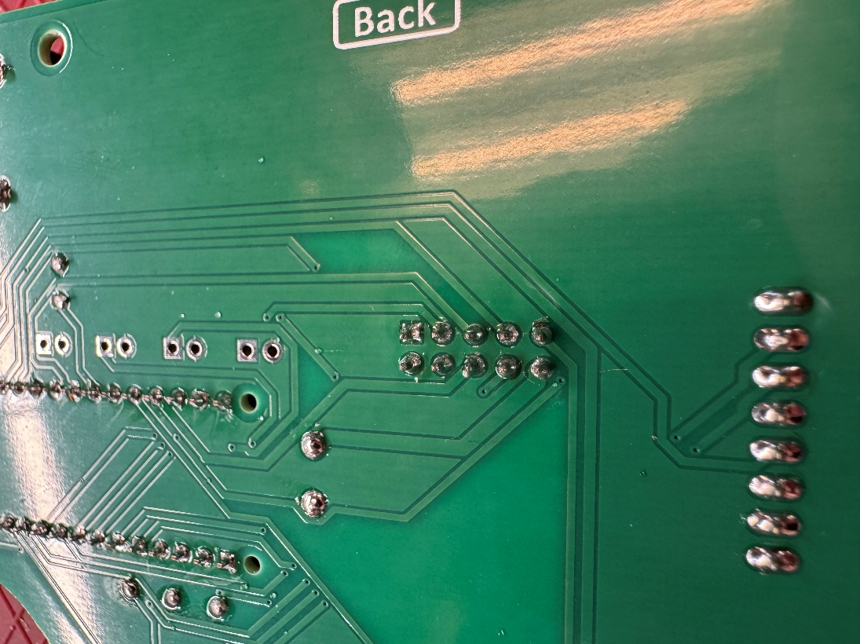

#### Step A-30: Insert potentiometer

Insert the potentiometer (A14) into the position labeled “VOLUME” on the main PCB. Make sure the adjustment knob of the potentiometer is pointing out of the PCB.

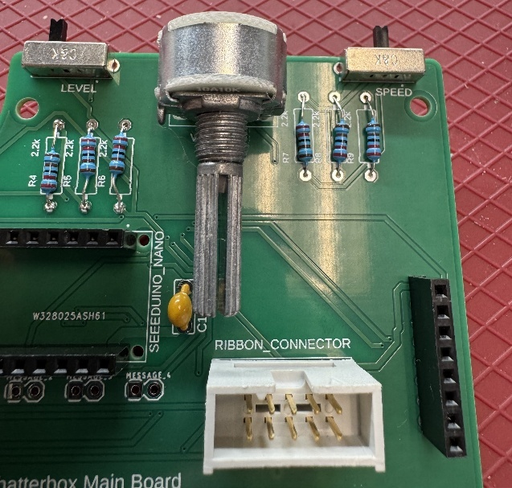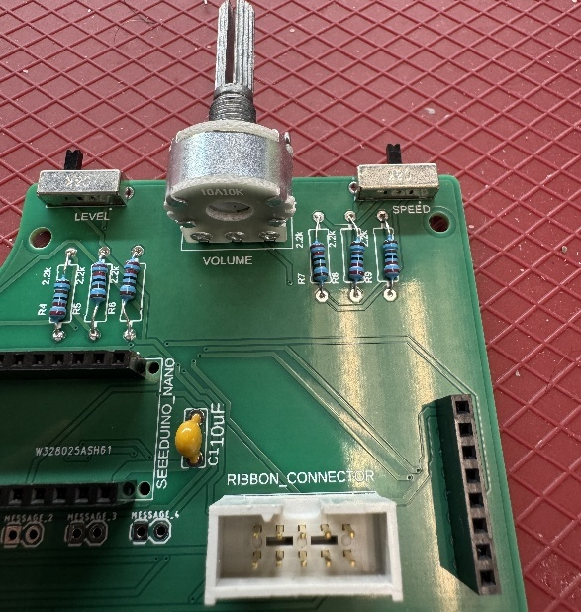

X

✓

#### Step A-31: Solder one lead and check alignment

Solder one of the six leads to the main PCB. Double check that the potentiometer is sitting flush and square to the board. If the potentiometer is sitting flush, move to the next step.

If the potentiometer is not sitting flush, you can reheat the soldered joint to melt the solder and realign the potentiometer as needed.

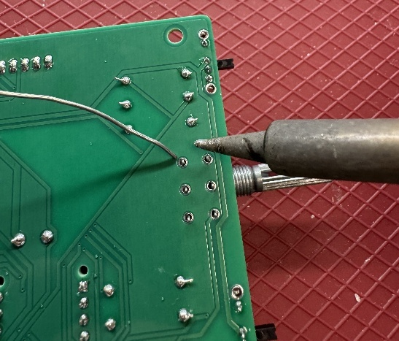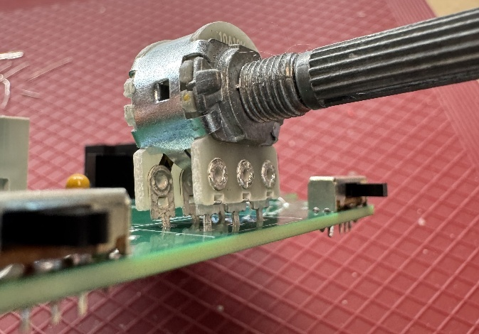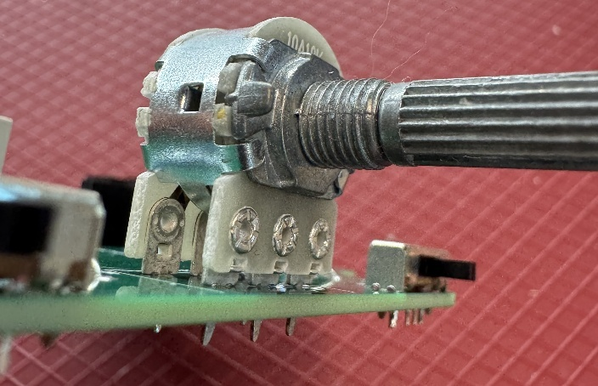

X

✓

#### Step A-32: Solder remaining leads

Once the potentiometer is aligned properly, solder the remaining five leads to the main PCB.

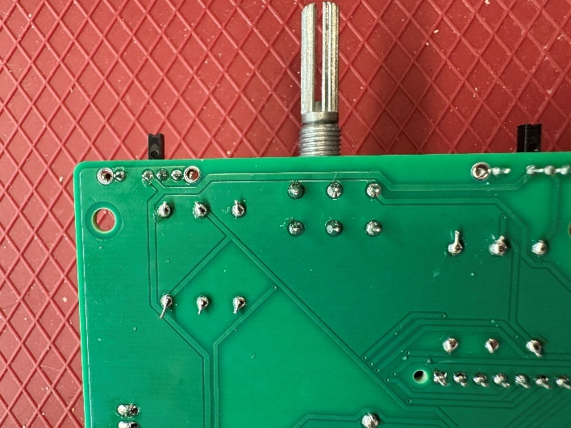

#### Step A-33: Cut wire to length

Cut the 24 AWG wire (A13) into two sections each of the following lengths: 13, 17, 24, and 29 cm. You will have cut off eight pieces of wire from the main length.

#### Step A-34: Strip ends of wires

Use the wire strippers to strip 0.5 cm of the insulation off both ends of each wire section you cut in Step A-33.

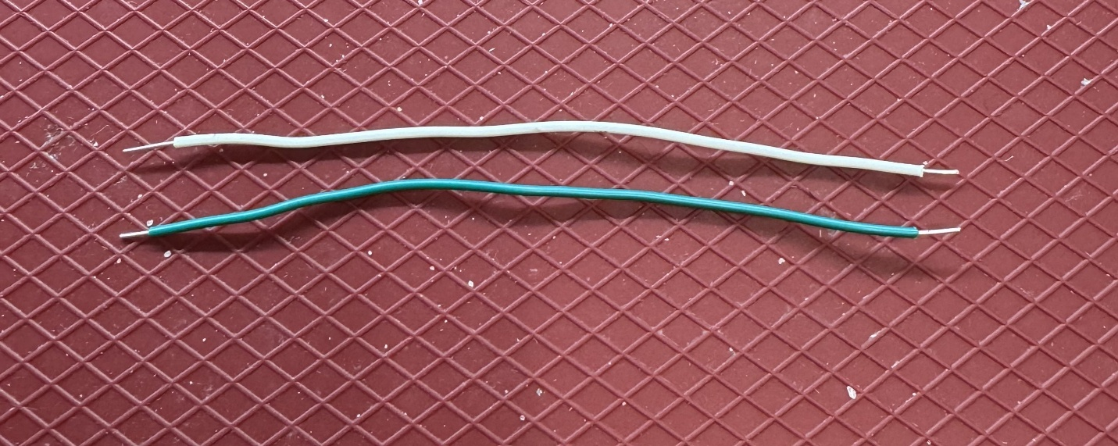

#### Step A-35: Insert message 1 wires

Insert both of the shortest wires (13 cm) into the positions labeled “MESSAGE_1” on the main PCB. Bend the wires to hold them in place. Make sure the exposed ends of the wires are not touching each other.

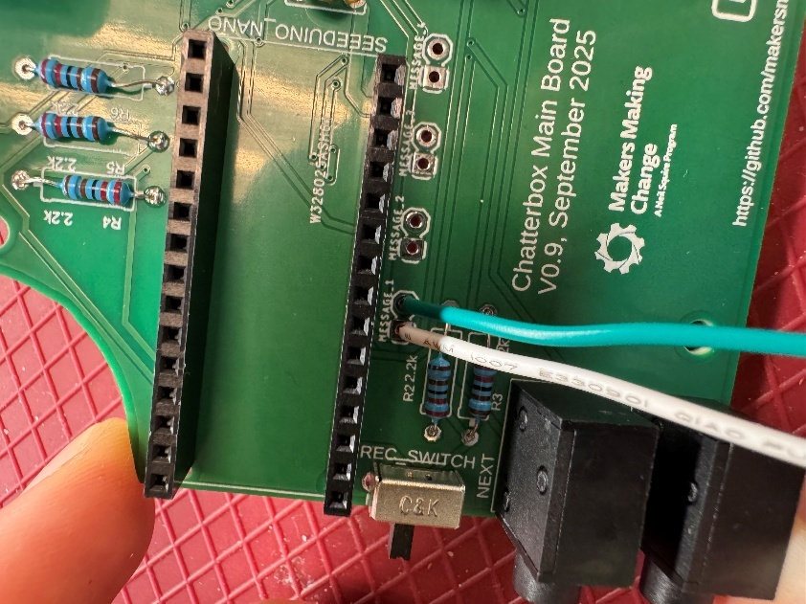

#### Step A-36: Solder the wires and trim excess

Solder the wires to the main PCB. Trim the excess from the wires with the flush cutters.

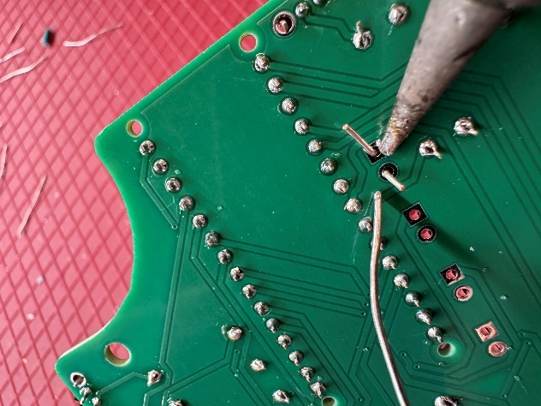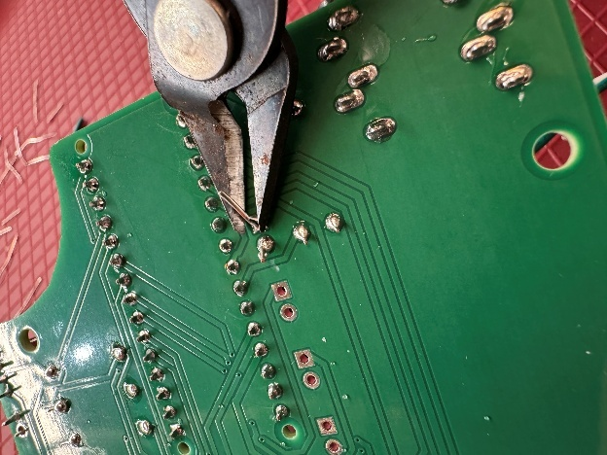

#### Step A-37: Insert message 2 wires

Insert both of the next shortest wires (17 cm) into the positions labeled “MESSAGE_2” on the main PCB. Bend the wires to hold them in place. Make sure the exposed ends of the wires are not touching each other.

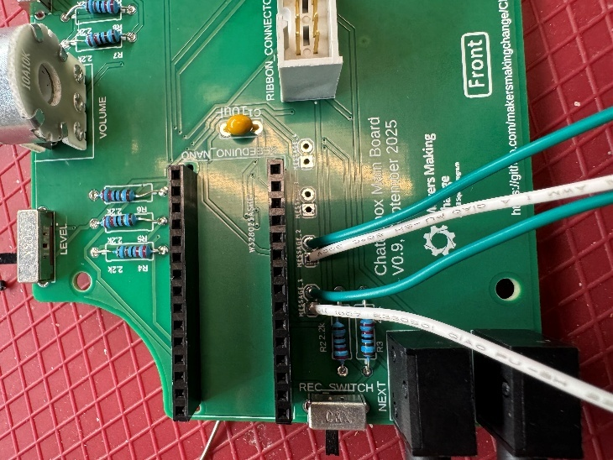

#### Step A-38: Solder the wires and trim excess

Solder the wires to the main PCB. Trim the excess from the wires with the flush cutters.

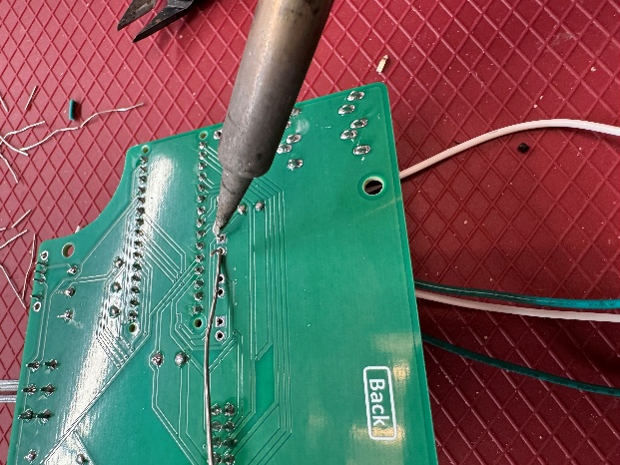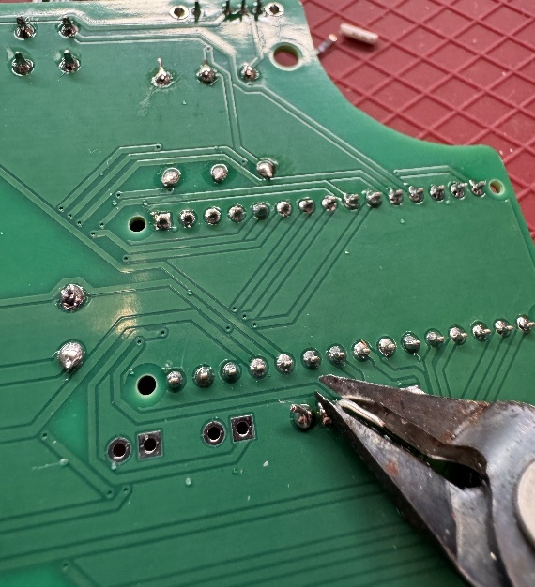

#### Step A-39: Insert message 3 wires

Insert both of the next shortest wires (24 cm) into the positions labeled “MESSAGE_3” on the main PCB. Bend the wires to hold them in place. Make sure the exposed ends of the wires are not touching each other.

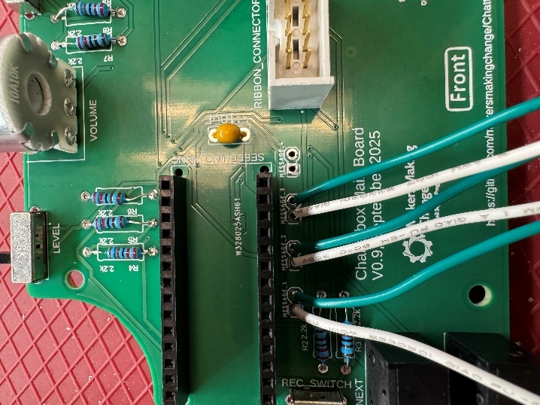

#### Step A-40: Solder the wires and trim excess

Solder the wires to the main PCB. Trim the excess from the wires with the flush cutters.

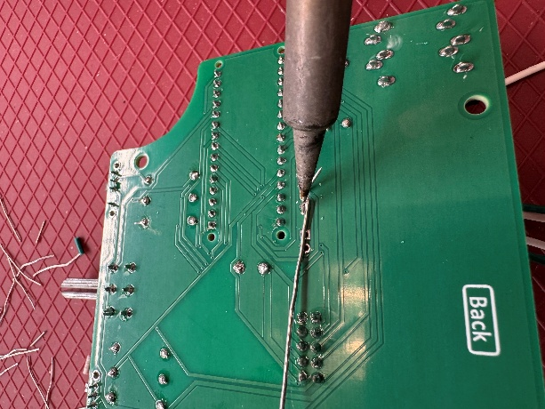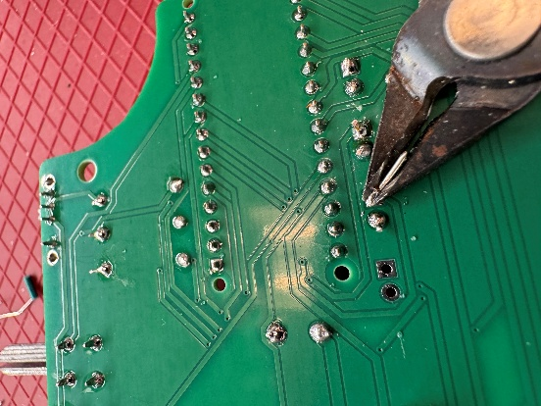

#### Step A-41: Insert message 4 wires

Insert both of the last wires (27 cm) into the positions labeled “MESSAGE_4” on the main PCB. Bend the wires to hold them in place. Make sure the exposed ends of the wires are not touching each other.

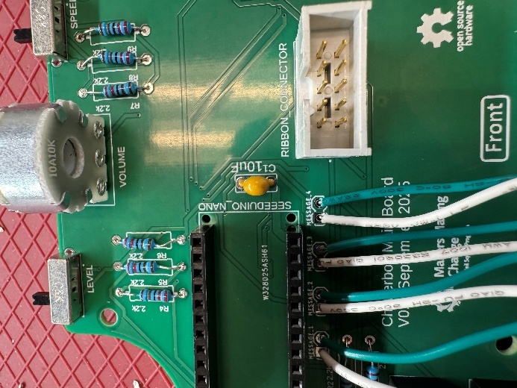

#### Step A-42: Solder the wires and trim excess

Solder the wires to the main PCB. Trim the excess from the wires with the flush cutters.

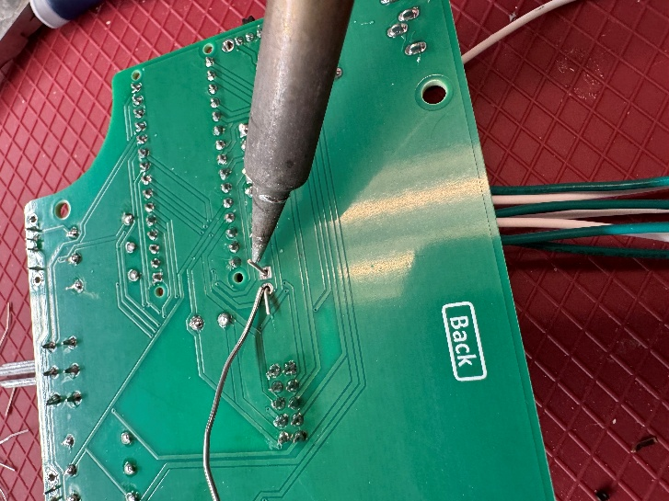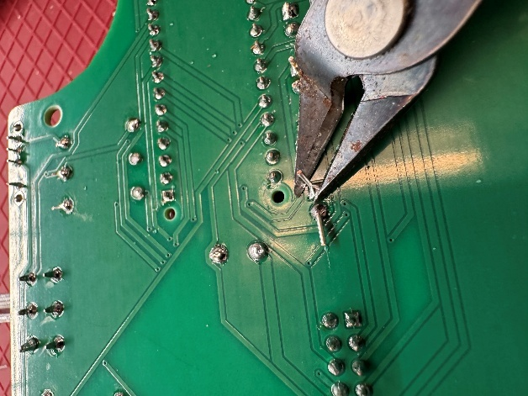

#### Step A-43: Double check all solder joints

Double check all the solder joints on the main PCB to ensure none have been missed, there are no shorts (solder connecting two or more leads together), and that all joints are good quality.

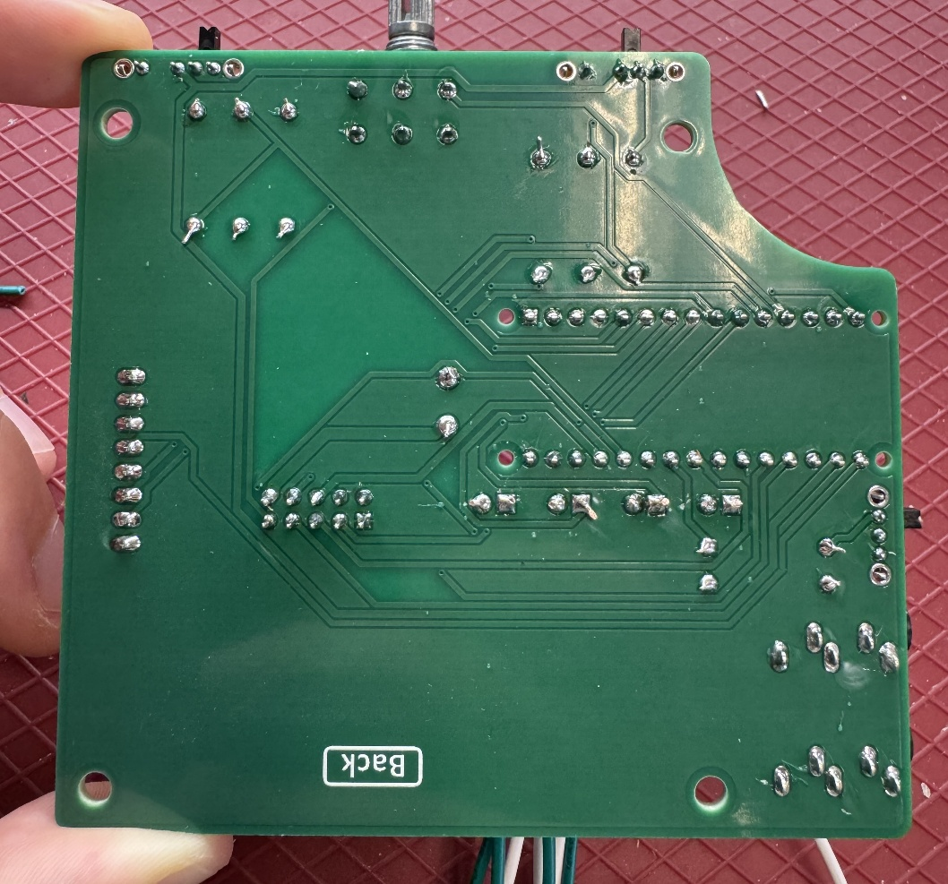

#### Step A-44: Solder headers to SD Card Reader

Solder the male header that came with the microSD card reader (A11) to the reader with the short pins of the header in the microSD card reader and the long side of the pins facing away from the reader as shown in the below picture. Insert the microSD card (18) into the reader. You may need to trim one pin from the header that comes with the reader to get it to the correct number of pins.

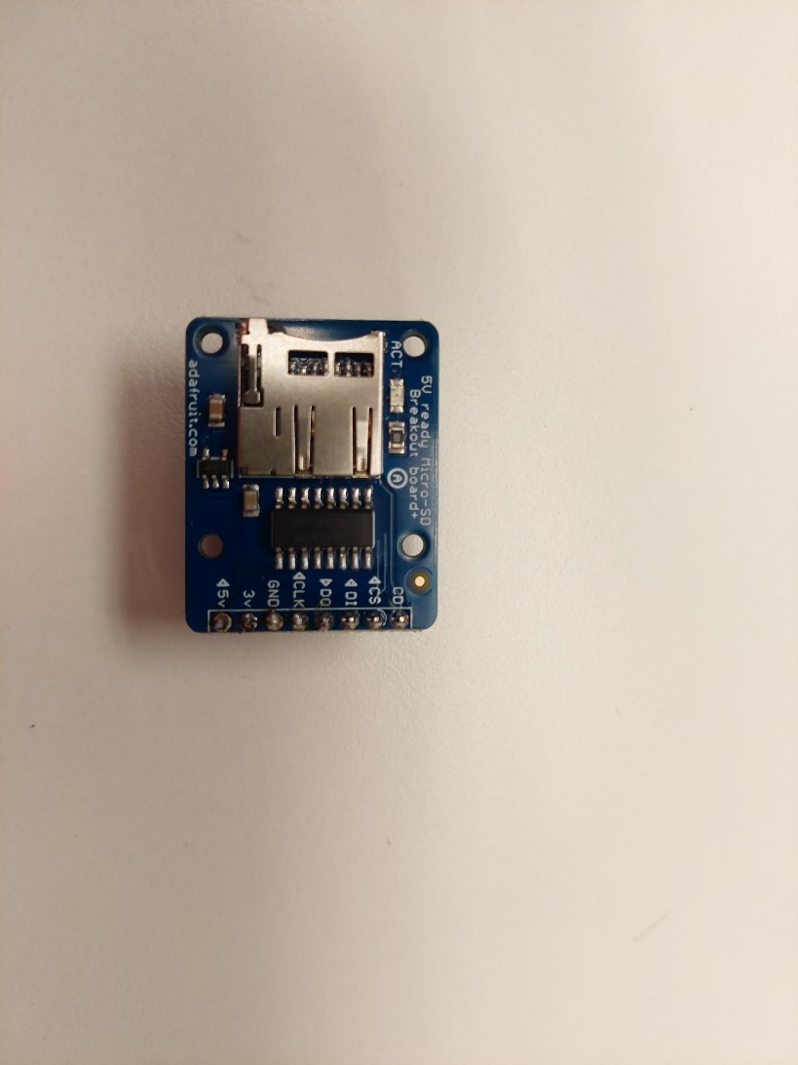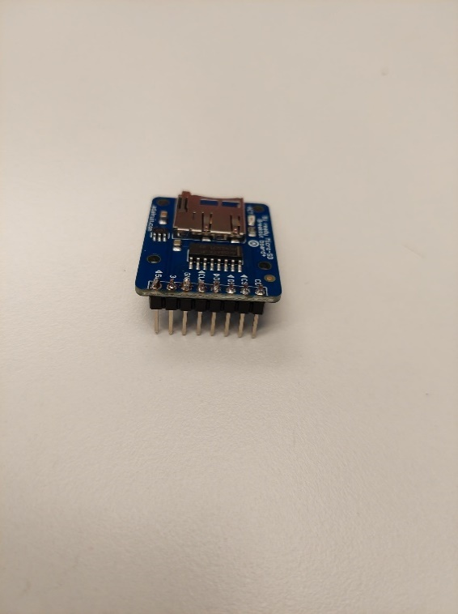

#### Step A-45: Insert SD card into reader

Insert the micro SD card (A12) into the slot in the micro SD card reader.

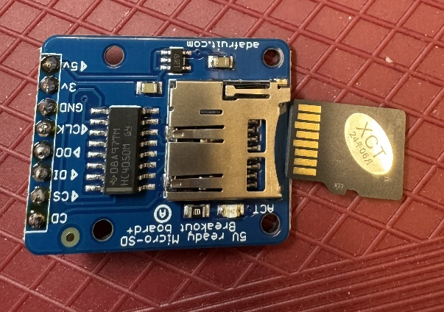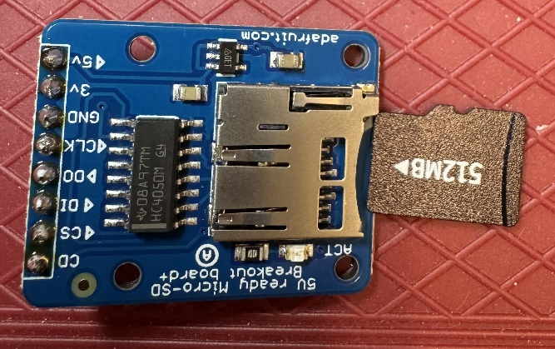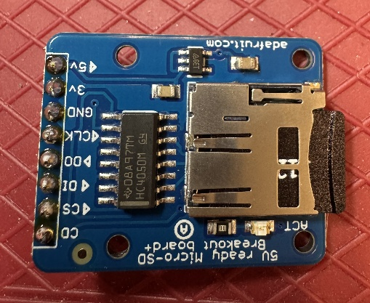

X

✓

✓

#### Step A-46: Insert SD card reader into Main PCB

Insert the SD card reader into the female headers labeled “SD_CARD_READER” on the Main PCB. Make sure the reader points off the board and does not block the Ribbon Cable Connector.

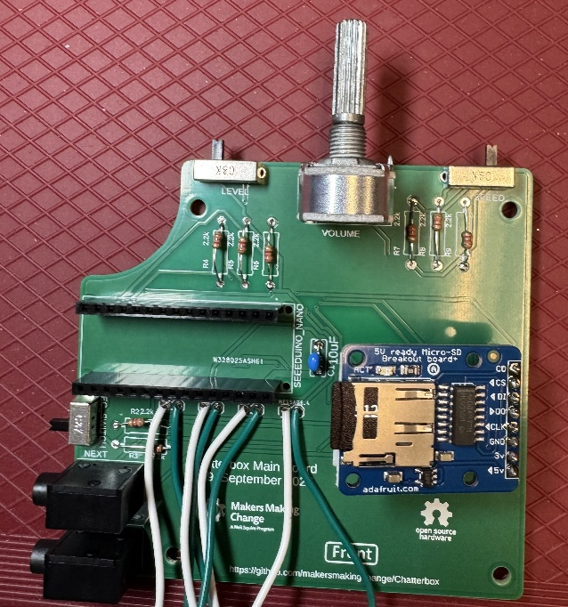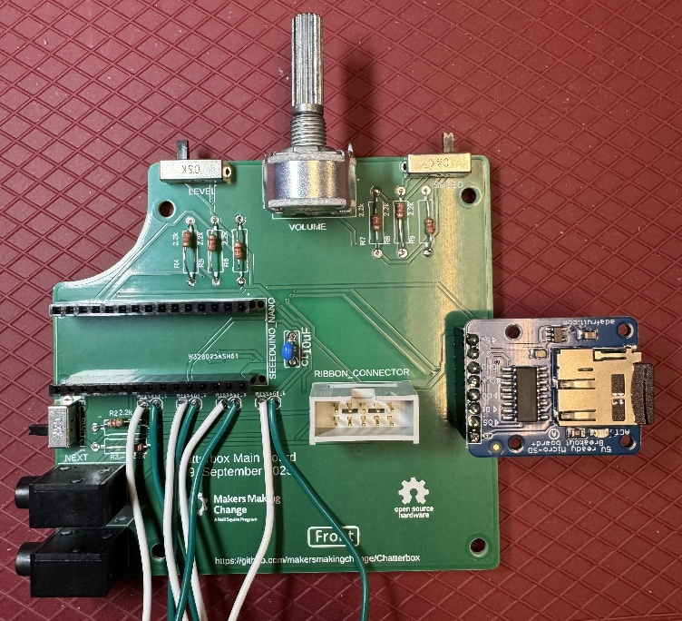

✓

X

#### Step A-47: Insert Seeeduino Nano into female headers

Insert the Seeeduino Nano (A10) into the female headers on the Main PCB. Make sure the USB-C connector is facing out from the Main PCB.

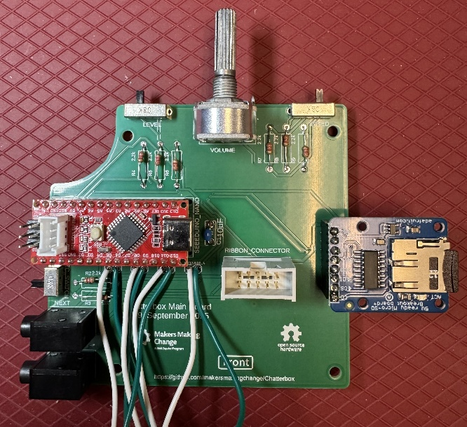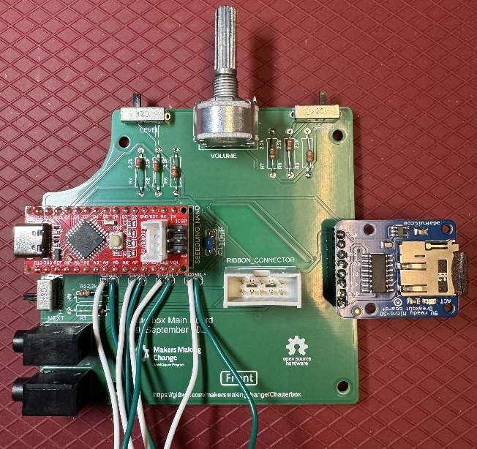

X

✓

The Main PCB is now complete.

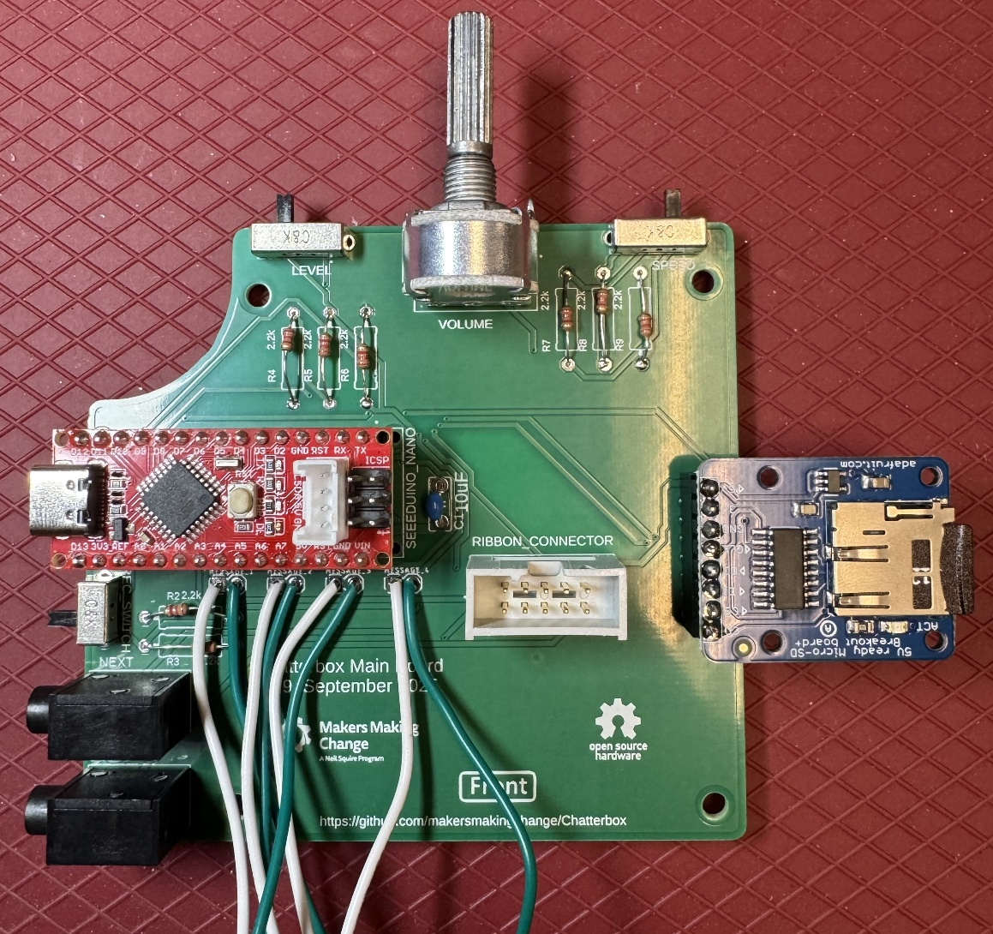

## Part B: Secondary PCB

### Part B: Required Components

|  |  |  |  |  |  |  |  |  |
| --- | --- | --- | --- | --- | --- | --- | --- | --- |
| Secondary PCB | | | | | | | | |
| B01 | Secondary PCB | QTY: 1 | B02 | 10uF Capacitor | QTY: 2 | B03 | Two position switch | QTY: 1 |
|  | | | A blue capacitor with metal rods  AI-generated content may be incorrect.  Note: The capacitor may be labelled with the number 106, and the colour may be different. | | | Slide switch | | |
| B04 | 5 position female header | QTY: 2 | B05 | 9V battery clip | QTY: 1 | B06 | Ribbon cable connector | QTY: 1 |
| 5 pin female header | | | Battery Clip | | | Ribbon cable header | | |
| B07 | Amp | QTY: 1 | B08 | Microphone | QTY: 1 | B09 | 24 AWG wire | QTY: 132 cm |
| Audio Amplifier | | | Max9814 microphone | | |  | | |
| B10 | Speaker | QTY: 1 |
| Speaker sitting on its coiled cable | | |

### Part B: Required Tools and Supplies

* Soldering iron
* Solder
* Flush cutters
* Wire strippers
* Precision flathead screw driver (2.5mm or smaller)

### Part B: Required Personal Protective Equipment (PPE)

* Safety glasses/goggles

### Part B: Secondary PCB Assembly Steps

Note that different components will need to be soldered on different sides of the board. Each step will say from which side of the board (front or back) the part should be inserted.

#### Step B -00: Break off LED PCBs

Separate the four LED PCBs from the secondary PCB along the mouse bites (small holes). Separate the four LED PCBs from each other along the other mouse bites. In future, the LED PCBs will be separate so we will be able to remove this step.

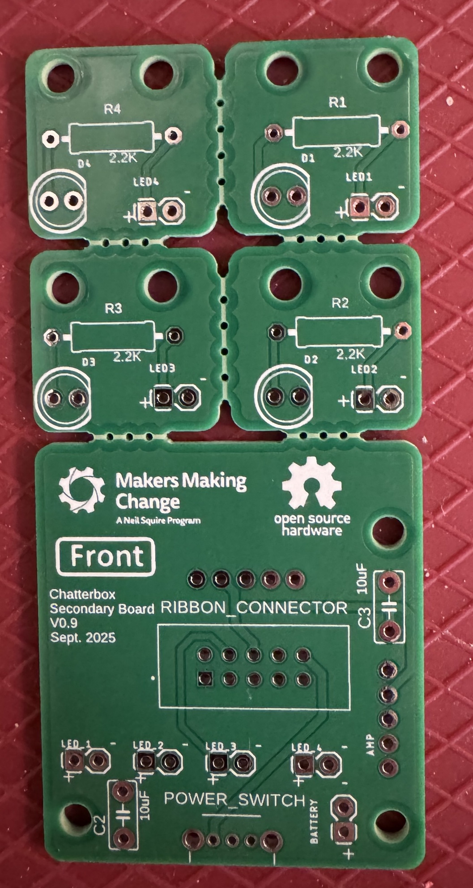

#### Step B -01: Insert capacitors

Insert the capacitors (B02) into the positions labeled “C_2” and “C_3” from the Front side of the secondary PCB (B01). Bend the leads on the Back side of the board to hold them in place.

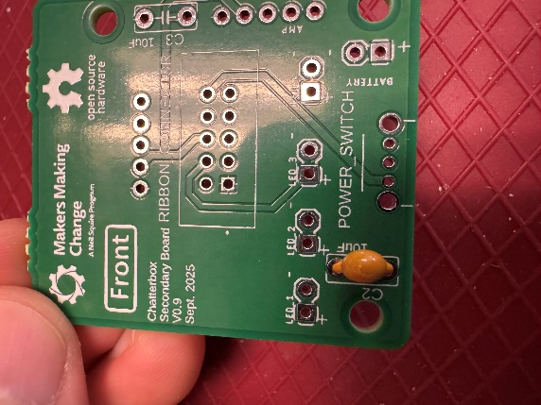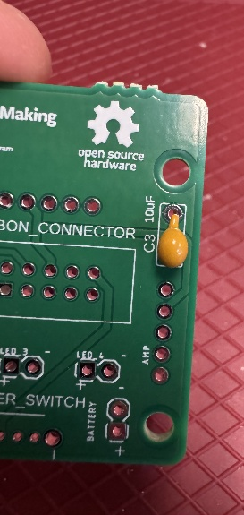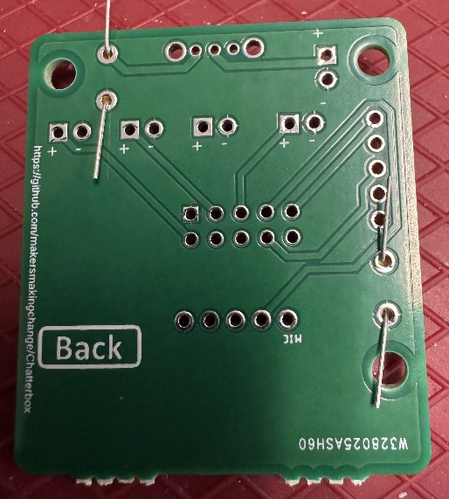

#### Step B -02: Solder capacitor and trim leads

Solder both leads of the capacitor to the pads on the main PCB. Once soldered, trim the excess lead with the flush cutters.

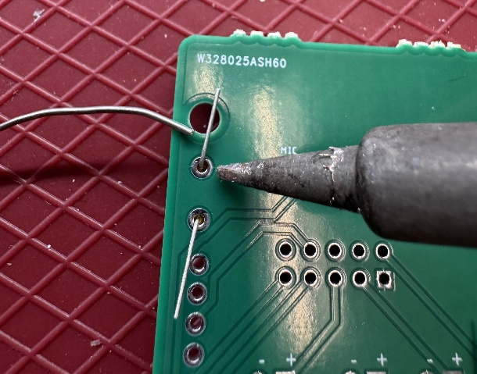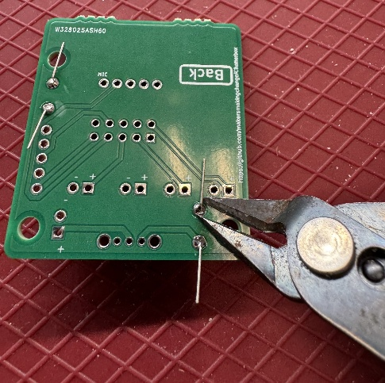

#### Step B -03: Insert “Power” switch

Insert the two position slide switch (B03) from the Front side of the board into the position labeled “POWER_SWITCH”. Make sure the slider on the switch (the black rectangle) is facing out of the board.

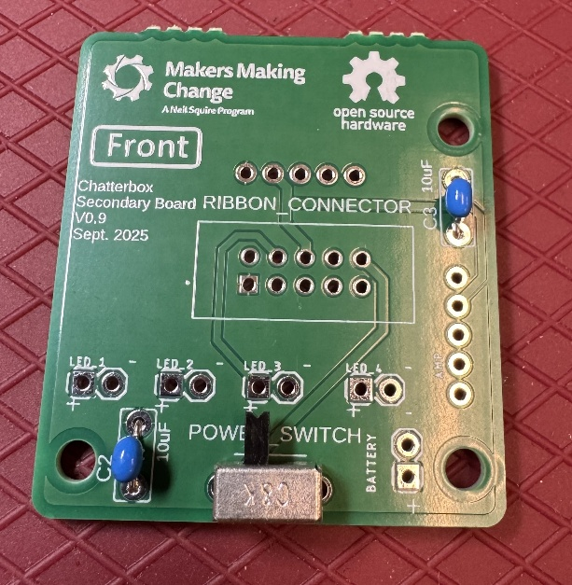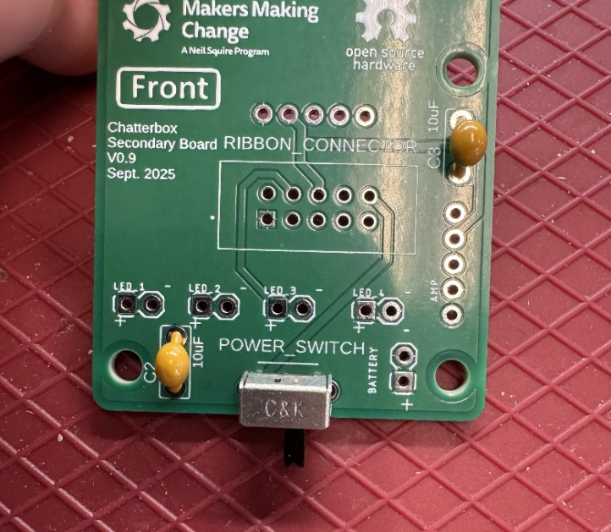

✓

X

#### Step B -04: Solder one switch lead and check alignment

Solder one of the three leads of the two position slide switch to the main board. Double check that the switch is sitting flush and square to the board. If the switch is sitting flush, move to the next step.

If the switch is not sitting flush, you can reheat the soldered joint to melt the solder and realign the switch as needed.

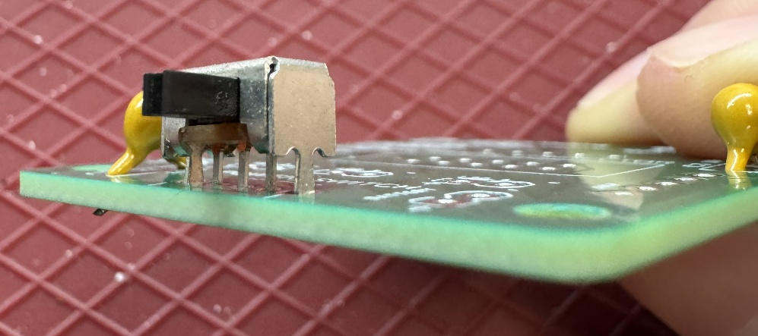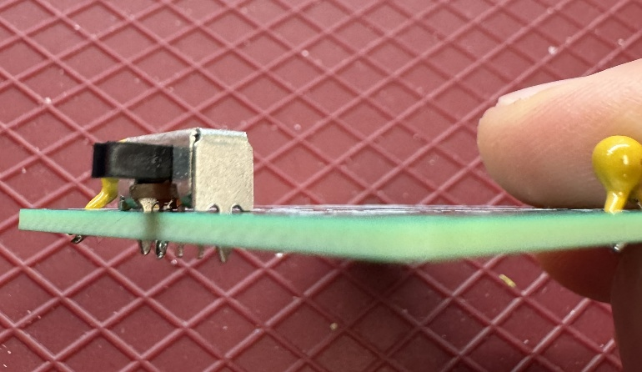

X

✓

#### Step B -02: Solder the remaining switch leads

Once the switch is aligned properly, solder the remaining two leads to the PCB.

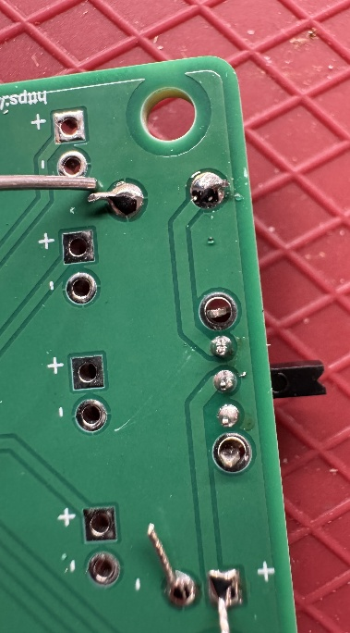

#### Step B -05: Insert battery cap wires

Insert the wires from the battery cap (B09) into the position labeled “BATTERY” from the Front side of the PCB. Make sure the exposed wires are not touching each other.

NOTE: It is critical that the red wire goes to the positive terminal (labeled with a “+”) and the black wire goes to the negative terminal (labeled with a “-“).

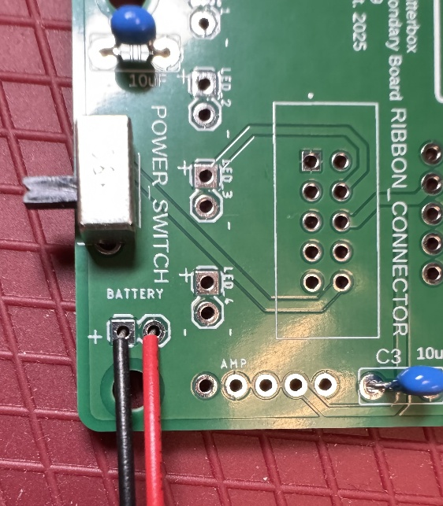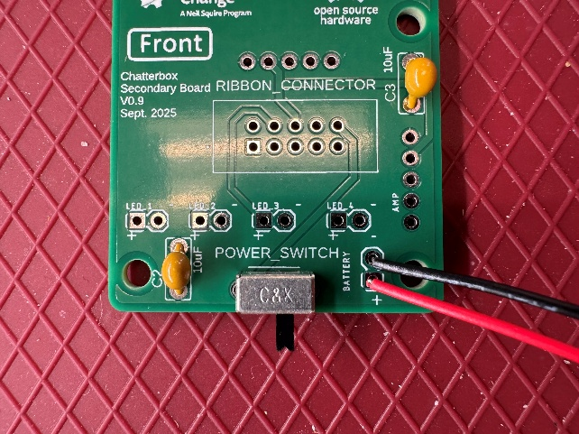

✓

X

#### Step B -06: Solder and trim the battery cap wires

Solder the wires from the battery cap to the PCB. Make sure the exposed sections of the wires are not touching. Trim the excess wire after soldering.

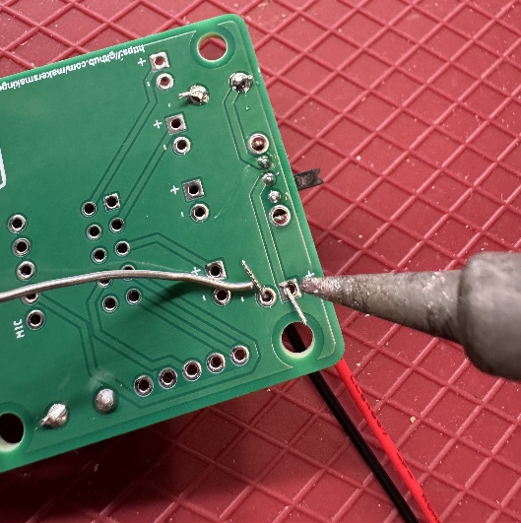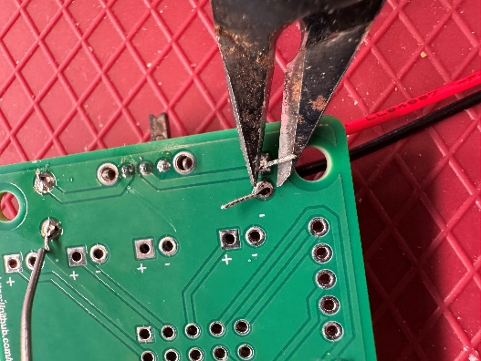

#### Step B -07: Insert amp female headers

Insert one of the two sets of five position female headers (B04) into the position labeled “AMP” from the Front side of the PCB.

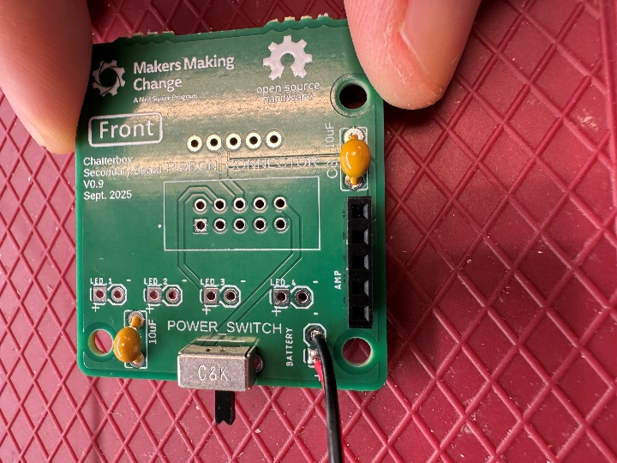

#### Step B -08: Solder one lead of the female headers and check alignment

Solder one of the five leads to the PCB. Double check that the headers are sitting flush and square to the board. If the headers are sitting flush, move to the next step.

If the headers are not sitting flush, you can reheat the soldered joint to melt the solder and realign the headers as needed.

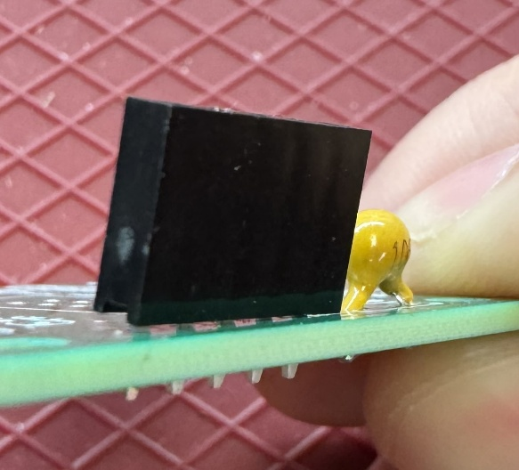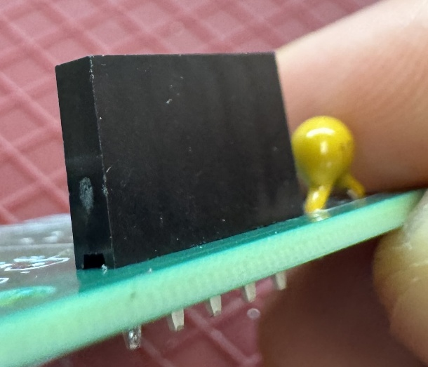

X

✓

#### Step B -09: Solder the remaining leads

Once the headers are aligned properly, solder the remaining four leads on the female header to the PCB.

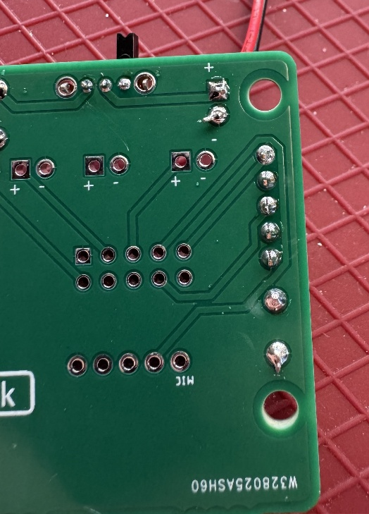

#### Step B -10: Insert ribbon cable connector

Insert the ribbon cable connector (B06) into the position labeled “RIBBON_CONNECTOR” from the Front side of the board. Make sure the slot in the top of the connector is on the same side as the opening in the outline on the PCB.

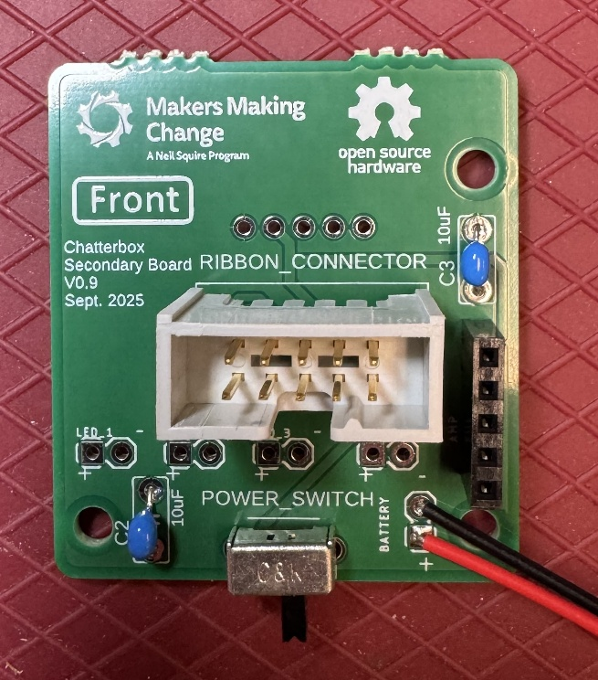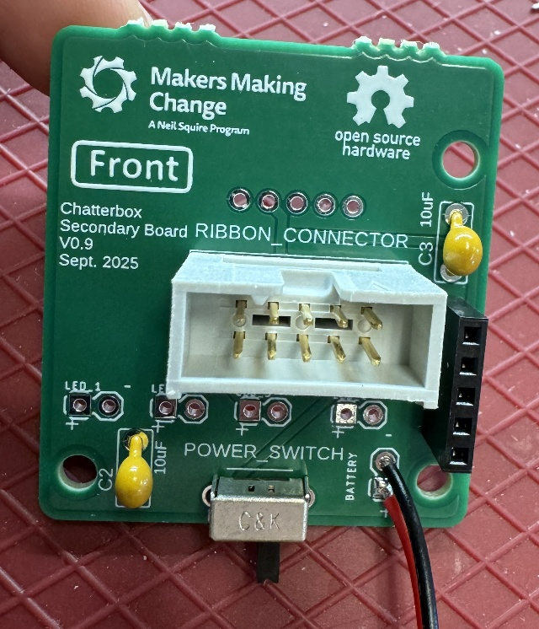

X

✓

#### Step B -11: Solder one lead and check alignment

Solder one of the 10 leads to the PCB. Double check that the connector is sitting flush and square to the board. If the connector is sitting flush, move to the next step.

If the connector is not sitting flush, you can reheat the soldered joint to melt the solder and realign the connector as needed.

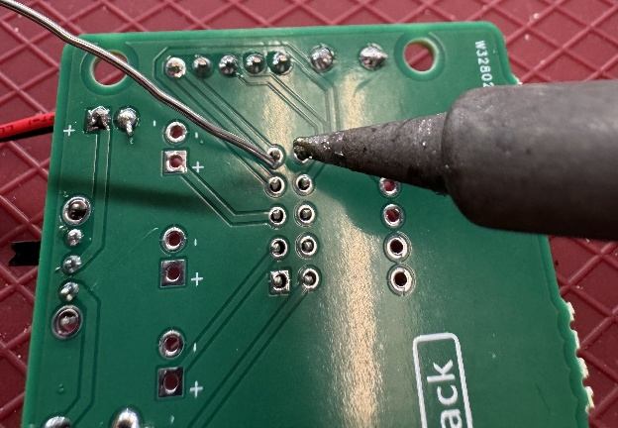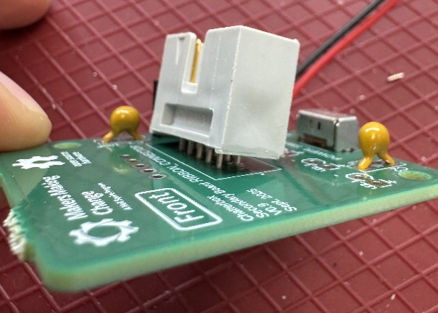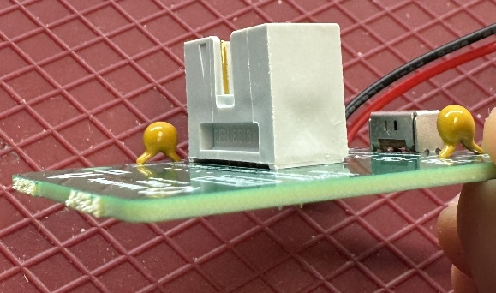

✓

X

#### Step B -12: Solder the remaining leads

Once the connector is aligned properly, solder the remaining nine leads to the PCB.

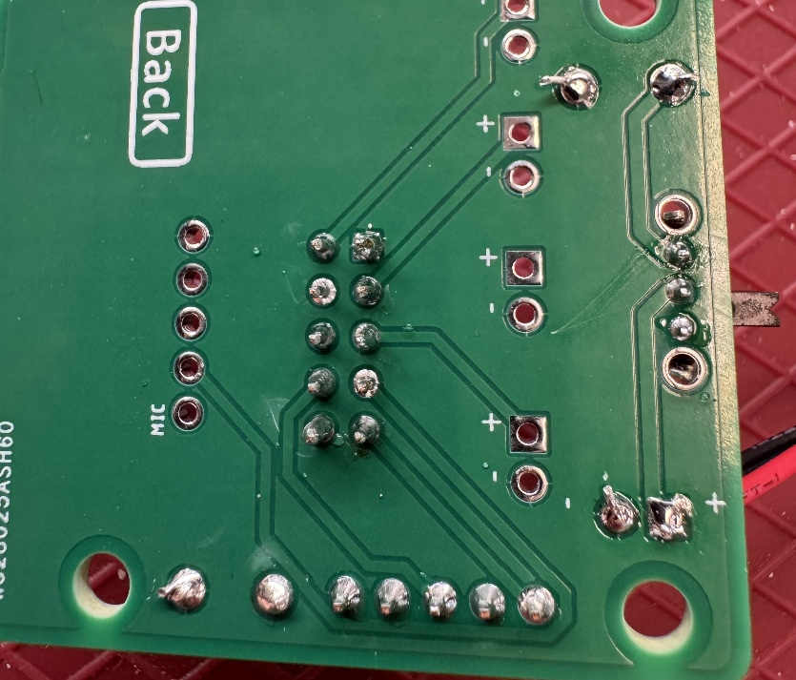

#### Step B -13: Cut wires to length

Cut the 24 AWG wire (B09) into two sections each of the following lengths: 8, 14, 19, and 25 cm. You will have cut off eight pieces of wire from the main length.

#### Step B -14: Strip ends of wires

Use the wire strippers to strip 0.5 cm of the insulation off both ends of each wire section you cut in Step B-07.

#### Step B -15: Insert LED 1 wires

Insert the shortest wires (8 cm) into the position labeled “LED_1” from the Front of the PCB. Make sure the exposed ends of the wires are not touching.

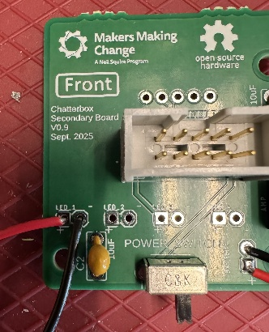

#### Step B -16: Solder the wires and trim excess

Solder the wires to the PCB. Trim the excess from the wires with the flush cutters.

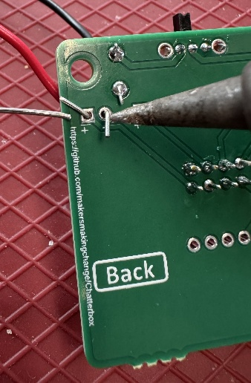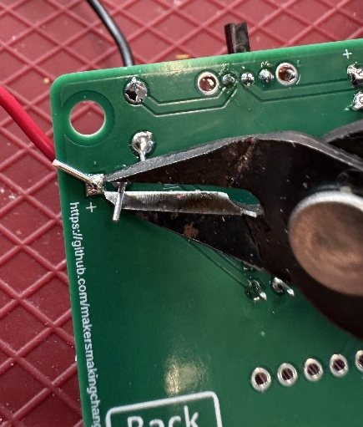

#### Step B -17: Insert LED 2 wires

Insert the next shortest wires (14 cm) into the position labeled “LED_2” from the Front of the PCB. Make sure the exposed ends of the wires are not touching.

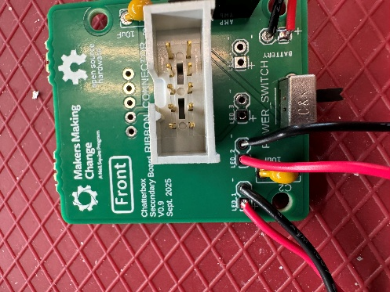

#### Step B -18: Solder the wires and trim excess

Solder the wires to the PCB. Trim the excess from the wires with the flush cutters.

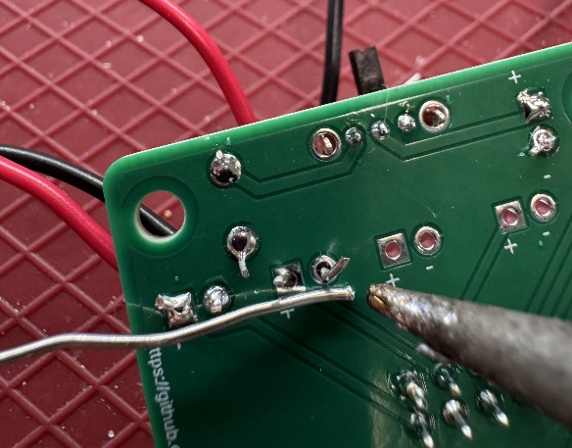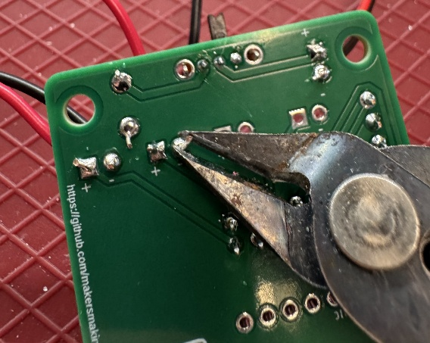

#### Step B -19: Insert LED 3 wires

Insert the next shortest wires (19 cm) into the position labeled “LED_3” from the Front of the PCB. Make sure the exposed ends of the wires are not touching.

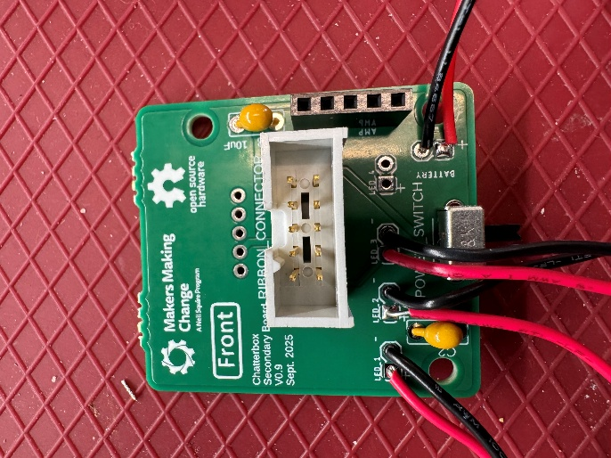

#### Step B -20: Solder the wires and trim excess

Solder the wires to the PCB. Trim the excess from the wires with the flush cutters.

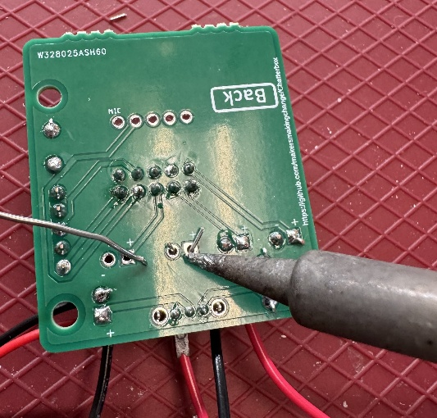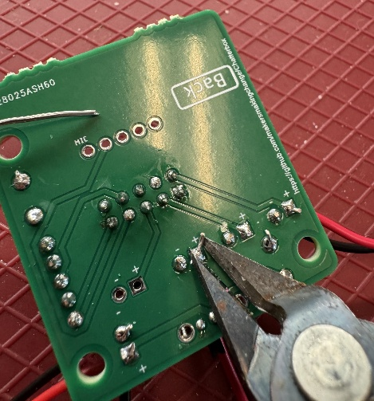

#### Step B -21: Insert LED 4 wires

Insert the next longest wires (24 cm) into the position labeled “LED_4” from the Front of the PCB. Make sure the exposed ends of the wires are not touching.

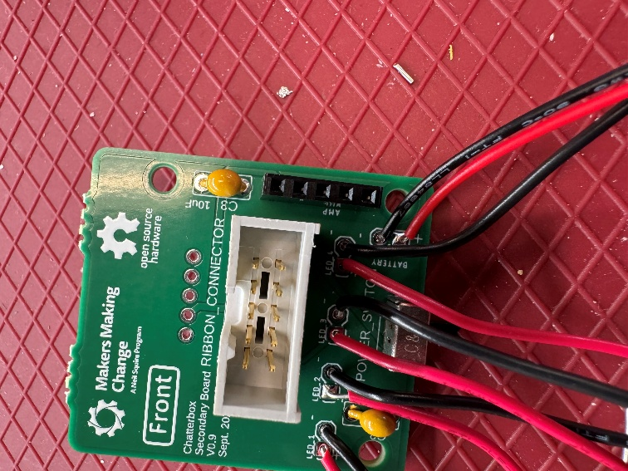

#### Step B -22: Solder the wires and trim excess

Solder the wires to the PCB. Trim the excess from the wires with the flush cutters.

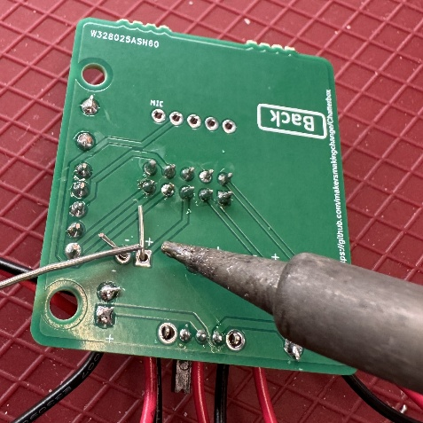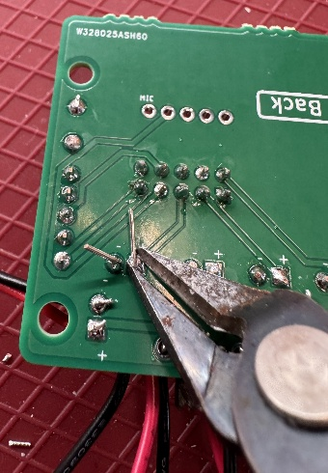

#### Step B -23: Insert microphone female headers

Insert the remaining set of five position female headers (B04) into the position labeled “MIC” from the Back side of the PCB.

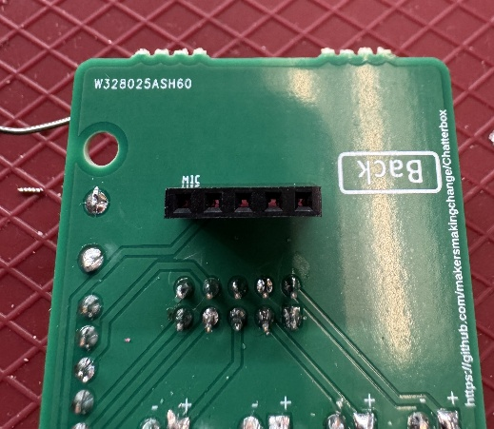

#### Step B -24: Solder one lead of the female headers and check alignment

Solder one of the five leads to the PCB. Double check that the headers are sitting flush and square to the board. If the headers are sitting flush, move to the next step.

If the headers are not sitting flush, you can reheat the soldered joint to melt the solder and realign the headers as needed.

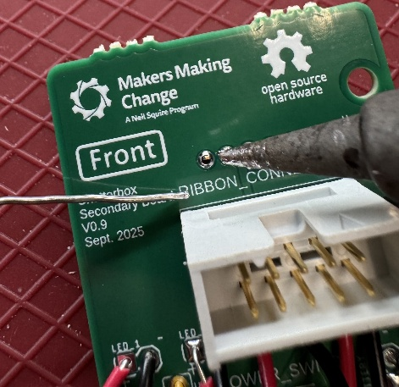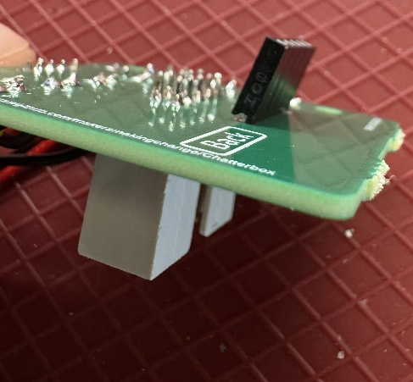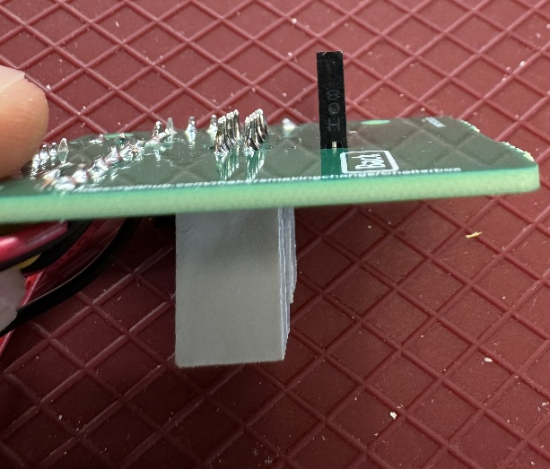

✓

X

#### Step B -25: Solder the remaining leads

Once the headers are aligned properly, solder the remaining four leads on the female header to the PCB.

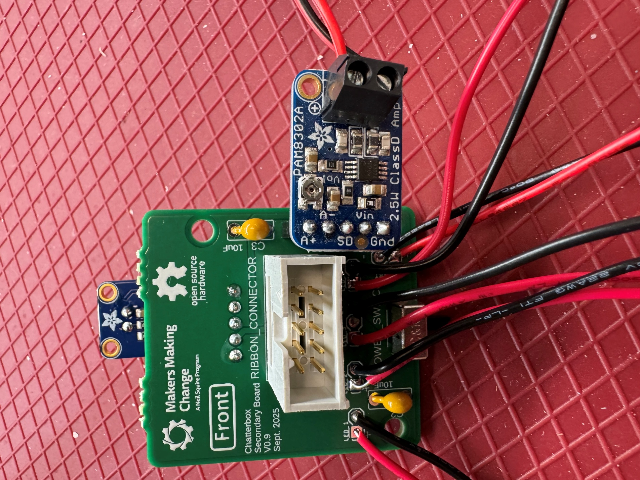

#### Step B -26: Solder male headers to microphone

Insert the shorter side of the male headers through the microphone PCB (B08) from the side without the round microphone. Solder the headers so they are flush and square to the microphone PCB.

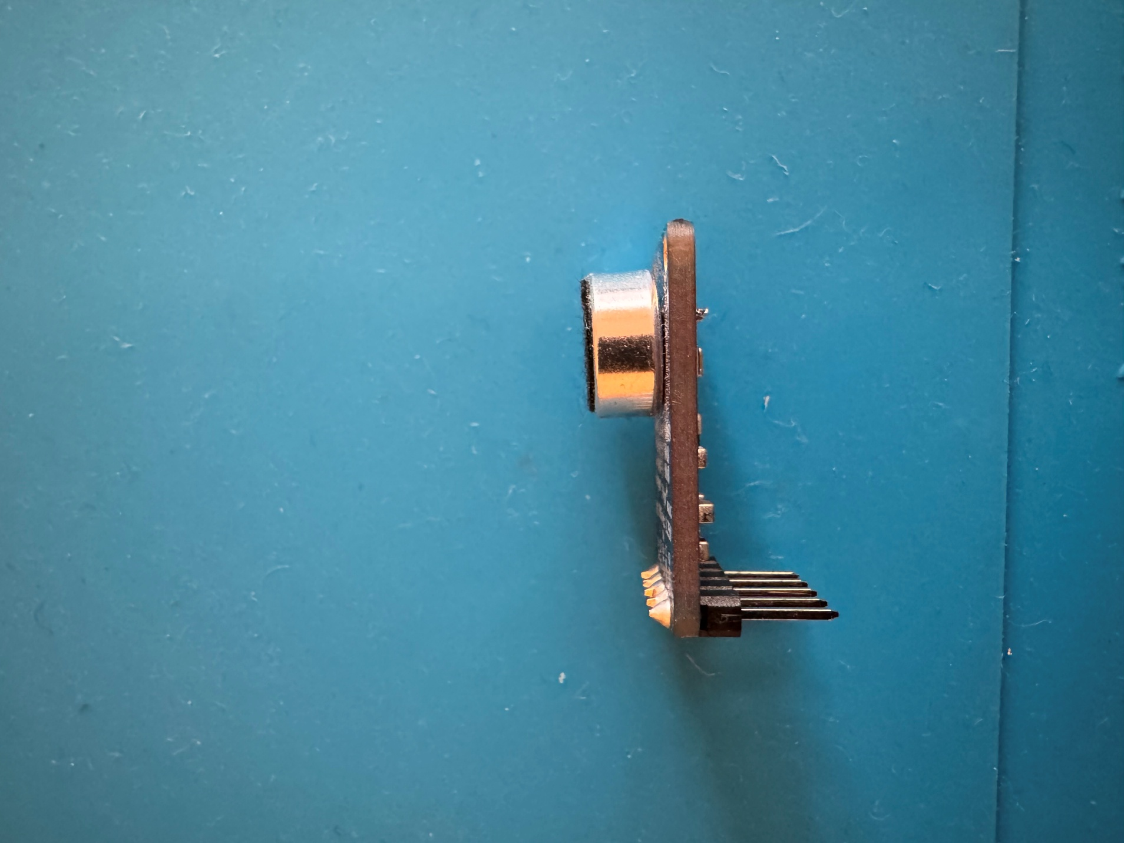

#### Step B -27: Insert microphone into female headers

Insert the long end of the male headers from the microphone into the “MIC” female headers on the secondary PCB. Make sure the circular microphone is directed away from the secondary PCB.

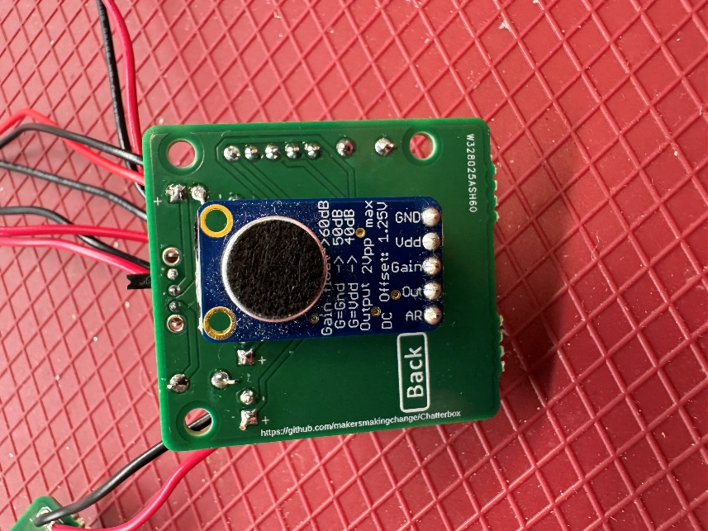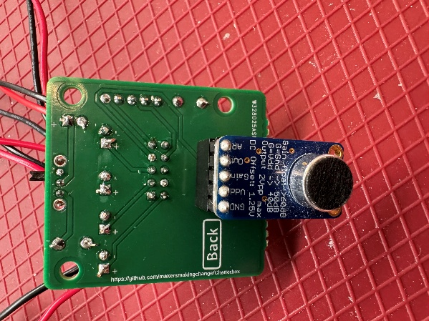

✓

X

#### Step B -28: Solder male headers to amp

Insert the shorter side of the male headers through the amp PCB (B07) from the side without any electronics on it. Solder the headers so they are flush and square to the microphone board.

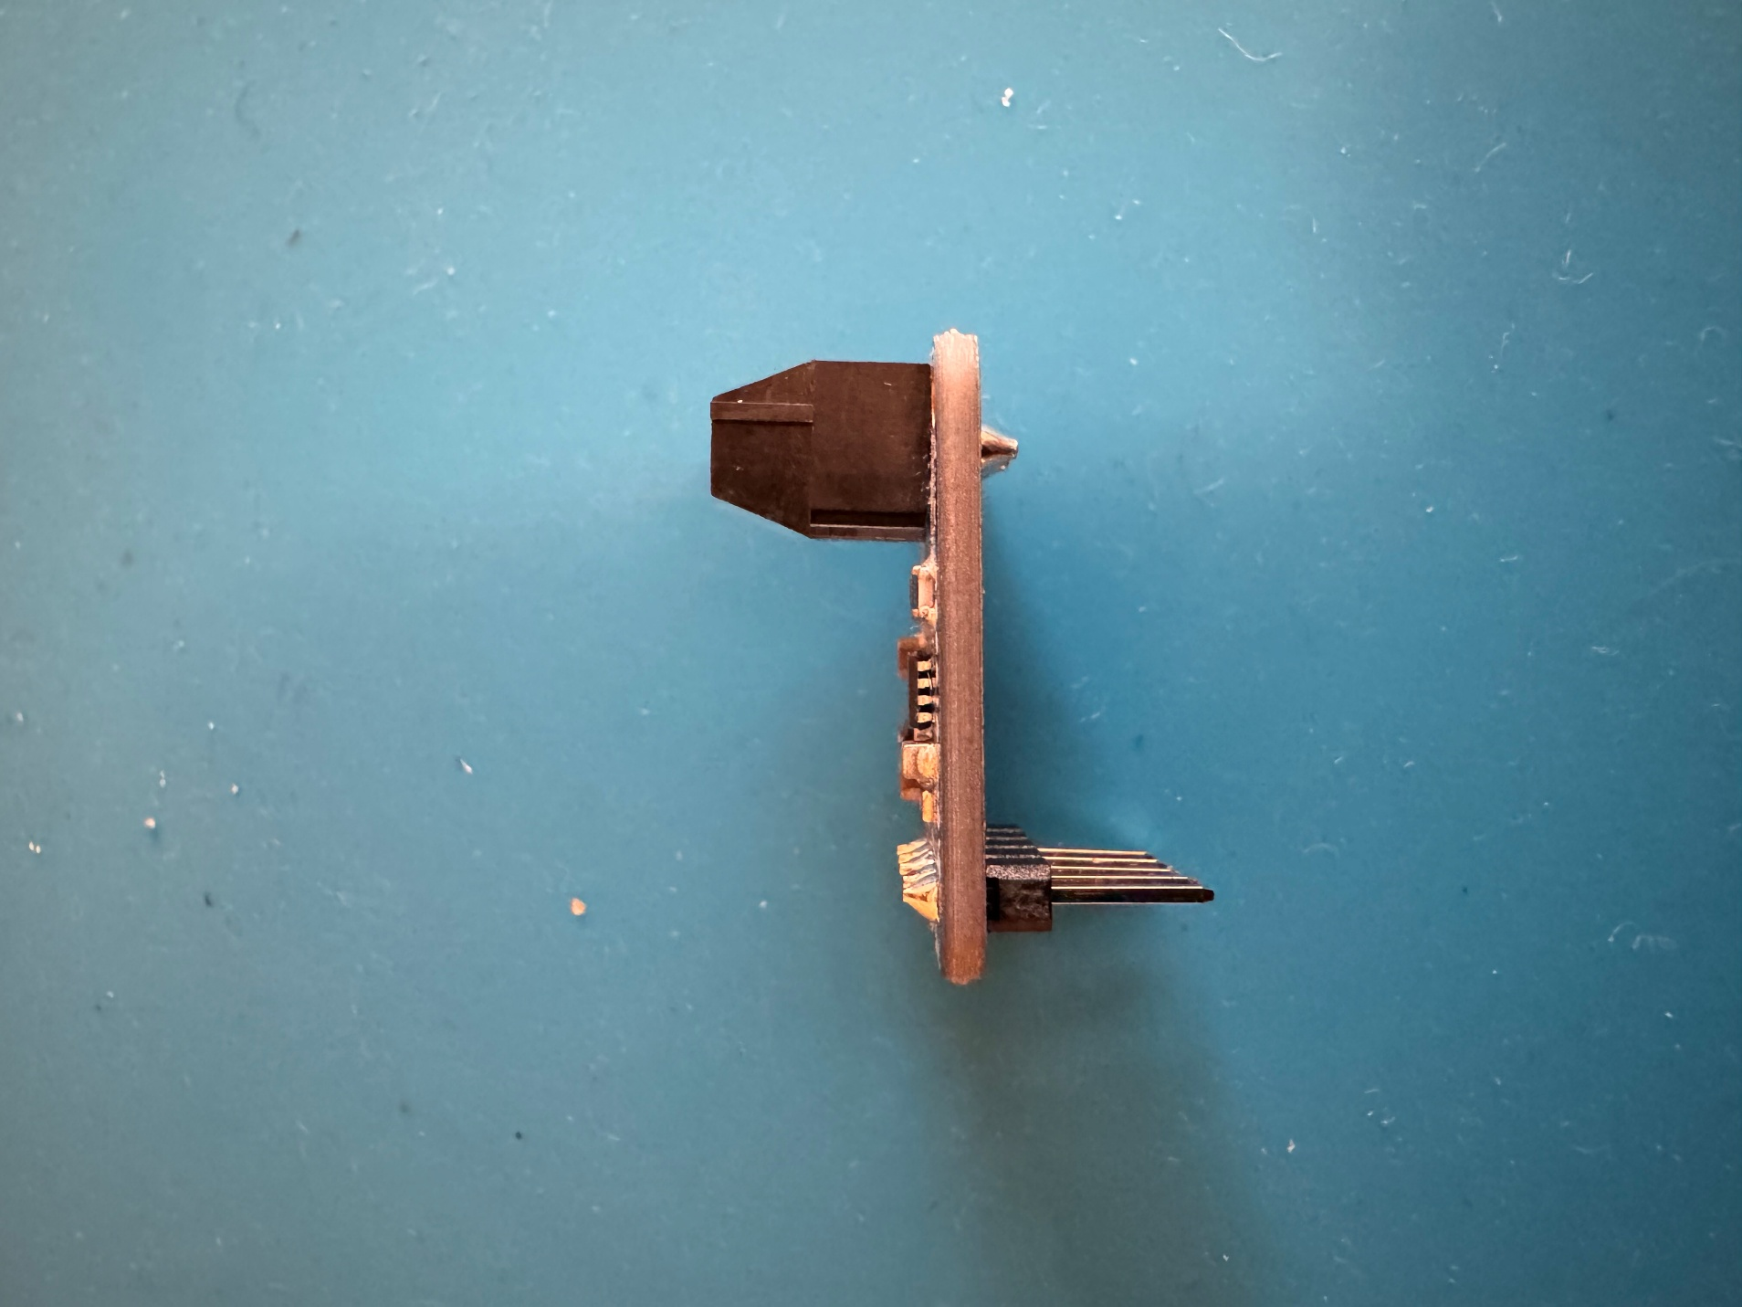

#### Step B -29: Solder screw terminals to amp

Insert the screw terminal into the amp PCB (B07) from the side with the electronics on it. Make sure the screw terminal openings face out from the board. Solder the screw terminals so they are flush and square to the amp PCB.

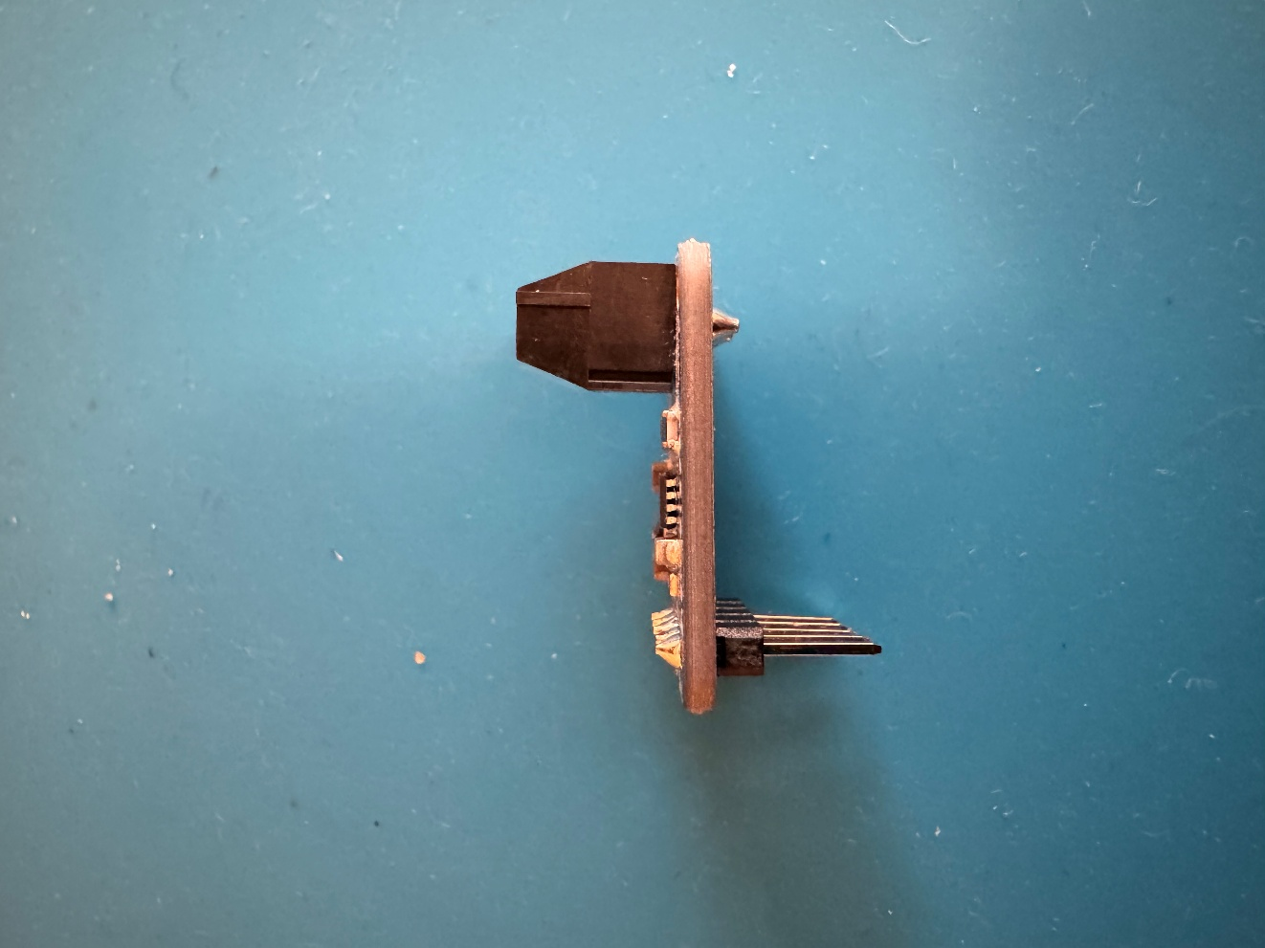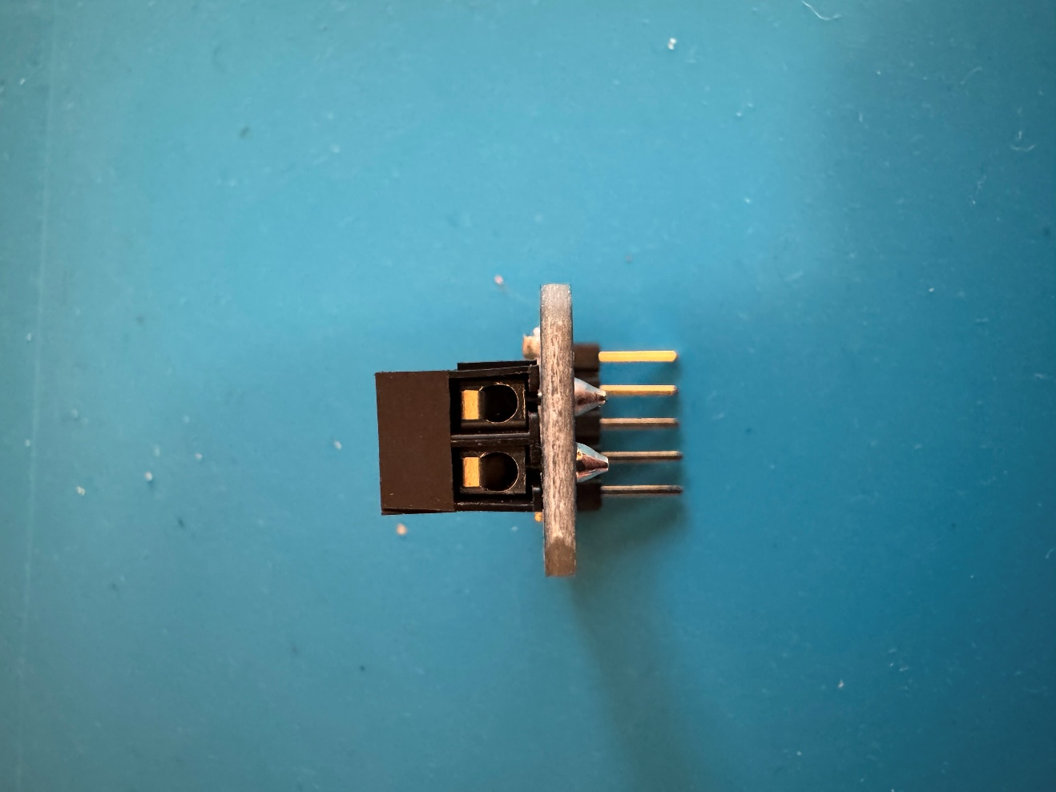

#### Step B -30: Trim and strip speaker wires

Trim off the plug terminal from the speaker wires. Strip roughly 0.5 cm of the insulation from the ends of the speaker wires.

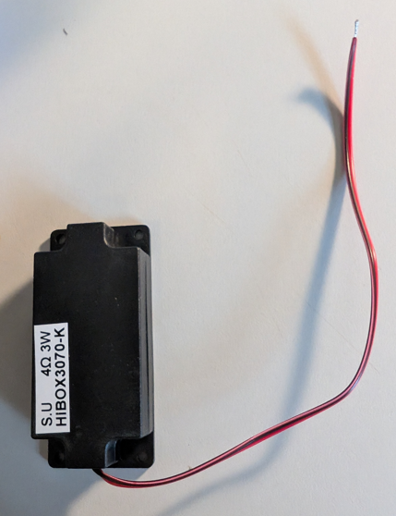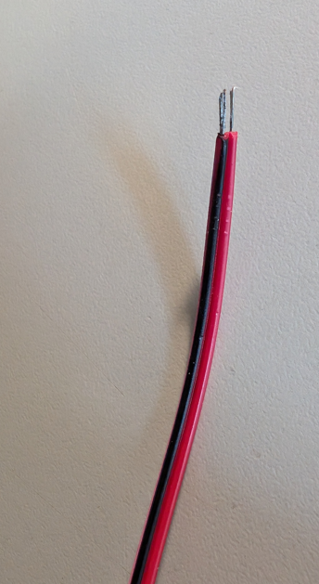

#### Step B -31: Connect speaker to amp

Take the stripped ends of the speaker wire, and screw them into the terminal blocks on the amp using the small flathead screwdriver.

It is critical that the red wire is connected to the terminal labeled with a “+” and the black wire is connected to the terminal labeled with a “-“. You may notice the black wire has some red on it, but the red wire will only have red.

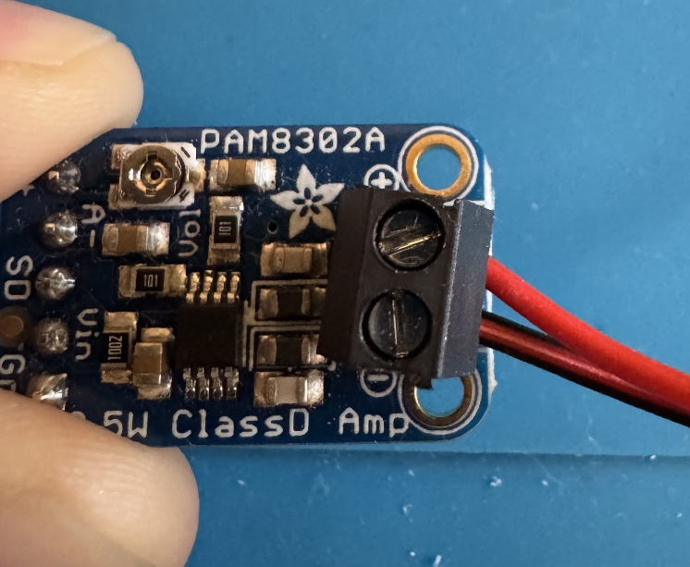

#### Step B -32: Insert amp into female headers

Insert the long end of the male headers from the amp into the “AMP” female headers on the secondary PCB. Make sure the amp is facing away from the secondary PCB.

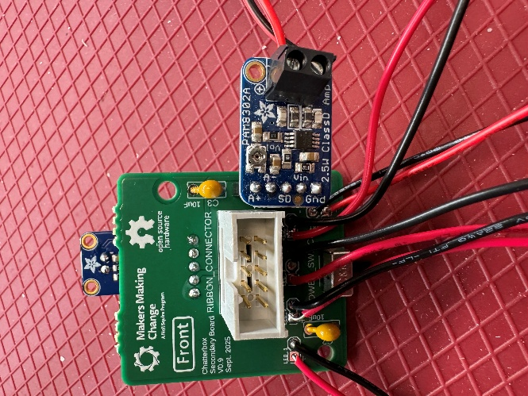

#### Step B -33: Double check all solder connections

Double check all the solder joints on the secondary PCB to ensure none have been missed, there are no shorts (solder connecting two or more leads together), and that all joints are good quality.

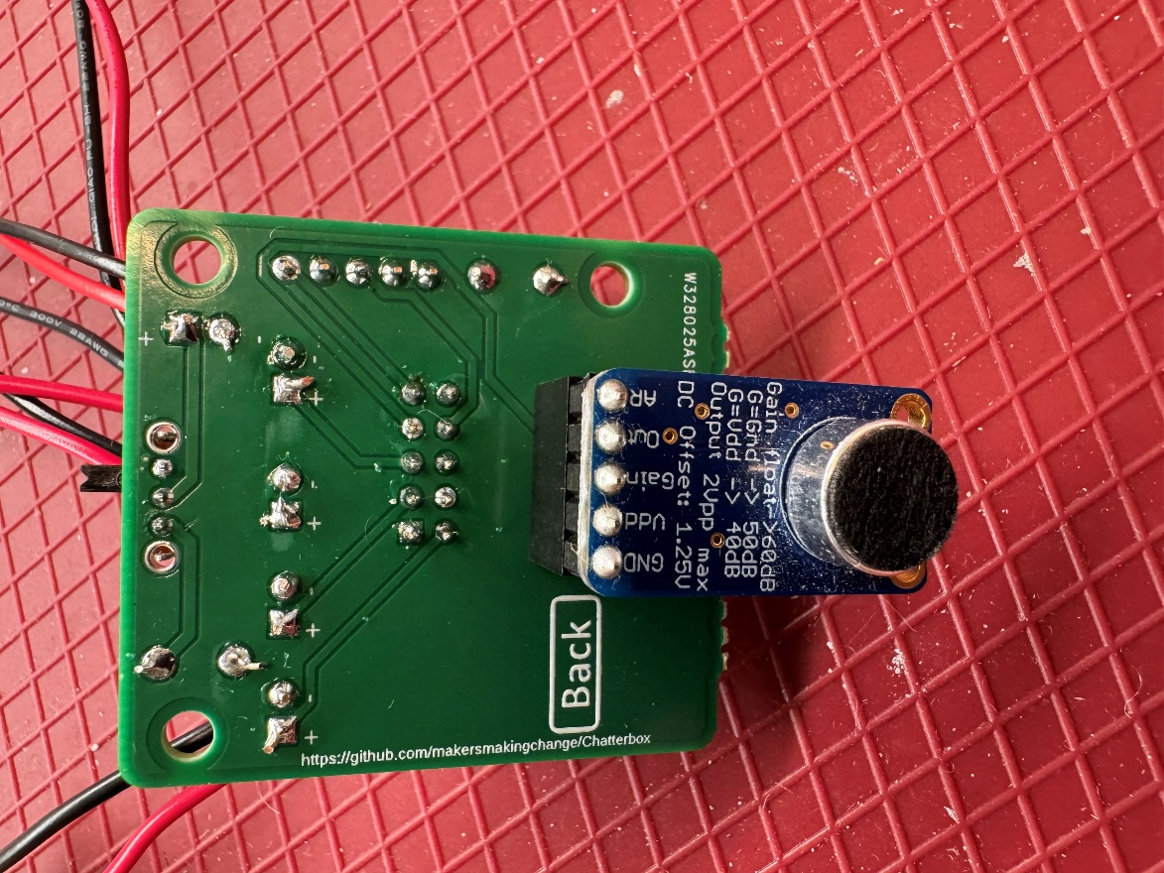

The secondary PCB is now complete.

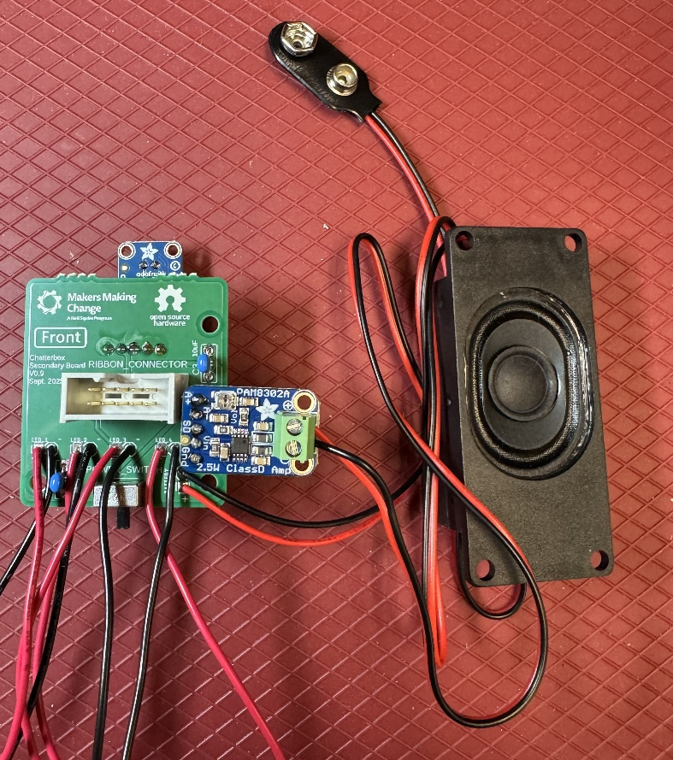

## Part C: LED PCBs

### Part C: Required Components

|  |  |  |  |  |  |  |  |  |
| --- | --- | --- | --- | --- | --- | --- | --- | --- |
| LED PCBs | | | | | | | | |
| C01 | LED PCB | QTY: 4 | C02 | 2.2k Ohm resistor | QTY: 4 | C03 | 5mm LED | QTY: 4 |
|  | | | Resistor 2.2K Ohm 5% 1/4W (25-Pack) - ProtoSupplies  A red and white rectangle  AI-generated content may be incorrect.  Note: The resistor body colour may change, but the bands will be the same. | | |  | | |
| C04 | Completed Secondary PCB | QTY: 1 |
|  | | |

### Part C: Required Tools and Supplies

* Soldering iron
* Solder
* Flush cutters

### Part C: Required Personal Protective Equipment (PPE)

* Safety glasses/goggles

### Part C: LED PCB Assembly Steps

#### Step C-00: Sort LED PCBs

Currently, the are four LED PCBs have slight differences which mean they must be connected to their corresponding number on the Secondary PCB (i.e. LED 1 to LED 1). Start with LED 1, and work up to LED 4, making sure when you connect the correct boards on Step C-06. In future, the four boards will be identical, so we can remove this step.

#### Step C -01: Insert resistor

Insert the resistors (C02) into the spaces “R_1”on the LED PCB (C01). Make sure the resistor is lying flat on the board, and bend the leads to hold the resistor in place.

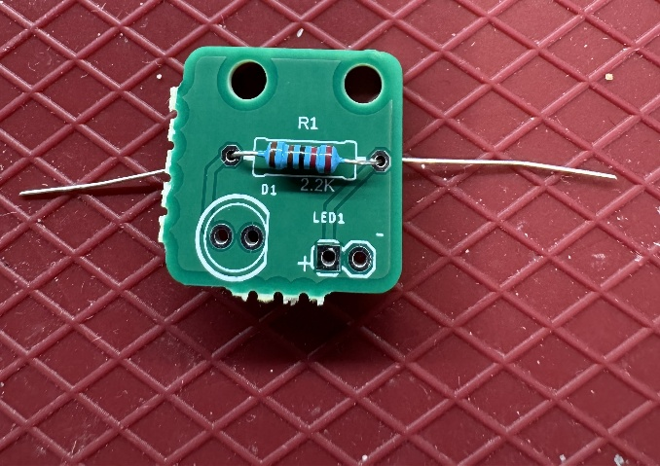

#### Step C -02: Solder and trim resistor leads

Solder both leads of the resistor to the PCB. Once the leads are soldered, trim the excess wire off using the flush cutters.

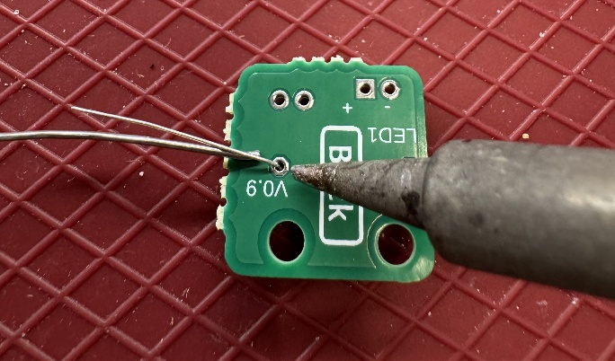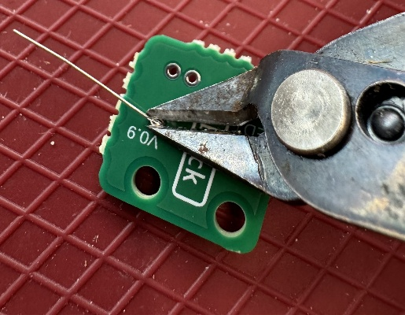

#### Step C -03: Insert the LED

Insert the LED (C03) into the position labeled “D1”. It is critical that the LED is oriented properly. There are two ways to check the orientation: a flat section on the LED, and the length of the leads. The flat section on the LED should line up with the flat side on the outline of the LED on the PCB. The leads are different lengths, and the longer lead should be closest to the edge of the PCB.

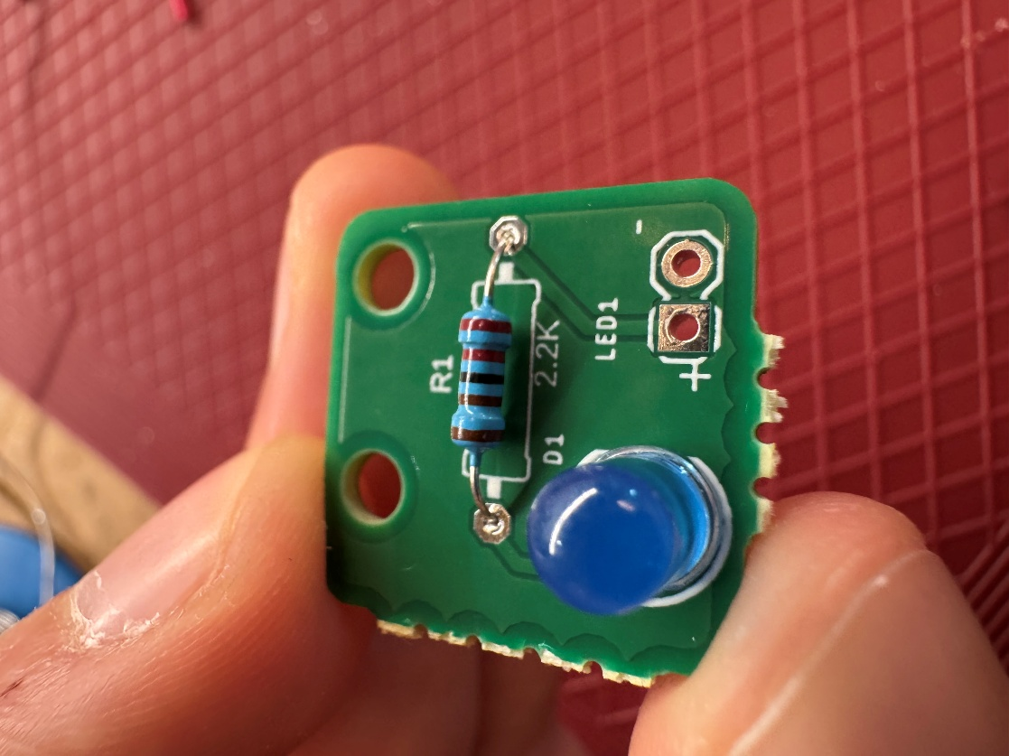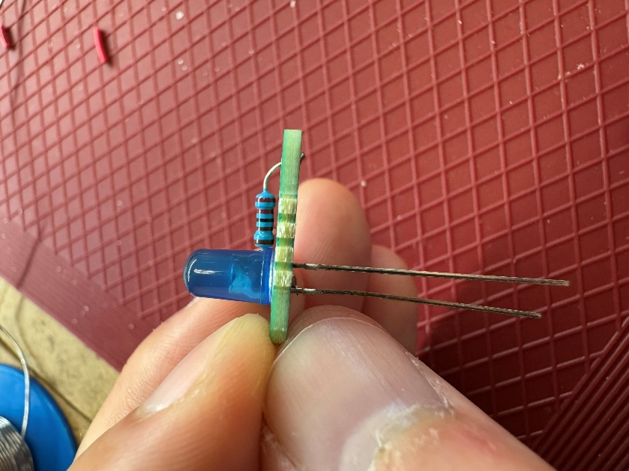

X

X

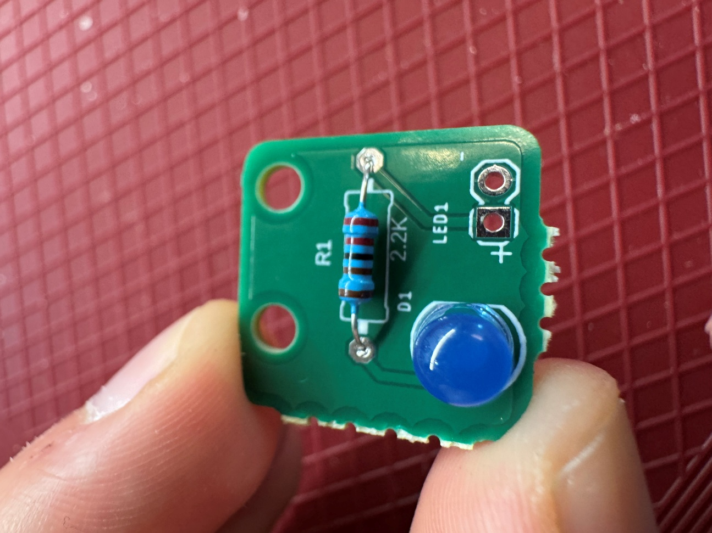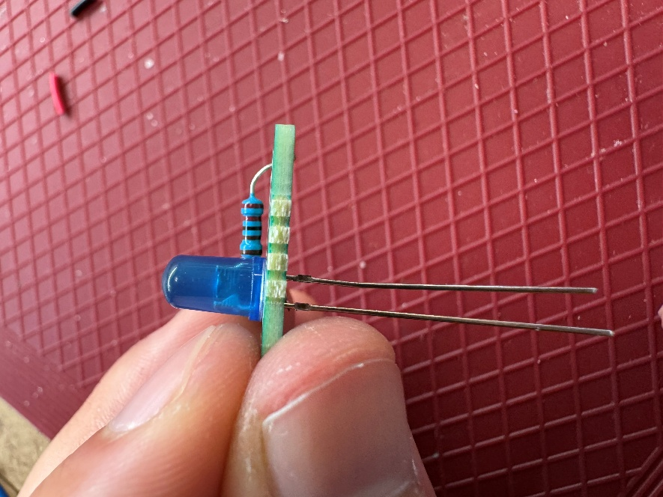

✓

✓

#### Step C -04: Solder one lead and check alignment

Solder one of the two leads to the PCB. Double check that the LED is sitting flush and square to the board. If the LED is sitting flush, move to the next step.

If the LED is not sitting flush, you can reheat the soldered joint to melt the solder and realign the LED as needed.

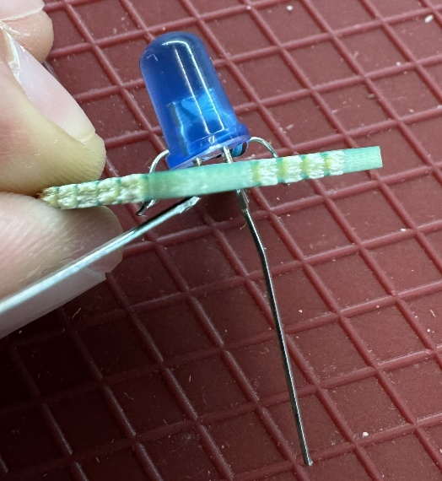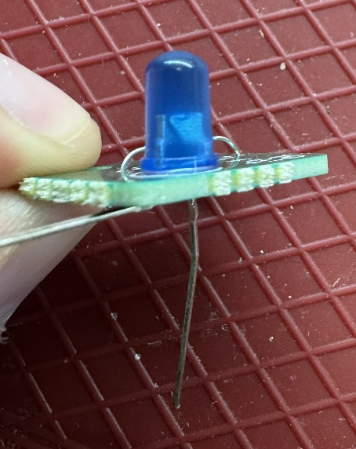

✓

X

#### Step C -05: Solder the remaining lead and trim excess

Once the LED is aligned properly, solder the remaining lead to the PCB. Trim the excess from both leads.

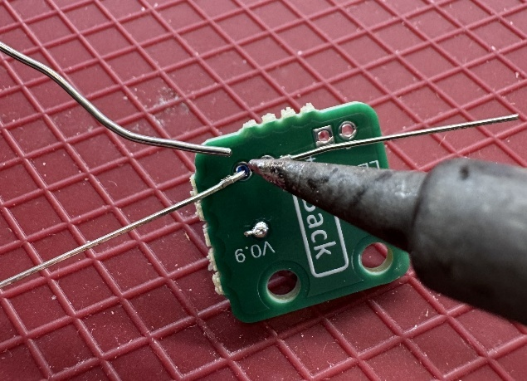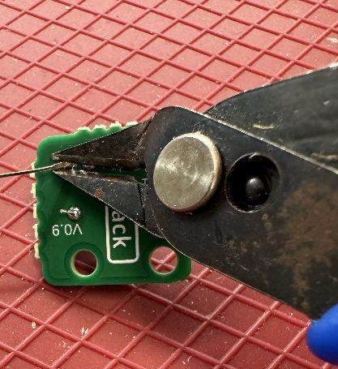

#### Step C -06: Connect LED PCB to the Secondary PCB

Connect the wires from the Secondary PCB (C04) to the LED PCB. It is critical that the polarity (positive and negative) of the wires is the same on LED PCB as it is on the Secondary PCB. Make sure the wire coming from the position labeled “+” on the Secondary PCB goes to the “+” on the LED PCB, and the “-“ goes to the “-“.

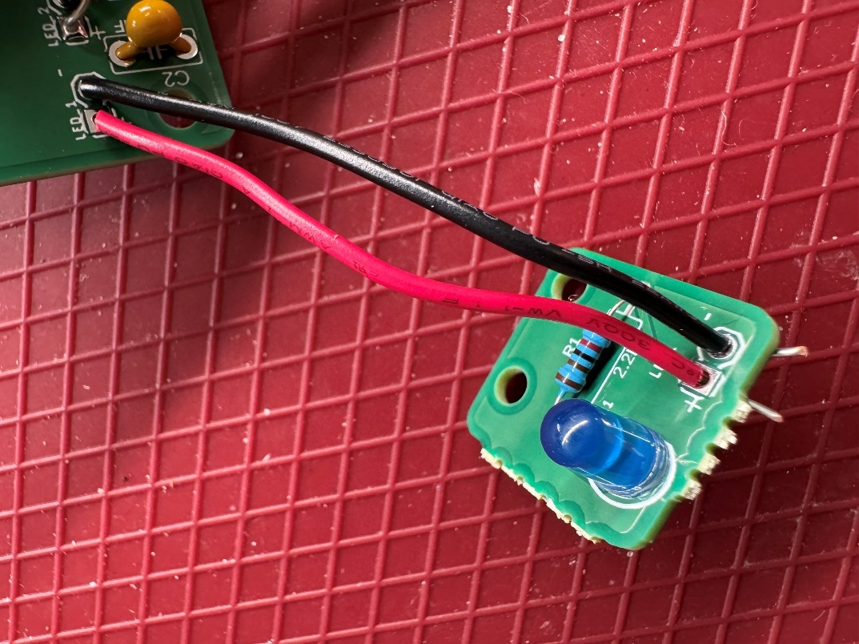

#### Step C -07: Solder the wires to the LED PCB and trim excess

Make sure the exposed ends of the wires are not touching, then solder the wires to the LED PCB. Trim any excess exposed wire after soldering.

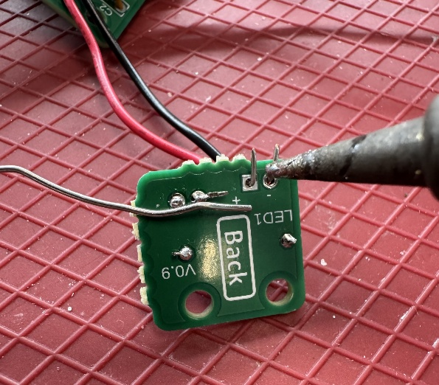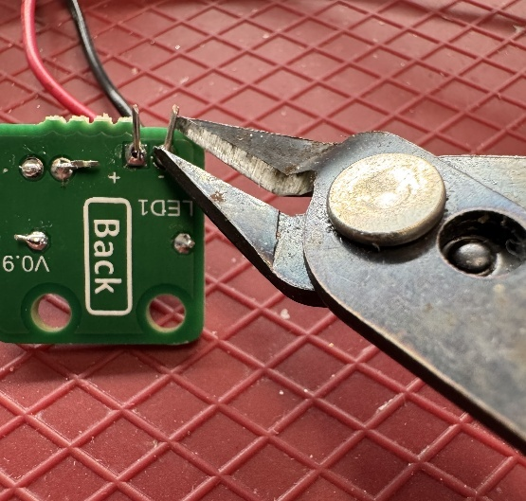

#### Step C -08: Double check all solder connections

Double check all the solder joints on the LED PCB to ensure none have been missed, there are no shorts (solder connecting two or more leads together), and that all joints are good quality.

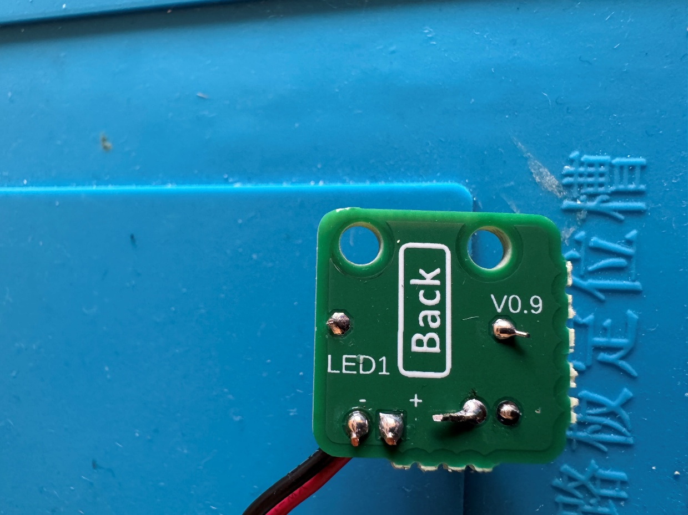

#### Step C -09: Repeat Steps C-01 to C-08 for the remaining three LED PCBs

Repeat Steps C-01 to C-08 for the remaining three LED PCBs. By the end, all the wires from the Secondary PCB should be connected to LED PCBs.

Once all LED PCBs have been connected to the Secondary PCB, this section is complete.

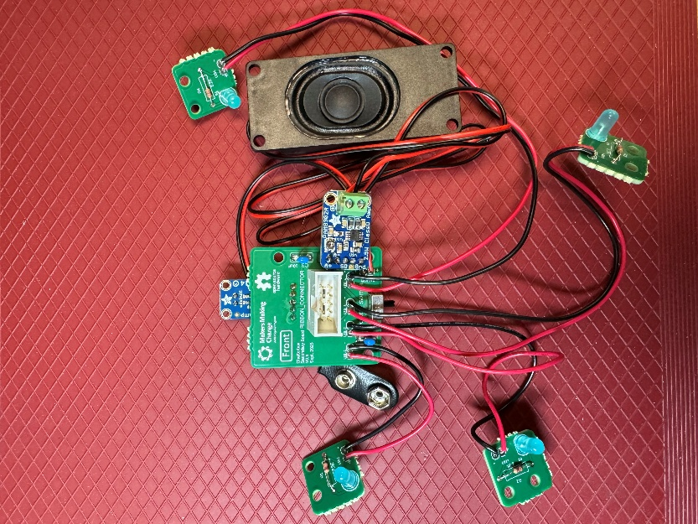

## Part D: Enclosure Assembly

### Part D: Required Components

|  |  |  |  |  |  |  |  |  |
| --- | --- | --- | --- | --- | --- | --- | --- | --- |
| Enclosure | | | | | | | | |
| D01 | Enclosure Bottom - Left | QTY: 1 | D02 | Enclosure Bottom - Right | QTY: 1 | D03 | Assembled Main PCB | QTY: 1 |
|  | | |  | | |  | | |
| D03 | #4x3/8” machine screw | QTY: 20 | D04 | Centre support | QTY: 2 | D05 | Button base | QTY: 4 |
| #4 sheet metal screw | | |  | | |  | | |
| D07 | Tactile switch | QTY: 4 | D08 | Enclosure Top - Left | QTY: 1 | D09 | Enclosure Top - Right | QTY: 1 |
|  | | |  | | |  | | |
| D10 | Ribbon Cable | QTY: 1 | D11 | Assembled Secondary PCB and LED PCBs | QTY: 4 | D12 | Button insert | QTY: 4 |
| Grey ribbon cable folded in half | | |  | | |  | | |
| D13 | Button cap | QTY: 4 | D14 | Label holder | QTY: 4 | D15 | 9V battery | QTY: 1 |
|  | | |  | | | 9V Battery | | |
| D16 | Battery Cover | QTY: 1 | D17 | Volume knob | QTY: 1 |
|  | | |  | | |

### Part D: Required Tools and Supplies

* Phillips head screwdriver (#2)
* Flush cutters
* Soldering iron
* Solder
* Hot glue gun and glue/Super glue

### Part D: Required Personal Protective Equipment (PPE)

* Safety glasses/goggles

### Part D: Enclosure Assembly Steps

#### Step D -01: Trim switch leads

Use a flush cutter to trim off the leads on one side of each of the tactile switches (D07). Make sure the leads are cut flush against the side of the switch and do not extend below the bottom of the switch.

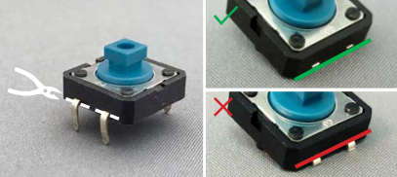

#### Step D -02: Straighten remaining switch leads

Straighten the remaining switch leads, ensuring they stick straight out from the side of the switches.

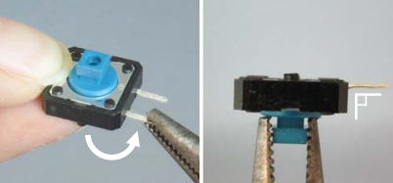

#### Step D -03: Trim mounting lugs

Use the flush cutters to trim the plastic mounting lugs (the plastic cylinders) off the bottom of the switches. Make sure the lugs are cut flush, with no remaining bumps.

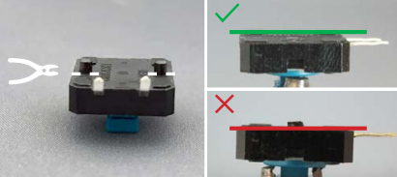

#### Step D -04: Solder switches to message wires from Main PCB

Starting with the wires leading from “MESSAGE_1” on the Main PCB (D03), solder one wire from the PCB to one of the leads on one switch. Solder the other wire to the other lead, making sure not to connect the two sides together with touching exposed wire or solder.

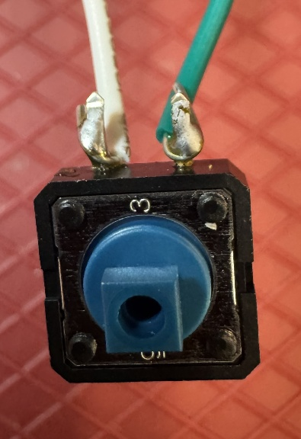

Repeat this step for the remaining switches and sets of wires.

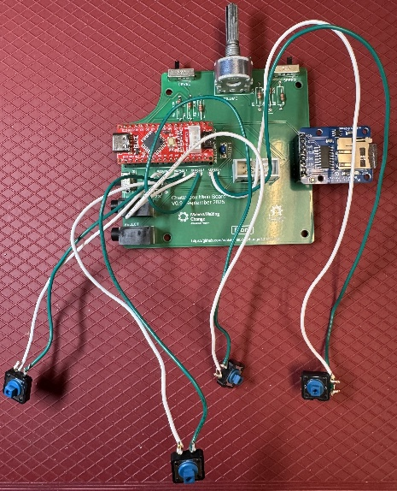

#### Step D -05: Connect bottom parts of the enclosure

Take the Enclosure Bottom – Left (D01) and Enclosure Bottom – Right (D02) and line up the connection snaps in the centre. Keeping your fingers out of the way, push the two parts together firmly, until they snap into place. It may help to angle the pieces while pushing together.

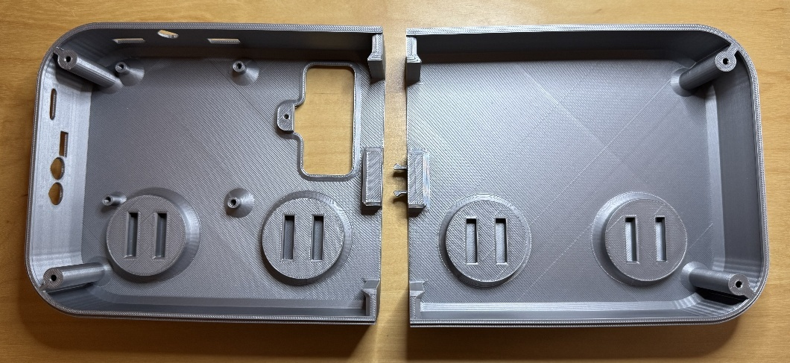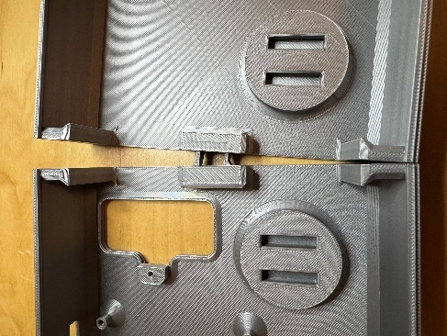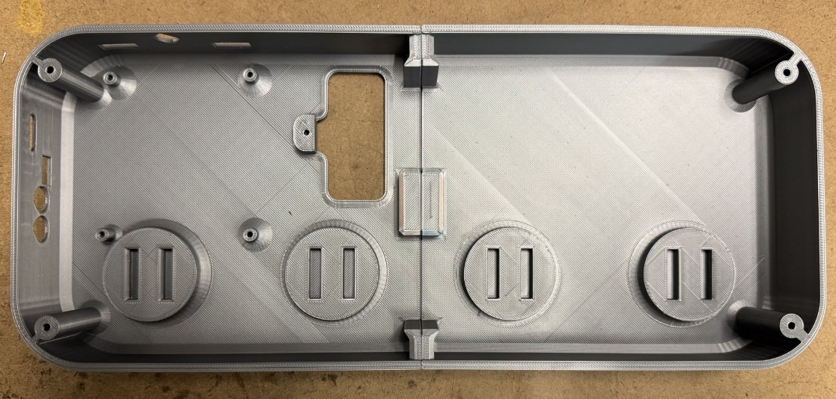

#### Step D -06: Insert centre support

Take one of the two Centre Supports (D05) and slide it into position.

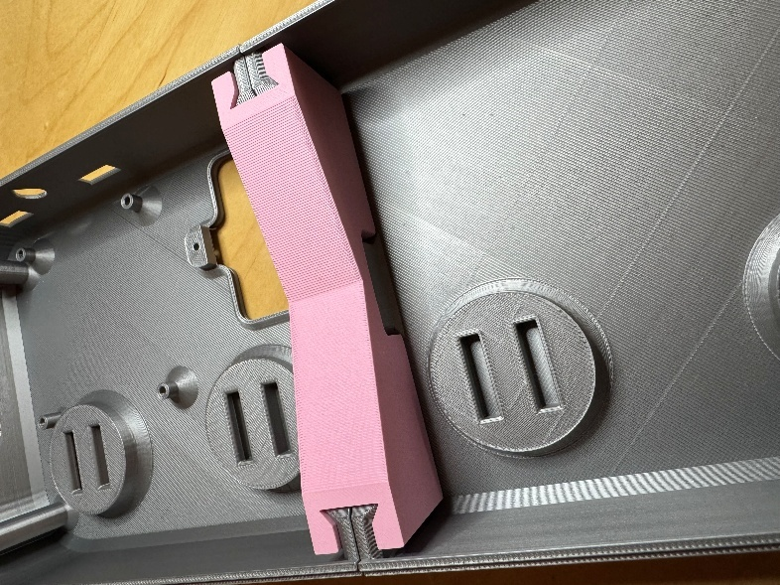

#### Step D -07: Position Main PCB

Insert the Main PCB (D03) into the enclosure. The volume knob will stick out the back, and the switches at the side will stick out slightly.

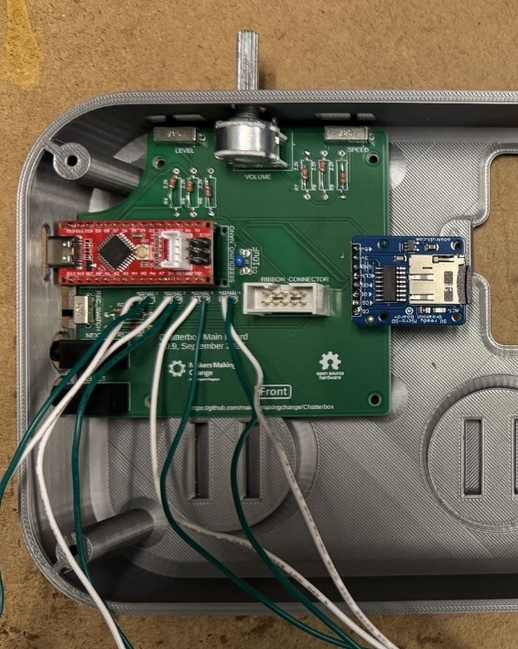

#### Step D -08: Screw down main PCB

Use four of the #4 screws (D04) to connect the main PCB to the enclosure bottom.

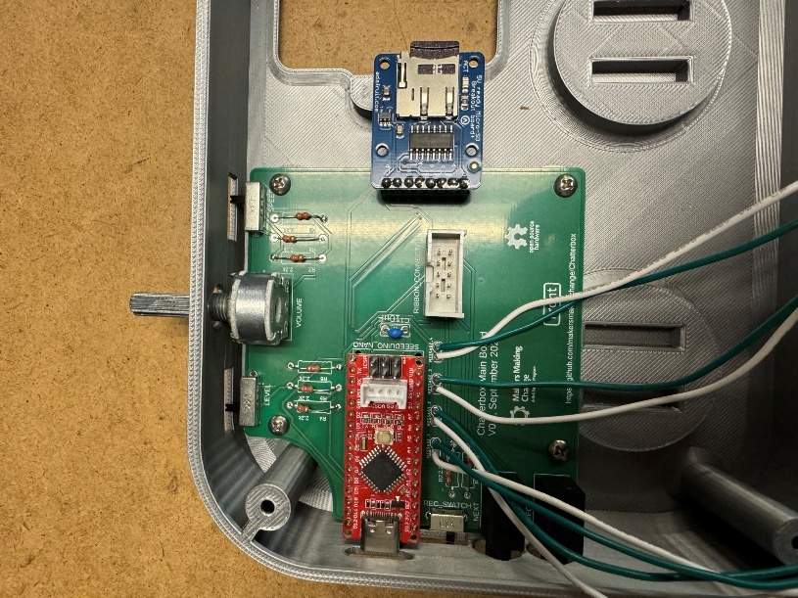

#### Step D -09: Insert button bases into enclosure

Insert each of the four Button Bases (D06) into the Enclosure Bottom. Make sure the flat side of the bases are closest to the inside of enclosure, and the rounded side is closest to the outside edge. Press the bases firmly until they snap into place.

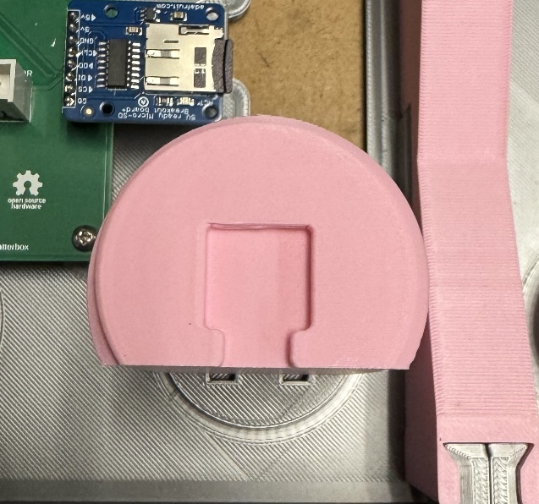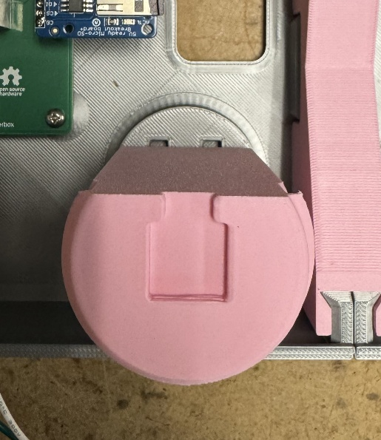

✓

X

#### Step D -10: Glue message switches to bases

Working one switch at a time, glue the switches to their corresponding bases. The messages go from 1 to 4 from left to right (i.e., the switch connected to “MESSAGE_1” on the Main PCB should be in the left-most base, closest to the Main PCB, and the “MESSAGE”4” switch will be on the furthest right base). The wire lengths have been cut to make it so a switch cannot be attached to a base further down from its correct position (ex: the wires from “MESSAGE_1” are too short to reach the second base).

Make sure that the switches are glued flat to the base and are not sitting proud or at an angle.

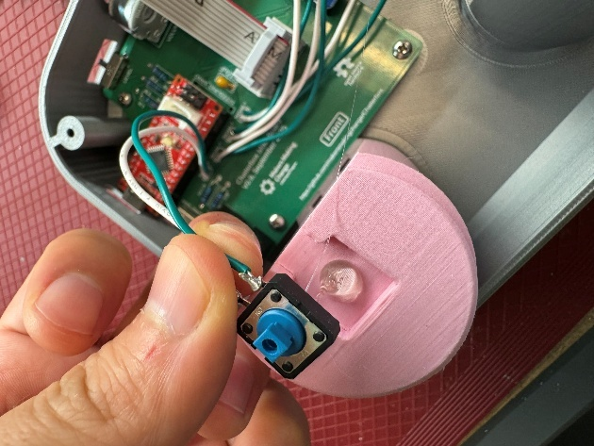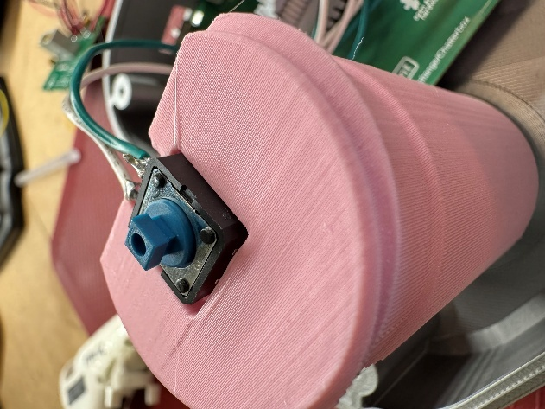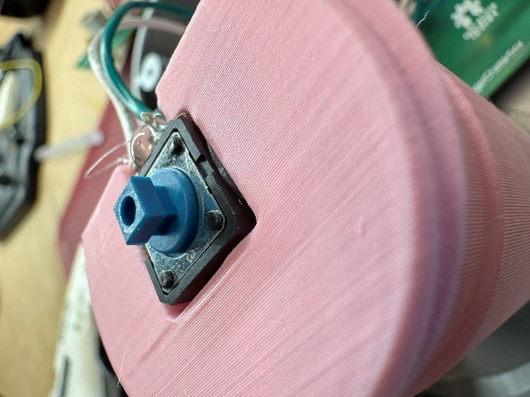

✓

X

#### Step D -11: Bend wires flat to bases

Bend the wires from each switch so they lit flat against the flat side of the button bases.

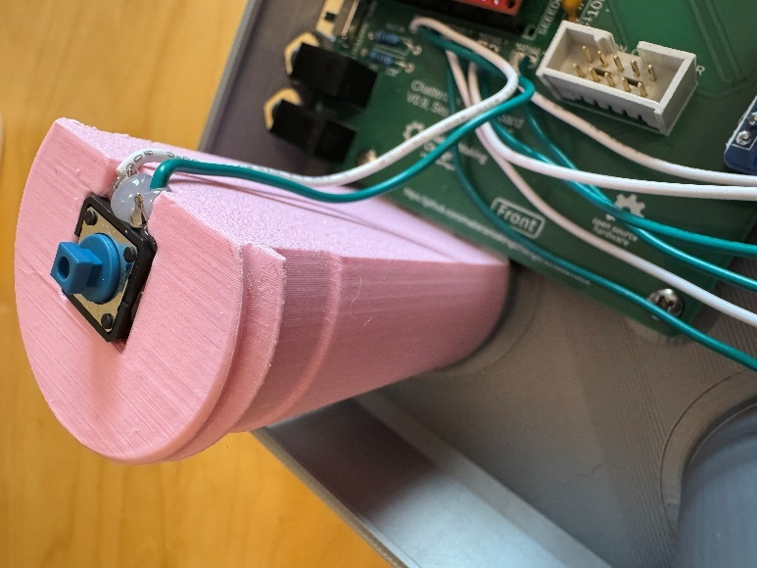

#### Step D -12: Connect ribbon cable

Connect the ribbon cable (D10) to the ribbon cable connector on the Main PCB.

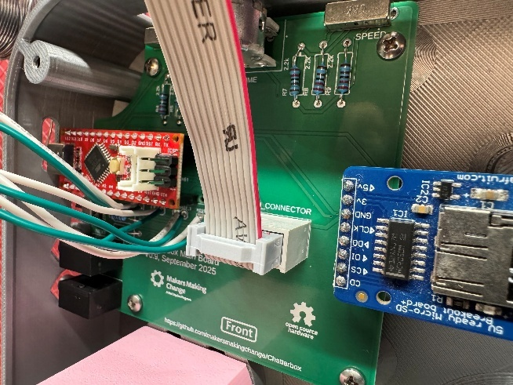

#### Step D -13: Connect top parts of the enclosure

Take the Enclosure Top – Left (D08) and Enclosure Top – Right (D09) and line up the connection snaps in the centre. Keeping your fingers out of the way, push the two parts together firmly, until they snap into place. It may help to angle the pieces while pushing together.

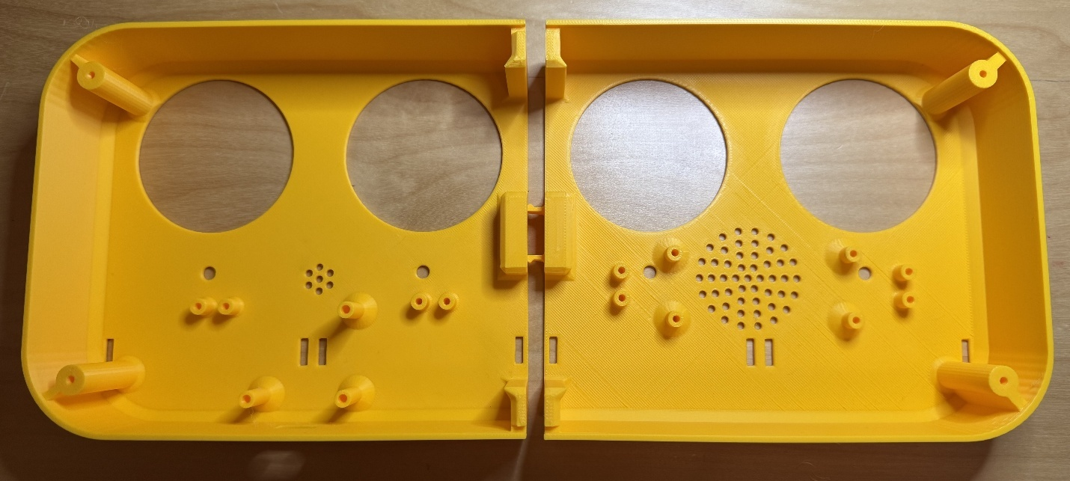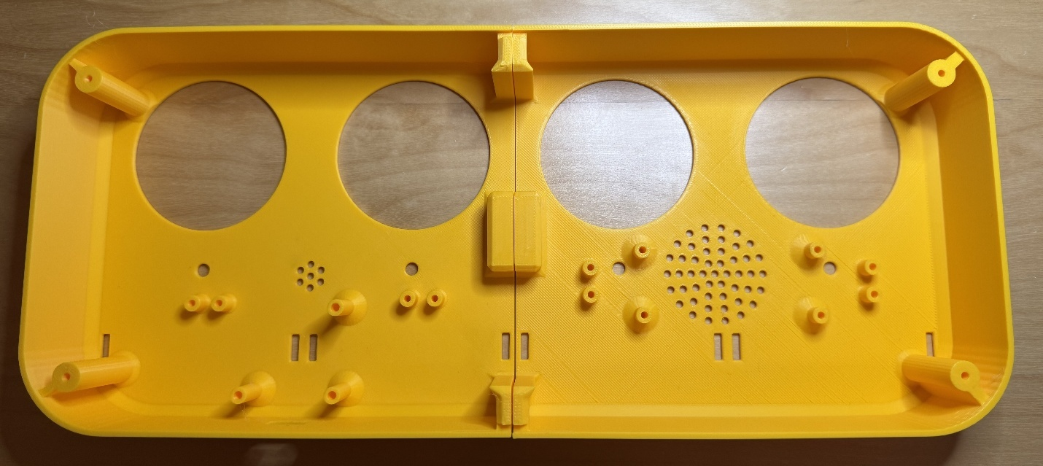

#### Step D -14: Insert centre support

Take the remaining Centre Support (D05) and slide it into position.

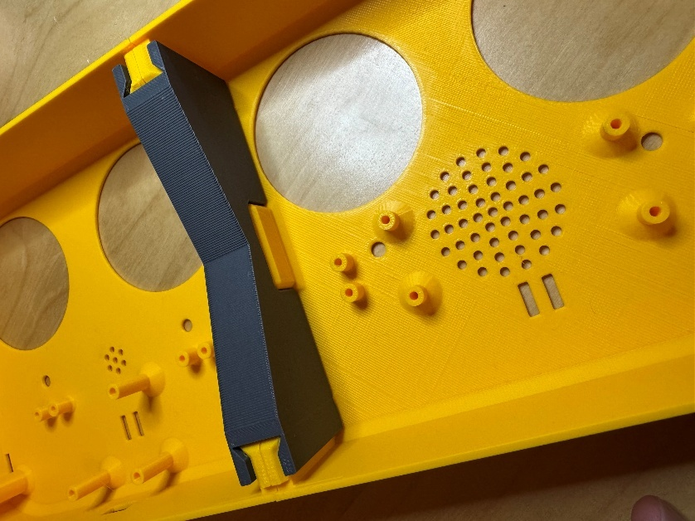

#### Step D -15: Insert Secondary PCB

Insert the Secondary PCB (D11) into position on the enclosure top. The power switch should stick out from the edge of the enclosure, and the mic should be facing toward the holes in the enclosure top.

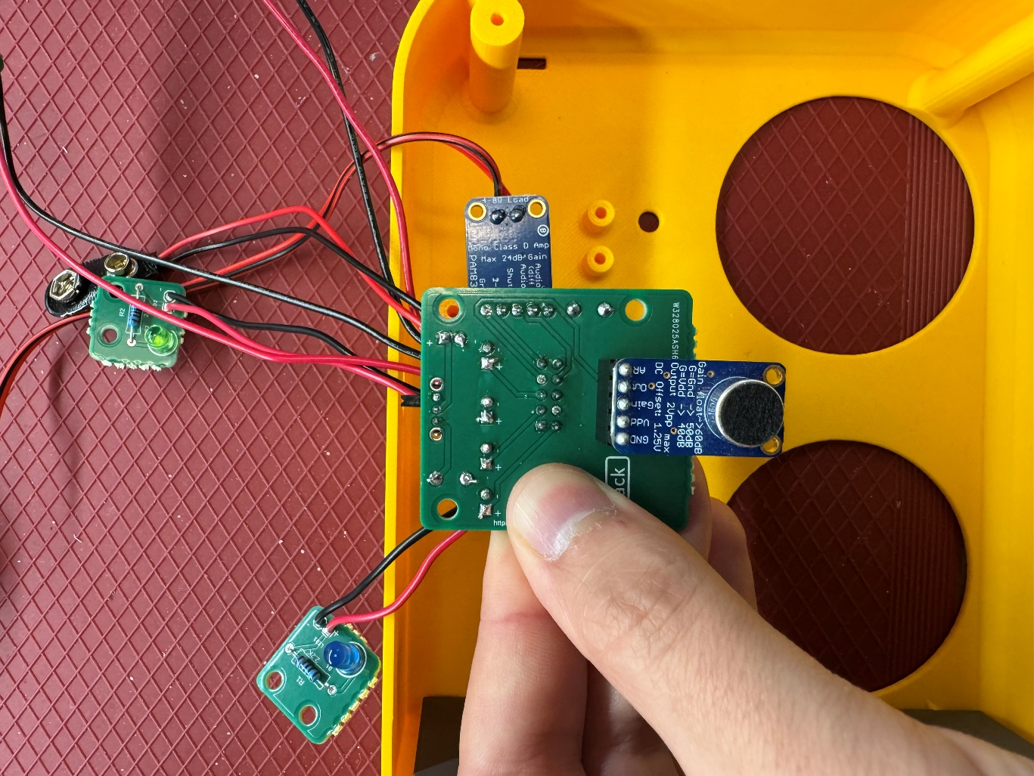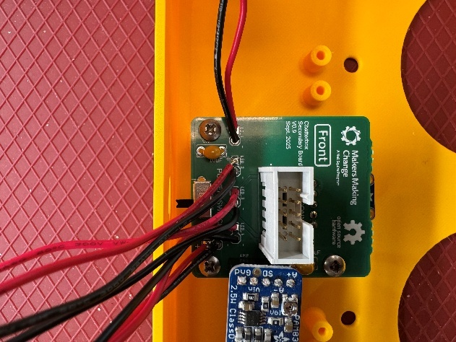

X

✓

#### Step D -16: Screw down Secondary PCB

Use three of the #4 screws (D04) to fix the Secondary PCB to the enclosure top.



#### Step D -17: Attach LED PCBs to enclosure top

Working one LED PCB at a time, position the PCBs to the LEDs line up with the holes in the top of the enclosure and the screw holes line up with the posts on the top of the enclosure. Like the message wires, the LED wires are cut to lengths to make it so the PCB will not reach a position too far from its required position.

Once the PCB is aligned correctly, secure it to the enclosure with two of the #4 screws.

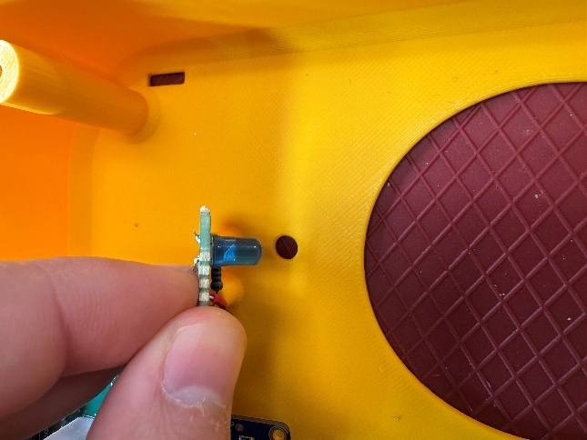

Repeat this step for the remaining three LED PCBs.

#### Step D -18: Connect speaker to enclosure top

Use four of the #4 screws to connect the speaker to the enclosure top. Make sure the speaker faces toward the holes in the top of the enclosure top.

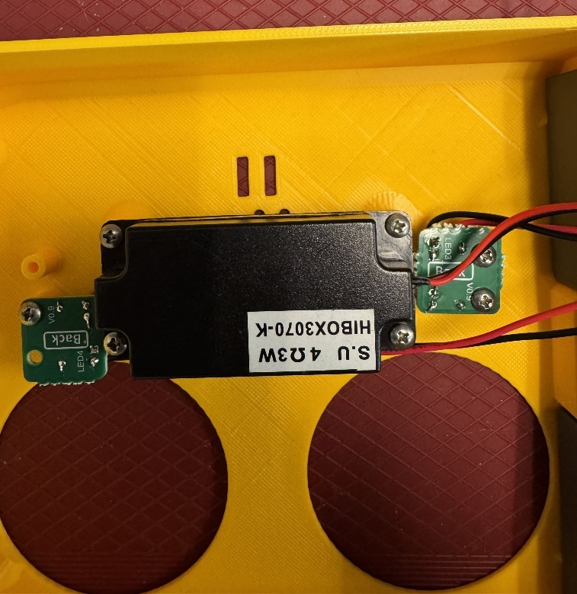

#### Step D -19: Connect ribbon cable to Secondary PCB

Plug the ribbon cable into the ribbon cable connector on the Secondary PCB.

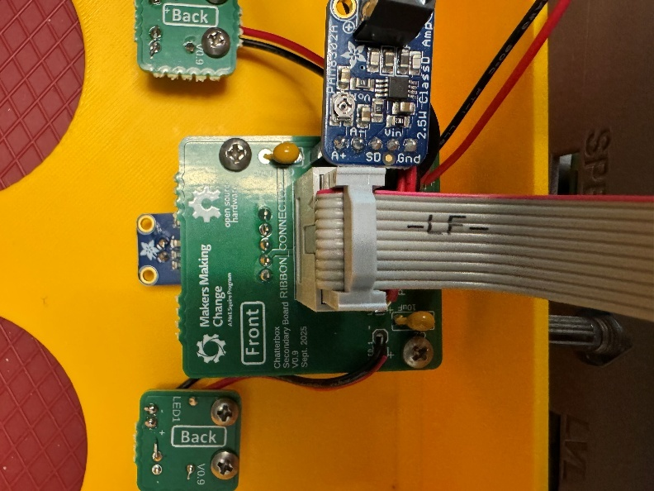

NOTE: You may want to move to Part E: Flashing the Firmware to the Chatterbox before completely assembling the enclosure. Some issues you may encounter when flashing the firmware may require you to access the electronics to troubleshoot.

#### Step D -20: Connect top and bottom halves of the enclosure

Line up the two halves of the enclosures, and fold them together. Use four of the #4 screws to connect the top and bottom halves.

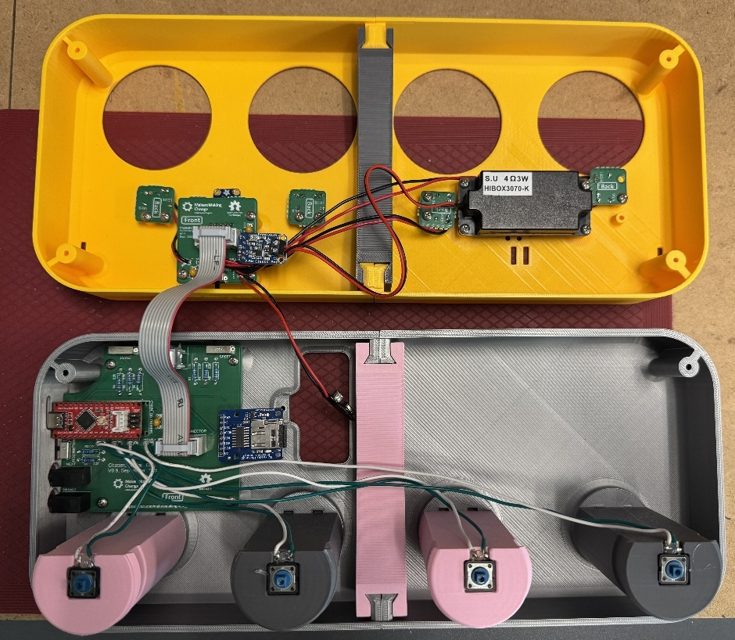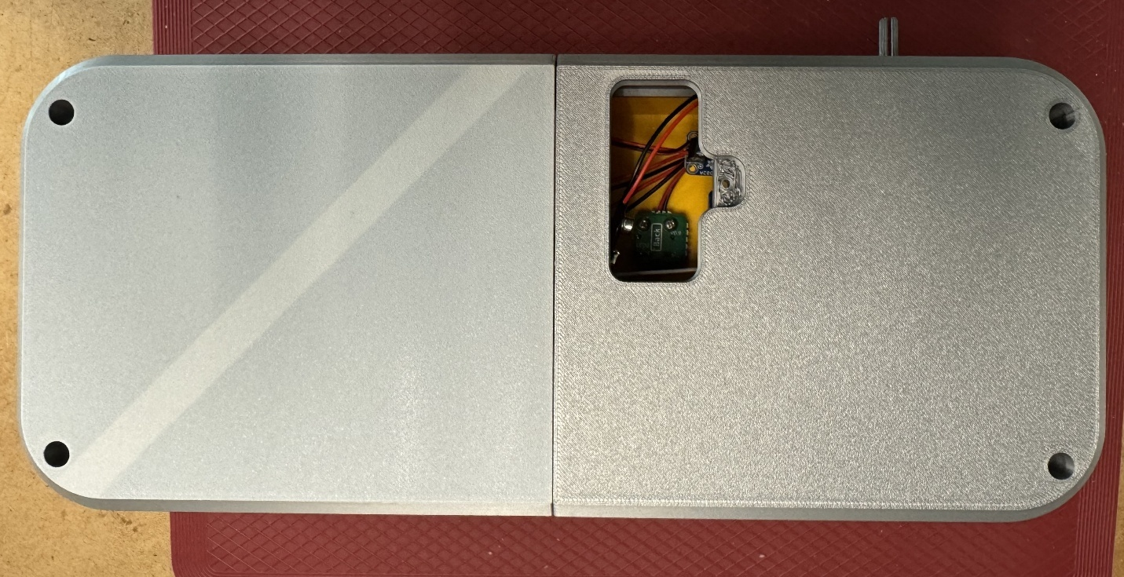

#### Step D -21: Connect the battery

Connect the 9V battery (D15) to the battery cap.

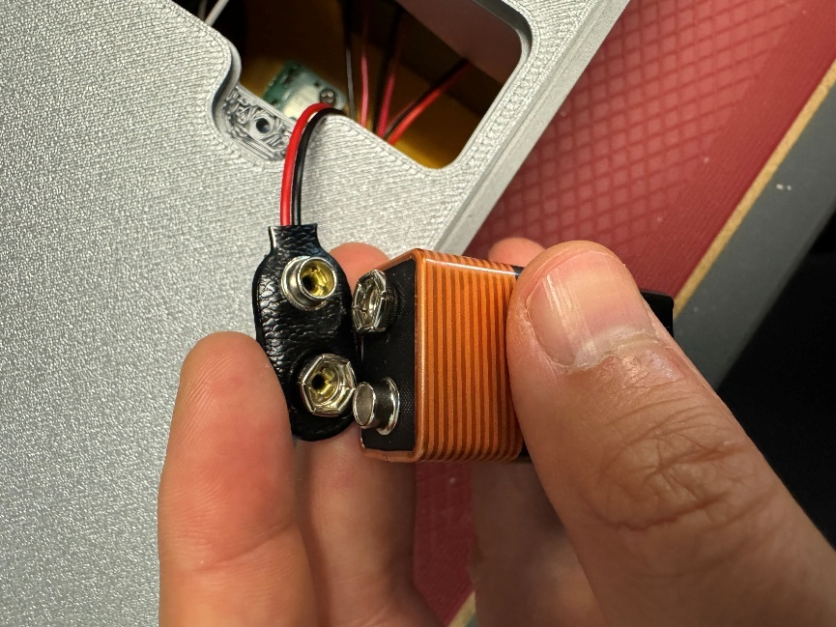

#### Step D -22: Insert battery into battery cover

Slide the battery into the battery cover (D16). Make sure the wires from the battery cap face toward the open section.

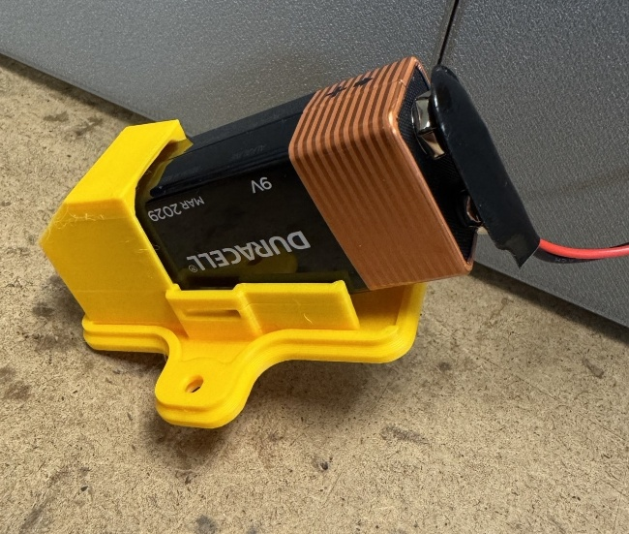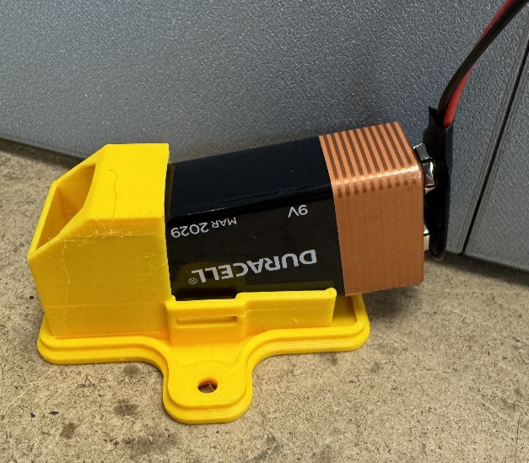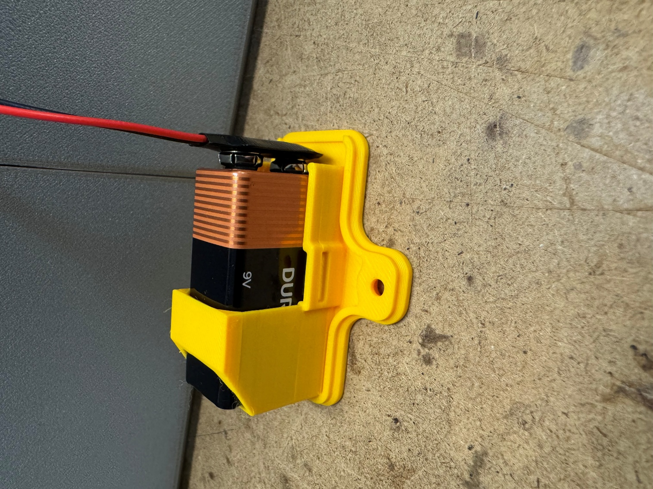

✓

✓

X

#### Step D -23: Connect battery cover to enclosure

Use the remaining #4 screw to connect the battery cover to the enclosure. The screw head should not stick past the bottom of the battery cover.

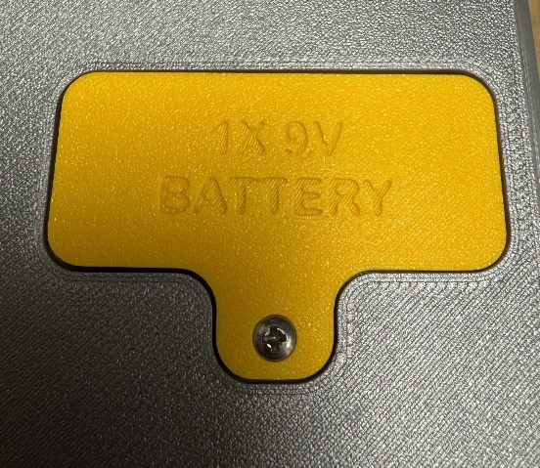

#### Step D -24: Put button inserts into button caps

Insert the Button Inserts (D12) into the Button Caps (D13). Line the tabs on the inserts up with the slots on the inside edge of the cap. Press firmly to snap the inserts into place. The insert should slide up and down easily within the cap, but no fall out or rotate.

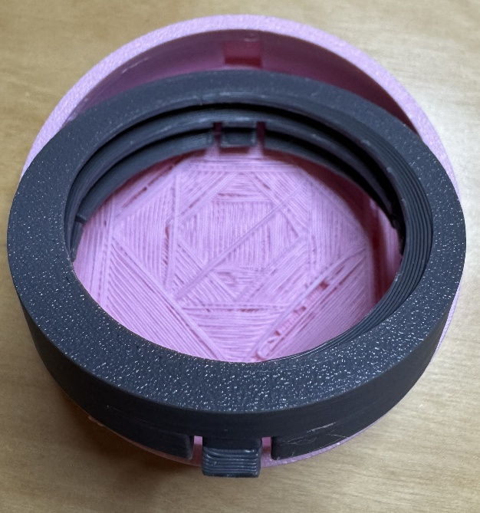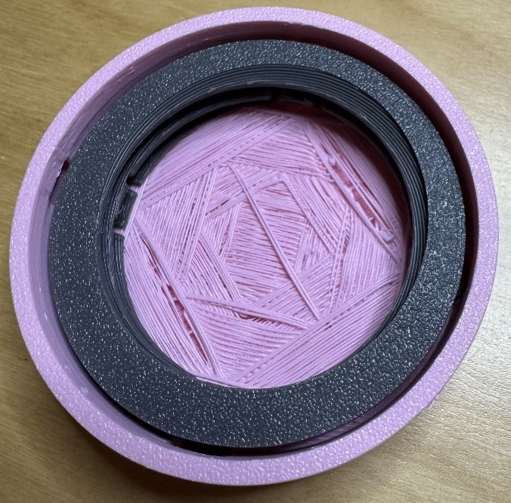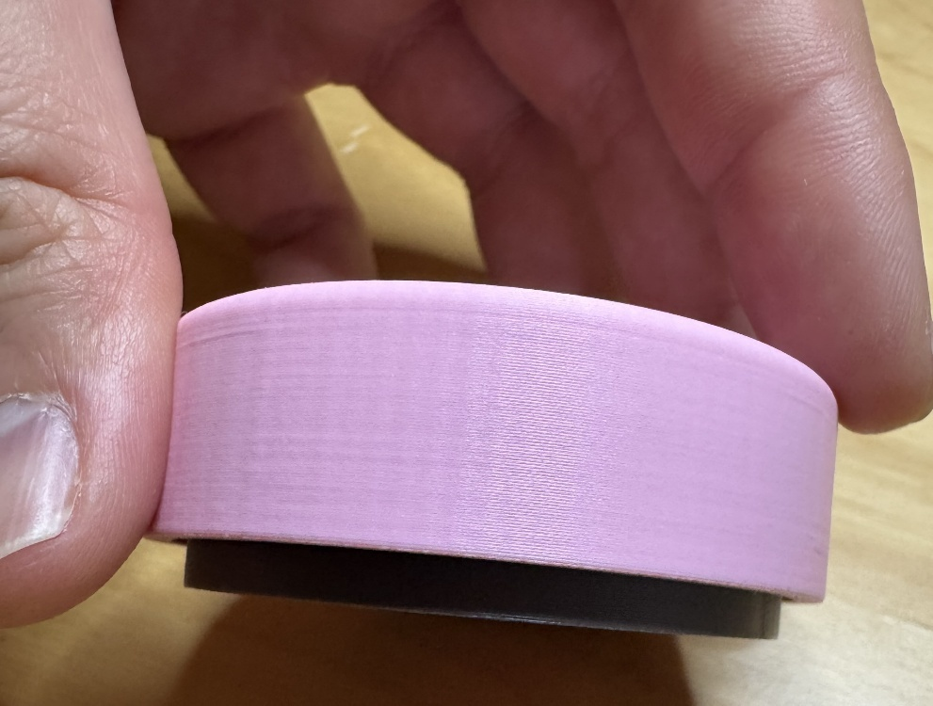

Repeat this step for the remaining three inserts and caps.

#### Step D -25: Screw button caps onto bases

Screw the button caps onto the button bases. The caps should stay flat while screwing on (i.e. not tilt to the side) and should screw on smoothly without a lot of resistance. If the cap is going on at a tilt or out encounter a lot of resistance, reposition the cap and try again.

The caps are designed to be able to rotate freely on the bases, so they will continue to spin, even when completely screwed down. To check the cap is fully attached to the base, try pressing on the cap. You should be able to feel and/or hear the tactile switch being pushed. If that is not the case, try unscrewing the cap and screwing it back on.

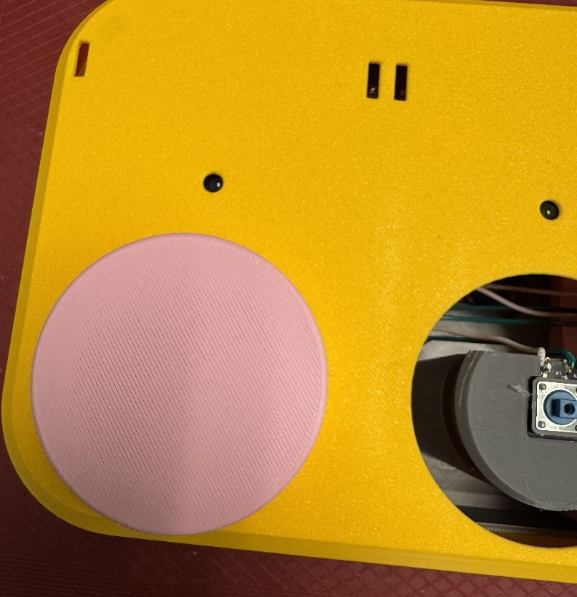

Repeat this step for the remaining three caps.

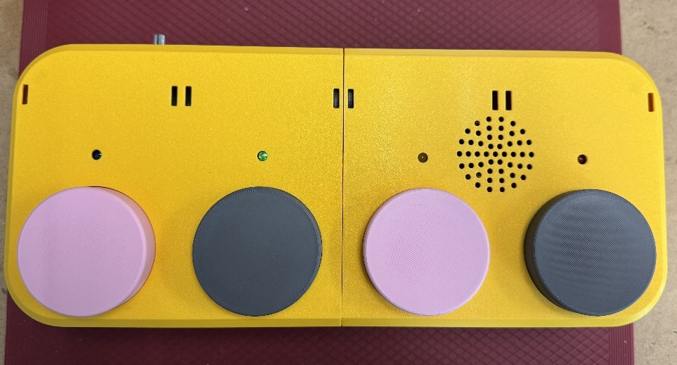

#### Step D -26: Connect label holders (If the requestor asked for them to come connected)

If the requestor asked for the label holders (D14) to be connected, connect the label holders. Line up the holders with the slots in the enclosure. Keeping your fingers out of the way, push firmly to snap the holders in place. It may help to angle the holders when pushing them in.

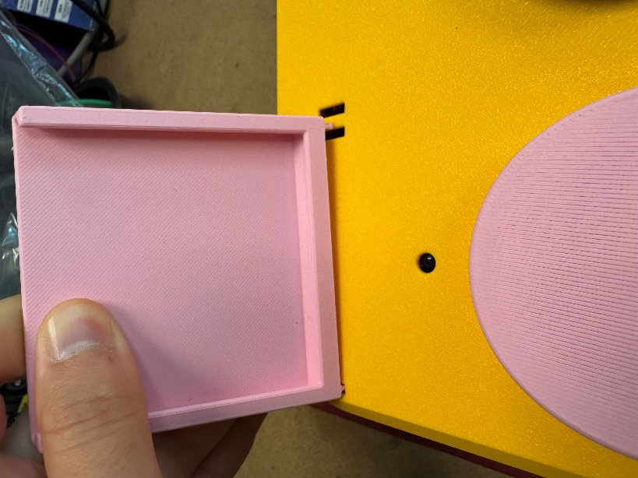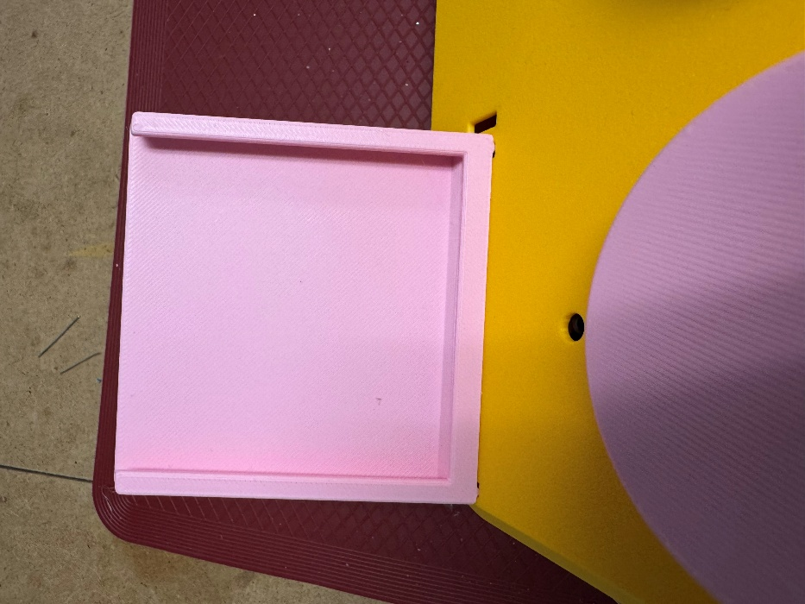

Repeat this step for the remaining three label holders.

The Chatterbox is now fully assembled.

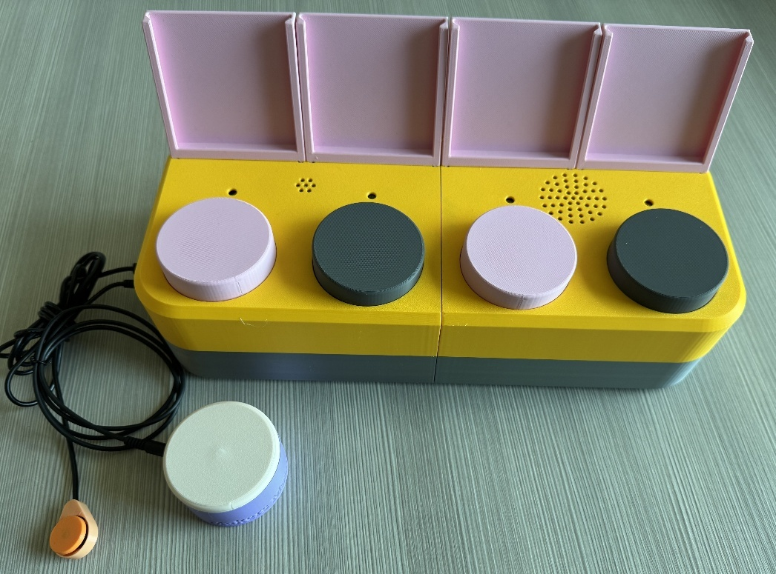

## Part E: Flashing Firmware to the Chatterbox

### Part E: Required Components

* Assembled Chatterbox
* USB-C cable
* Computer that can install and run Arduino IDE

### Part E: Required Tools and Supplies

* Computer that is able to install Arduino IDE and other Arduino libraries to flash firmware
* USB C cable to plug into the Chatterbox

### Step E-01: Connect the Chatterbox to the Computer

Make sure the power switch on the Chatterbox is in the “OFF” position. Plug the USB C cable into the port labeled “USB” on the side of the Chatterbox, and plug the other end of the cable into your computer. The computer will provide power to the Chatterbox, so you can leave the power switch set to “OFF”.

### Step E-02: Setup Arduino IDE on Computer

1. Download Arduino IDE for your operating system at <https://www.arduino.cc/en/software>.
2. Install the Arduino IDE.

### Step E-03: Setup Arduino IDE for the Seeeduino Nano

1. Open Arduino IDE.
2. Click on **File -> Preferences**
3. Locate the text field that reads **Additional Boards Manager URLs** beside it.
4. Copy and paste the following link into the field as a new line:

[raw.githubusercontent.com/Seeed-Studio/Seeed_Platform/master/package_legacy_seeeduino_boards_index.json](https://raw.githubusercontent.com/Seeed-Studio/Seeed_Platform/master/package_legacy_seeeduino_boards_index.json)

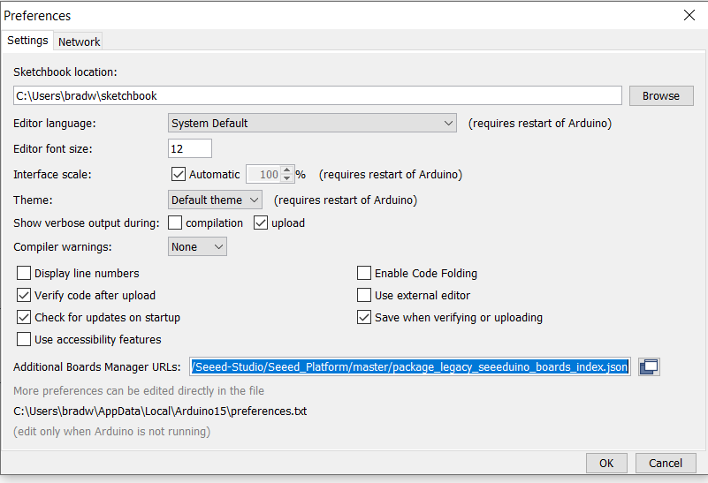

1. Click on **OK**.
2. Restart the Arduino IDE by closing and opening the program.
3. Open the **Boards Manager** option from the **Tools -> Board -> Boards Manager…** menu.
4. Search for “Seeeduino AVR” and select “Seeeduino AVR” by Seeed Studio. Make sure you select the exact board manager name stated as there may be some with similar names that will not work.
5. Click **Install** to install the board.

### Step E-04: Install Libraries

1. Go to the **Tools -> Manage Libraries…** menu.
2. For each library in the table below, search for the name. Ensure the Author and Version is correct, then install the library. If prompted to install any dependent libraries, click **OK**.

|  |  |  |
| --- | --- | --- |
| Library Name | Author | Version |
| TMRpcm | TMRh20 | 1.3.6 |
| StateMachine | Jose Rullan | 1.0.13 |
| Neotimer | Jose Rullan | 1.1.6 |

### Step E-05: Enable Recording

Find the folder where the TMRpcm library was installed. This is usually in C:\Users\[NAME]\sketchbook\libraries\TMRpcm. Open the file pcmConfig.h in notepad or a similar text editor.

Uncomment the line “#define buffSize 128” by removing the “//” before #define buffSize128

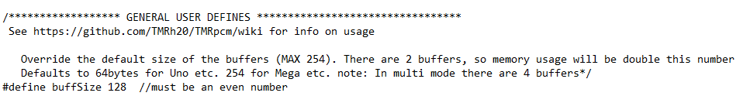

Uncomment the line “#define ENABLE_RECORDING” by removing the “//” before #define ENABLE_RECORDING

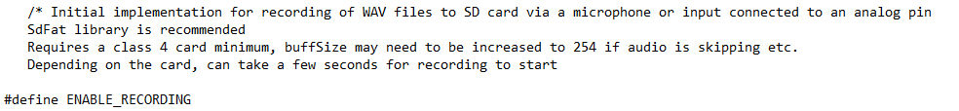

Save the file and close it.

### Step E-06: Setup Local Code Directory

1. Download the Firmware_Files from the GitHub Repository

<Insert link to GitHub firmware files zip file>

1. Extract / unzip the folder to a known location on your computer.
2. Confirm you have the following folder structure:

* Chatterbox_Firmware (folder)
  + Chatterbox_Firmware.ino

### Step E-07: Flash Firmware to the Chatterbox

1. Open the Chatterbox_Firmware.ino with Arduino IDE.
2. Select Seeeduino Nano from the **Tools -> Board -> <Boards Type>** menu
3. Connect the Chatterbox to the computer using the USB-C cable.
4. Select the correct port from the **Tools -> Port** menu.
5. Verify and upload to code by clicking the arrow in the top-left corner of the Arduino program.

# Testing

It is important to test the following functions of the Chatterbox before it is sent to the requestor. If you encounter any issues while testing, refer to the Troubleshooting section for help solving the problem. The tests are summarized in the table below to make it easy to check if all tests have been completed. Each test is described in detail following the table.

|  |  |  |
| --- | --- | --- |
| Test | Description | Passed or Failed |
| Battery power | Check the device powers on from the battery |  |
| Mode switch | * Check the mode switch changes modes * Check all LEDs blink while in Record Mode |  |
| Record Messages | * Record a message on each button on one level * Check that only the one LED blinks while recording on a switch * Check that the messages play back in Record Mode * Check that playback is audible/clear |  |
| Level switch | * Check that moving the Level switch changes the recording/playback level * Record new messages for each button at each level * Check that message play back in Record Mode |  |
| Message Playback | * Check that messages play back in Playback mode * Check that only the LED for the message being played lights up |  |
| Switch Scanning | * Check that pressing the Select switch once starts switch scanning * Check that the LED for a message stays lit during the delay before playing the next message * Check that only the playing message LED stays lit * Check that switch scanning stops if the last message times out * Check that pressing the Select switch again while switch scanning replays the current message |  |
| Next switch | * Check that pressing the Next switch when not switch scanning does nothing * Check that pressing the Next switch while switch scanning moves to the next message |  |
| Speed switch | * Check that moving the Speed switch changes the length of the delay between messages being automatically played while switch scanning * Check all three speeds |  |
| Volume | * Check that the volume knob changes the volume of the messages |  |

## Battery Power

Slide the Level and Speed switches to the first positions (left-most when looking at them, labeled “1” on the enclosure). Slide the Mode switch to the position closest to the USB port (this is the Record mode position).

With the Chatterbox unplugged from any other power source, turn the power switch to the “On” position. The Chatterbox should turn on. If it’s in Record mode, all four lights will start blinking. If it is in Playback mode, no lights will turn on, but starting switch scanning or pressing a message button should like the LEDs as messages play. Note, no messages will play if they have not been recorded yet.

Passing this test means the device powers on with the battery.

## Mode Switch

With the Chatterbox on, slide the Mode switch to its different positions (only two positions). As you change the mode, the LEDs should either all blink (Recording mode), or no LEDs should light up unless a message is being played.

Passing this test means the Mode switch changes mode consistently.

## Record Messages

With the Chatterbox on and in Recording mode, press and hold one of the message buttons. Once the other LEDs stop blinking and only the LED for the button being held is bringing, start recording the message you would like on that button (ex: say “Level 1, Message 1” for the first button on the first level). Once you have finished the message, release the button. All LEDs should start blinking again after you release the button. Press the button to preview the message; the Chatterbox should play that message back to you.

Record and preview a message on each of the buttons for that message level.

Passing this test means that you can record and preview messages on each of the buttons.

## Level Switch

Move the Level switch to position 2 (the centre position) to switch to Level 2. Repeat the Record Messages test on this level. Move the Level switch to position 3 (right-most position when looking at the switch) and repeat the Record Messages test a third time.

Passing this test means that the Level switch consistently switches between levels, and allows you to record and preview messages on the different levels.

## Message Playback

Slide the Mode switch so it is closest to the assistive switch jacks (Next and Select), and slide the Level switch to the first position. One at a time, press each message button and listen to the playback. Once the message has played back, move on to the next button. Repeat this with all message buttons and on all three levels.

Passing this test means:

* The correct LED lights up and stays on while a message is playing
* Each message plays back when the button is pressed

## Switch Scanning

Plug an assistive switch into each of the assistive switch ports. Press the switch connected to the Select port to start switch scanning and complete each of the following:

1. Allow the Chatterbox to go through all messages.
2. Select a message to playback by pressing the Select switch again
   1. While a message is playing.
   2. During the delay between messages.
3. Advance through the messages by pressing the switch connected to the Next port
   1. While a message is playing.
   2. During the delay between messages.

Passing this test means that while a message is playing and during the delay between messages, only the corresponding LED is lit, and it turns off when the next message is played. Additionally:

1. The Chatterbox stops cycling through messages if it advances past the fourth message on the level (whether from pressing the Next switch or going past the delay).
2. The Chatterbox replays the current message when the Select switch is pressed again.
   1. The message playing stops and restarts.
   2. The message replays.
3. The Chatterbox advances one message when the switch connected to the Next port is pressed.
   1. The message stops playing and advances to the next.
   2. The next message starts playing.

## Next Switch

While not actively switch scanning, the Next switch has no function. Press the assistive switch connected to the Next port while not switch scanning.

Passing this test means nothing happens when the Next switch is activated if the Chatterbox is not currently switch scanning.

## Speed Switch

Check that changing the position of the Speed switch changes the delay between messages when switch scanning. Move the Speed switch to the middle position (2) and press the Select switch. Let the messages advance automatically, comparing the delay between a message finishing playing and the next starting. Repeat this after changing the Speed switch to the last position (right-most when looking at it).

Passing this test means the length of the delay between messages increases with increasing Speed position. At the time of writing, the default delay times are 3, 5, and 7 seconds for Speeds 1, 2, and 3, respectively.

## Volume

Test that turning the volume knob changes the volume of the messages. Play a message, and while it is playing, turn the volume knob clockwise, then counterclockwise.

Passing this test means the volume increases when turning the knob clockwise, and decreases when turning it counterclockwise.

# Troubleshooting

Below are some potential common issues and how to solve them. If you have any issues with the Chatterbox that are not solved through this troubleshooting, please add them as an Issue to the Chatterbox GitHub repository.

## When powered, the first two lights start blinking and nothing else will happen

This is an error state from the micro-SD card reader not finding a micro-SD card.

1. Double check that the micro-SD card has been inserted properly into the micro-SD card reader.
2. Double check the format of the micro-SD card. The micro-SD card reader requires the card to be formatted in FAT16 or FAT32. The [Adafruit website for the micro-SD reader](https://learn.adafruit.com/adafruit-micro-sd-breakout-board-card-tutorial/formatting-notes) has detailed instructions on how to reformat the micro-SD card, if needed.
3. If you used/purchased a different micro-SD card than in the Bill of Materials, double check the size of the card. Windows sets an artificial limit on the size of memory it will format as FAT32 to 32GB. While FAT32 can work on data storage up to 2TB, a Windows system will not allow you to format anything above 32GB as FAT32 without bypassing this artificial limit.

## Chatterbox does not turn on with battery, but did on USB-C power

This is likely due to a dead battery, or bad solder connections for the battery or power

1. Double check if messages play back when a button is pressed, or if LEDs blink when in Record mode. No visible lights turn on while in Playback mode.
2. Replace the battery.
3. Double check solder connections for the battery cap and power switch on the Secondary PCB.

## An LED does not turn on

This is likely due to a bad connection between the LED PCB and Secondary PCB.

1. Check the solder connections on each PCB.
2. Check that the LED was connected in the correct orientation.
3. Check that the LED has not broken.

## When a button is pressed, the corresponding LED turns on very briefly but nothing else happens

This is likely due to there not being a message recorded for that button.

1. Put the Chatterbox in Record mode and record a message on the corresponding button.

## The Chatterbox seems to skip playing a message while switch scanning, and goes right to the delay between messages

This is likely due to there not being a message recorded for that button.

1. Put the Chatterbox in Record mode and record a message on the corresponding button.

## Nothing happens when I press a message button

This may be due to the button cap not being seated correctly, or issues with the connection between the tactile switch and Main PCB.

1. Remove the button cap and try pressing the switch. If the switch works without the button cap, reposition the button cap and screw it back on.
2. Check the solder joints on the Main PCB and the tactile switch for that button.
3. Check the tactile switch is working.

## Nothing happens when I press the assistive switch attached to the Select jack

This may be due to the switch not working, a bad connection on the Main PCB, or being in the wrong mode.

1. Check that the Chatterbox is powered on and in Playback mode.
2. Check that the assistive switch is working properly.
3. Check the solder connections on the Main PCB.

## Nothing happens when I press the assistive switch attached to the Next jack

The Next jack only works while switch scanning, so if it does not do anything when pressed and you are not switch scanning, that is fine. If you are switch scanning and pressing the Next button does nothing, it may be due to the assistive switch not working, or a bad connection on the Main PCB.

1. Start switch scanning by pressing the switch connected to the Select jack, then press the switch connected to Next again.
2. Check that the assistive switch is working properly.
3. Check the solder connections on the Main PCB.